ORDINANCE AMENDMENT TO THE TOWN ZONING ORDINANCE
ACCESSORY STRUCTURES
WHEREAS, the Town of Springfield (the “Town”) has adopted a Town Zoning Ordinance, which has been in effect since January 1, 2018;
WHEREAS, the Town has determined that it is appropriate to modify the Ordinance to address questions which have arisen concerning accessory structures;
WHEREAS, the Town finds that the proposed amendments to the Ordinance are consistent with the Comprehensive Plan of the Town;
NOW, THEREFORE, the Town Board of Supervisors of the Town of Springfield does hereby Ordain as follows:
ARTICLE ONE. Section 1.045, the Land Use Table, is amended as follows:
USES DISTRICTS | AG | EA | AE | RC | NBR | PRD | COM | IND | NR | RCOM | RBB | RUC | PUD | SFR | MFR
Plumbing fixtures in accessory buildings. | C | C | C | C | C | C | P | P | C | C | C | C | C | C | C

ARTICLE TWO. Section 1.06285 is created to read:
1.06285 Plumbing Fixtures in Accessory Buildings. Sinks, toilets, showers, bathtubs and other fixtures connected to a water supply may be installed only if permitted in the applicable zone or authorized under a conditional use permit. Installation of plumbing fixtures does not authorize use of an accessory structure for human habitation. Floor drains in garages or storage buildings are not considered “plumbing fixtures” and are permitted in all districts if drained into an approved private on-site waste treatment system or sewer.
ARTICLE THREE. Section 1.071 (7)(a) is amended to read:
(7) Zoning District Dimensional Requirements.
(a) The graphics in secs (8) through (21) (22) identify the dimensional requirements which apply to each of the zoning districts in this ordinance,:

(8) Agriculture
(9) Exclusive Agricultural
(10) Agricultural Enterprise
(11) Resource Conservancy
(12) Nature-Based Recreation
(13) Planned Rural Development
(14) Commercial
(15) Industrial
(16) Neighborhood Retail
(17) Recreational Commercial
(18) Rural-Based Business
(19) Rural Community District
(20) Planned Unit Development
(21) Single Family Residential
(22) Multi-Family Residential
ARTICLE FOUR. Section 1.071 (22)(graphic) is amended as shown on the attached Exhibit One.
ARTICLE FIVE. This Ordinance Amendment shall be effective upon its adoption.
Dated ______________, 2019. TOWN OF SPRINGFIELD
By the Town Board:

____________________________ _________________________
Dave Laufenberg, Supervisor I Bill Statz, Supervisor II

____________________________ _________________________
Art Meinholz, Supervisor III Dan Dresen, Supervisor IV

____________________________
Jim Pulvermacher, Town Chair

CERTIFICATION
I, the Town Clerk of the Town of Springfield, do hereby certify that the above Ordinance Amendment was adopted by majority vote of the members of the Town Board of Supervisors at a duly-noticed meeting thereof.
__________________________
Dianah Fayas, Town Clerk-Treasurer
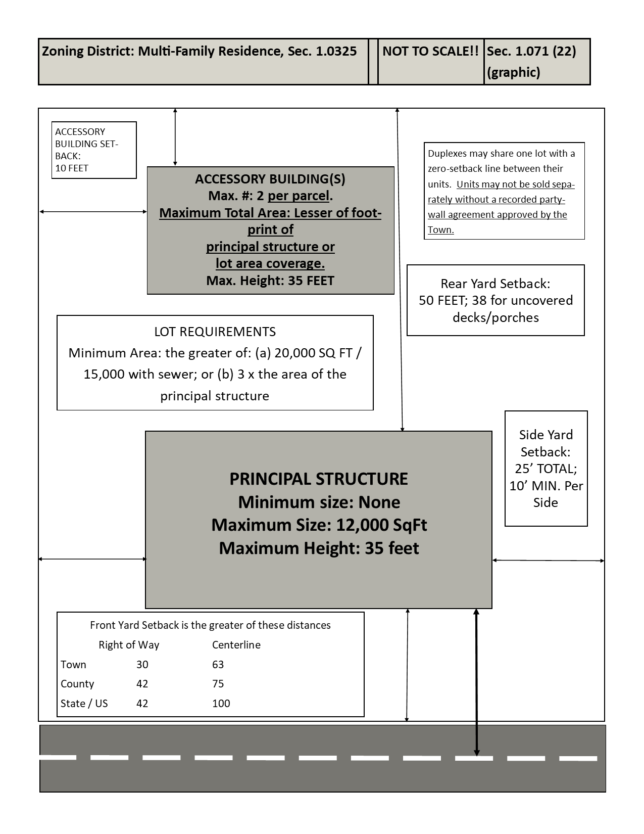
EXHIBIT ONE: AMENDED VERSION OF SEC. 1.071 (22)(graphic)

