TOWN OF SPRINGFIELD ZONING
ZONING ORDINANCE

SUBCHAPTER I
ZONING ESTABLISHED; OFFICIAL MAP

1.010 Title
1.011 Authority.
1.012 Land Use Regulated.
1.013 Purpose.
1.014 Relationship to the Town Comprehensive Plan
1.015 Zoning District Boundaries.
1.016 Previous Ordinance.
1.017 Minimum requirements and compliance with other applicable regulations.
1.018 Severability.
1.019 Official Map.

SUBCHAPTER II
DEFINITIONS

1.020 Purpose.
1.021 Word usage.
1.022 Definitions.

SUBCHAPTER III
ZONING DISTRICTS

1.030 Purpose
1.0311 Agriculture Zoning District (AG)
1.0312 Exclusive Agriculture Zoning District (EA)
1.0313 Agricultural Enterprise District (AE).
1.0314 Resource Conservancy Zoning District (RC)
1.0315 Nature-Based Recreational District (NBR)
1.0316 Planned Rural Development District (PRD).
1.0317 Commercial Zoning District (COM)
1.0318 Industrial Zoning District (IND).
1.0319 Neighborhood Retail District (NR).
1.0320 Recreation Commercial Zoning District (RCOM)
1.0321 Rural-Based Business District (RBB).
1.0322 Rural Community Zoning District (RUC).
1.0323 Planned Unit Development District (PUD).
1.0324 Single Family Residential Zoning District (SFR)
1.0325 Multiple family residential zoning district (MFR)

SUBCHAPTER IV
PERMITTED AND CONDITIONAL USES

1.040 Purpose.
1.041 Land Use Categories And Principal Uses.
1.042 Uses Not Specifically Listed And Comparable Uses.
1.043 Uses Not Permitted Or Comparable.
1.044 Land Use Table Key.
1.045 Land Use Table.

SUBCHAPTER V
SPECIAL ZONING REGULATIONS

1.051 Planned Rural Development
1.052 Standards For Approving A Planned Rural Development (PRD).
1.053 Mobile Tower Siting.
1.054 Mobile Telecommunications; Structural, Design, And Environmental Standards.
1.055 Adult Entertainment Establishments.
1.056 Non-Metallic Mining And Extraction
1.057 Planned Unit Development.

SUBCHAPTER VI.
ADDITIONAL SECONDARY STANDARDS FOR APPROVAL OF CERTAIN SPECIFIED USES.

SUBCHAPTER VI. ADDITIONAL SECONDARY STANDARDS FOR APPROVAL OF CERTAIN SPECIFIED USES.

1.0600 Additional Secondary Standards.
1.0601 Accessible Element: Secondary Standards
1.0602 Accessory Structures, Secondary Standards.
1.0603 Agricultural Tourism, Secondary Standards.
1.0604 Agriculture: Secondary Standards.
1.0604r Airports and Landing Strips
1.0605 Animal Grooming, Veterinary Clinic: Secondary Standards.
1.0606 Animal Sanctuary: Secondary Standards.
1.0607 Animal Units.
1.0608 Aquaculture Facility: Secondary Standards.
1.0609 Art Gallery And Art Studio: Secondary Standards
1.0610 Auto Body, Vehicle Repair And Maintenance: Secondary Standards.
1.0611 Bed And Breakfast Establishment, Lodging Houses: Secondary Standards.
1.0611r Biofuel Manufacturing Facility.
1.0612 Campground.
1.0613 Child Care Center: Secondary Standards.
1.0614 Community Living Arrangements: Secondary Standards.
1.0615 Composting Facility, Recycling Center, Waste Transfer Station: Secondary Standards.
1.0616 Dwelling Used Temporarily During Construction: Secondary Standards.
1.0617 Exclusive Agriculture Zoning District: Secondary Standards.
1.0617r Farm Residences; secondary standards.
1.0618 Food Processing Facility And Grocery Store, Confectionary, Bakery, Deli, And Meat Market: Secondary Standards.
1.0619 Government Facilities, Buildings And Uses: Secondary Standards.
1.0620 Home-Based Business: Secondary Standards.
1.0621 Junkyard: Secondary Standards
1.0622 Kennel: Secondary Standards.
1.0622r Laboratories or research facilities.
1.0623 Landfill, Clean: Secondary Standards.
1.0624 Livestock Harvesting Facility; Secondary Standards
1.0625 Metal And Wood Fabrication: Secondary Standards
1.0626 Mobile Home Park And Mobile Homes: Secondary Standards.
1.0627 Non-Metallic Mining Sites, Small And Temporary; Secondary Standards.
1.0628 Nonmetallic Mining Site, Between One Acre And 15 Acres, Not Exceeding 24 Months: Secondary Standards.
1.0629 Ponds: Secondary Standards.
1.0630 Poultry And Egg Production, Beekeeping Residential: Secondary Standards.
1.0631 Recreation Facility, Outdoor: Secondary Standards.
1.0632 Rendering Plant Facility: Secondary Standards.
1.0633 Renewable Energy Structures: Secondary Standards.
1.0634 Resort.
1.0635 Roadside Stand And Farmer’s Market: Secondary Standards.
1.0636 Sawmill: Secondary Standards.
1.0637 Seasonal Storage Of Recreational Equipment And Motor Vehicles: Secondary Standards.
1.0638 Sport Shooting Range: Secondary Standards
1.0638r Stables and Equestrian Facilities.
1.0639 Storage Yard: Secondary Standards
1.0640 Temporary Secondary Dwelling For Dependency Living Arrangement Or Agricultural Use: Secondary Standards.
1.0640m Transportation, Pipeline and Communication Uses.
1.0604r Utility Uses.
1.0641 Vegetative Buffer.
1.0642 Vegetative Screening.
1.0643 Warehousing, Self-Storage Facility, Or Mini-Warehousing: Secondary Standards.
1.0644 Water Distribution, Wholesale, Processing, And Treatment Facility: Secondary Standards.
1.0645 Water Extraction And Removal Facility: Secondary Standards.
1.0646 Wholesale Distribution Facility: Secondary Standards.
1.0647 Subdivision Standard: Rural Residential.
1.0648 Subdivision Standard: Suburban Residential
1.0649 Subdivision Standard: Conservancy Residential.

SUBCHAPTER VII. DIMENSIONAL STANDARDS

1.070 Purpose.
1.071 Lot area, lot coverage, setbacks, floor area, and building height
1.072 Livestock related and manure storage structure setbacks.
1.073 Road setbacks.
1.074 Structures prohibited within setbacks.
1.075 Structures permitted within setbacks
1.076 Driveway, Field Road and Parcel Access Locations.
1.077 Maintenance of Topography.
1.078 Parking and Loading.
1.079 Required Parking Spaces.

SUBCHAPTER VIII. SIGNS.

1.0800 Purpose and findings.
1.0801 Definitions.
1.0802 Classifications of Signs.
1.0803 Sign Requirements, Applicability and Construction
1.0804 Sign Location and Use Regulations.
1.0805 Sign Structural Requirements
1.0806 Sign Placement.
1.0807 Flags.
1.0808 Prohibited Signs.
1.0809 Signs Not Requiring a Sign DAC.
1.0810 Sign Design Approval Certificate.
1.0811 Construction and maintenance.
1.0812 Nonconforming existing signs
1.0813 Sign enforcement and penalties

SUBCHAPTER IX
ADMINISTRATION OF THIS ORDINANCE

1.090 Purpose.
1.091 Town Zoning Administrator: Description And Roles.
1.092 Planning Commission.
1.093 Dane Town Board Of Zoning Appeals And Adjustment: Description And Rules.
1.094 Zoning Map Amendments: Review Procedure And Standards
1.095 Conditional Use: Review Procedure And Standards.
1.096 Land Use Permits: Review Procedure And Standards.
1.097 Enforcement And Penalties.
1.098 Variances.
1.099 Substandard Lots.

SUBCHAPTER X.
TRANSITION FROM THE DANE COUNTY CODE OF ORDINANCES;
NON-CONFORMING USES

1.0101 Prior Dane County Zoning
1.0102 Nonconforming Uses.
1.0103 Nonconforming lots of record.

SUBCHAPTER I
ZONING ESTABLISHED; OFFICIAL MAP

1.010 Title. This Ordinance is known as the “Town Zoning Ordinance.”
1.011 Authority. (1) This ordinance is enacted pursuant to the authority granted by the Wisconsin Statutes, including, but not limited to, secs. 60.23 (34), 60.61, 60.62, and chs. 91, 236, and 823, Wis. Stats.
(2) This ordinance applies to all land located within the Town.
(3) The Town directs that this Ordinance shall be construed to maximize the authority of the Town and minimize the regulatory control of other units of government.
1.012 Land Use Regulated. It shall be unlawful and in violation of this ordinance for any person to use a parcel of real estate, or, to establish, construct, reconstruct, alter, or replace any land use or structure, except in compliance with this ordinance.
1.013 Purpose. This ordinance is intended to protect the public health, safety, and welfare of the residents of the Town and the public, to plan for the future development of communities, and to further the purposes contained in sec. 62.23, Wis. Stats., and Ch. 91, Wis. Stats.
1.014 Relationship to the Town Comprehensive Plan. (1) The Town has formally adopted a comprehensive plan pursuant to sec. 66.1001, Wis. Stats. The Town Comprehensive Plan provides an integrated approach to the town’s physical development and economic and social potential. It emphasizes moving the Town toward economic, social, and environmental sustainability, enhancing education and health systems, improving transportation coordination, supporting economic development, strengthening agriculture, and developing prosperous places to live.
(2) This ordinance implements the Town Comprehensive Plan through zoning. In accordance with sec. 66.1001(3), Wis. Stats., this ordinance is consistent with the Town Comprehensive Plan.
1.015 Zoning district boundaries. (1) Zoning Districts Established. Areas that are subject to the jurisdiction of this ordinance are hereby divided into zoning districts for the purpose of achieving compatibility of land uses within each zoning district, to implement the Town Comprehensive Plan, and to achieve the purpose of this ordinance as described in s. 1.03.
(2) Official Zoning Maps. Zoning districts established by this ordinance are shown on the official zoning map of the Town. The Zoning Map is made part of this ordinance by reference. Where the official zoning map does not indicate a zoning district for a particular area, the area is either within the corporate limits of a town or village, or is not zoned. The official zoning map of the Town is a digital compilation made using a geographic information system. This digital map shall be the official map for the purpose of enforcement of this ordinance. Responsibility for the maintenance of this map is vested with the Town Zoning Administrator.
(3) Interpretation of Zoning District Boundaries. Where the exact location of the zoning district boundary as shown on the official zoning map is uncertain, the boundary location shall be determined by the Town Zoning Administrator. The following rules shall be used by the Town Zoning Administrator to determine the precise location of any zoning district boundary shown on the official zoning map of the Town.
(a) Zoning district boundaries shown as following or approximately following the limits of any town, village, town, extraterritorial zoning, or town boundary shall be construed as following such limits.
(b) Zoning district boundaries shown as following or approximately following roads or railroad rights-of-way shall be construed as following the centerline of such road or railroad line.
(c) Zoning district boundaries shown as following or approximately following platted lot lines or other property lines as shown on the Town tax parcel map shall be construed as following such lines.
(d) Zoning district boundaries shown as following or approximately following the centerlines of streams, rivers, or other continuously flowing water courses shall be construed as following the channel centerlines of such watercourses and, in the event of natural change in the location of such streams, rivers, or other water courses, the zoning district boundary shall be construed as moving with the channel centerline.
(e) Where a road is officially vacated or discontinued, the property that was formally in the road will be included within the zoning district boundary of the adjoining property on either side of the centerline of the vacated or discontinued road.
(f) Zoning district boundaries shown as separated from any of the features noted in this subsection shall be construed to be at such distances as shown on the official zoning map.
(g) Any legal description that may have been filed with a petition to rezone property filed with the Town Clerk and that was adopted by the Town Board of Supervisors.
(h) In the event of actual or apparent conflict between maps contained in the Town Comprehensive Plan and the boundaries of parcels shown on such maps, parcel lines shall control.
1.016 Previous ordinance. (1) In order to assure that each property owner retains the full extent of the rights of use which existed under the previous Dane County Zoning Ordinance, upon the enactment of this Ordinance, each Lot shall be zoned with the Legacy Zoning District which is identical to the zoning district that the Lot had under the Dane County Zoning Ordinance as it existed on the date of enactment of this Ordinance.
(2) The Legacy Zoning District shall continue to govern the use of a parcel until the parcel is rezoned pursuant to this Ordinance. Certain defined events stated in this Ordinance shall require that a parcel be rezoned.
(3) The Town shall follow interpretations of the Dane County Zoning Ordinance made prior to the effective date of this Ordinance where necessary to protect the use of a Lot. The Town may, by ordinance, overrule a previous interpretation.
1.017 Minimum requirements and compliance with other applicable regulations. (1) Minimum Requirements. The provisions of this chapter are the minimum requirements deemed necessary to carry out the purpose of this ordinance.
(2) Other Applicable Regulations. This Ordinance imposes a requirement that all activity subject to the provisions of this ordinance must comply with applicable federal, state, county and town ordinances or regulations. The Town does not have responsibility, and may not have authority, to enforce federal or state statutes or regulations, or County ordinances. However, non-compliance with federal or state statutes, regulations or rules, or county ordinances, related to the use of land may serve as a basis for the denial or revocation of any permit or authority conferred under this chapter. Stricter regulations may, if not pre-empted, be adopted by the Town. Further, other Town ordinances may also apply. Adoption of a rezoning or a conditional use permit is not an implied repeal of any other town ordinance.
(3) Regulation by Others. Nothing in this chapter shall be construed to limit or prevent the federal or state governments from regulating the same or similar subject matter as contained in this chapter.
(4) Deed Covenants or Restrictions. Subdivision covenants, deed restrictions or other private agreements may impose restrictions on the use of land, or authorize the use of land by others. This ordinance does not apply to or regulate any such restrictions or covenants. The Town may be involved in enforcement of deed covenants or restrictions only if the covenants or restrictions explicitly authorize the Town to do so.
1.018 Severability. It is the intention of the Town Board of Supervisors that the provisions of this chapter are severable as follows:
(1) Judgment of Ordinance Provisions. If any court of competent jurisdiction shall adjudge any provision of this chapter to be invalid, the judgment shall not affect any other provision of this chapter not specifically included in the judgment.
(2) Judgment of Ordinance Application. If any court of competent jurisdiction shall adjudge invalid the application of any portion of this chapter to a particular property, building, use, or structure, the judgment shall not affect the application of the provision to any other property, building, use, or structure not specifically included in the judgment.
(3) Judgment of Permit. If any court of competent jurisdiction determines that any requirement or limitation contained in a permit given under this chapter is invalid, it shall be presumed that the permit would not have been granted without the requirement or limitation, and therefore, the permit shall also be invalid.
1.019 Official Map. (1) By authority of sec. 62.23 (6), Wis. Stats., the Town hereby adopts the Official Map of the Town. The Official Map shall be a digital map formulated using accepted geographical information systems methods.
(2) The official map shall include the streets, highways, historic districts, parkways, parks and playgrounds laid out, adopted and established by previous action. The map may also include the location of railroad rights-of-way, and, waterways on its map.
(3) The official map is conclusive with respect to the location and width of streets, highways, and parkways, and the location and extent of railroad rights-of-way, public transit facilities, parks and playgrounds shown on the map.
(4) The official map is declared to be established to conserve and promote the public health, safety, convenience or general welfare. The Town Clerk shall record with the Register of Deeds of Dane County a certificate showing that the Town has established an official map.
(5) The Town Board may amend the official map of the town so as to establish the exterior lines of planned new streets, highways, historic districts, parkways, railroad rights-of-way, public transit facilities, waterways, parks or playgrounds, or to widen, narrow, extend or close existing streets, highways, historic districts, parkways, railroad rights-of-way, public transit facilities, waterways, parks or playgrounds. No such change may become effective until after a public hearing concerning the proposed change before the Town Board, at which parties in interest and citizens shall have an opportunity to be heard. Notice of the public hearing shall be published as a class 2 notice under ch. 985. Before amending the map, the Board may refer the matter to the Plan Commission for report, but if the Plan Commission does not make its report within 60 days of reference, it forfeits the right to further suspend action. When adopted, amendments become a part of the official map of the town, and are conclusive with respect to the location and width of the streets, highways, historic districts, waterways and parkways and the location and extent of railroad rights-of-way, public transit facilities, parks and playgrounds shown on the map. The placing of any street, highway, waterway, parkway, railroad right-of-way, public transit facility, park or playground line or lines upon the official map does not constitute the opening or establishment of any street, parkway, railroad right-of-way, public transit facility, park or playground or alteration of any waterway, or the taking or acceptance of any land for these purposes.
(6) The locating, widening or closing, or the approval of the locating, widening or closing of streets, highways, waterways, parkways, railroad rights-of-way, public transit facilities, parks or playgrounds by the town under provisions of law other than this section shall be deemed to amend the official map, and are subject to this section, except that changes or additions made by a subdivision plat approved by the town under ch. 236 do not require the public hearing specified in par. (5) if the changes or additions do not affect any land outside the platted area.
(7) No permit may be issued to construct or enlarge any building within the limits of any street, highway, waterway, railroad right-of-way, public transit facility or parkway, shown or laid out on the map except as provided in this section. Any person desiring to construct or enlarge a building within the limits of a street, highway, railroad right-of-way, public transit facility or parkway so shown as extended may apply to the authorized official of the town for a building permit. Unless an application is made, and the building permit granted or not denied within 30 days, the person is not entitled to compensation for damage to the building in the course of construction of the street, highway, railroad right-of-way, public transit facility or parkway shown on the official map. If the land within the mapped street, highway, railroad right-of-way, public transit facility or parkway is not yielding a fair return, the Town Board may, by the vote of a majority of its members, grant a permit for a building or addition in the path of the street, highway, railroad right-of-way, public transit facility or parkway, which will as little as practicable increase the cost of opening the street, highway, waterway, railroad right-of-way, public transit facility or parkway or tend to cause a change of the official map. The board may impose reasonable requirements as a condition of granting the permit to promote the health, convenience, safety or general welfare of the community. The board shall refuse a permit where the applicant will not be substantially affected by not constructing the addition or by placing the building outside the mapped street, highway, waterway, railroad right-of-way, public transit facility or parkway. For this purpose, such Board is authorized to act as a discretionary administrative or quasi-judicial body. When so acting it shall not sit as a legislative body but in a separate meeting and with separate minutes kept. Before taking any action authorized in this subsection, the board of appeals or Town Board shall hold a hearing at which parties in interest and others shall have an opportunity to be heard. At least 15 days before the hearing notice of the time and place of the hearing shall be published as a class 1 notice, under ch. 985. Any such decision shall be subject to review by certiorari issued by a court of record in the same manner and pursuant to the same provisions as in appeals from the decisions of a board of appeals upon zoning regulations.
(8) No public sewer or other street or utility improvement shall be constructed in any street, highway or parkway until such street, highway or parkway is duly placed on the official map. No permit for the erection of any building shall be issued unless a street, highway or parkway giving access to such proposed structure has been duly placed on the official map. Where the enforcement of the provisions of this section would entail practical difficulty or unnecessary hardship, and where the circumstances of the case do not require the structure to be related to existing or proposed streets, highways or parkways, the applicant for such a permit may appeal from the decision of the Town Zoning Administrator to the Town Board. The board may in passing on such appeal make any reasonable exception, and issue the permit subject to conditions that will protect any future street, highway or parkway layout. Any such decision shall be subject to review by certiorari issued by a court of record in the same manner and pursuant to the same provisions as in appeals from the decision of such board upon zoning regulations. For such purpose such Board is authorized to act as a discretionary administrative or quasi-judicial body. When so acting it shall not sit as a legislative body, but in a separate meeting and with separate minutes kept.

SUBCHAPTER II
DEFINITIONS

1.020 Purpose.
1.021 Word usage.
1.022 Definitions.

1.020 Purpose. The purpose of this subchapter is to define words, terms, and phrases contained in this chapter which are essential to the understanding, administration, and enforcement of this chapter.
1.021 Word usage. (1) For the purposes of this chapter, certain words and terms are used as follows:
(a) Words used in the present tense include the future.
(b) Words in the singular include the plural.
(c) Words in the plural include the singular.
(d) The word “shall” is mandatory and not permissive.
(e) All terms are gender-neutral.
(2) Terms which are not defined shall be understood and administered with their ordinary and accepted meaning, as determined by reference to a recognized and authoritative dictionary such as the American Heritage Dictionary or Merriam-Webster’s Dictionary.
(3) If a term has an established technical meaning in law, real estate, surveying, engineering, soils, hydrology, or other field, the term shall be applied in that technical sense.
1.022 Definitions. For the purposes of this chapter, certain words and terms are defined as follows:
(1) “Accessible element” means an exterior component of a building which complies with the Americans with Disabilities Act and provides an accessible route into a building. An accessible element may include curb ramps, ramps, elevators, or lifts.
(2) “Accessory dwelling” means a second dwelling that is located on the same lot and under the same ownership as the principal building, and which may be detached from the principal building. The second dwelling is auxiliary to, and smaller than the principal dwelling. It is intended for use as a complete, temporary, independent living facility in conjunction with a dependency living arrangement or agricultural use.
(3) “Accessory structure” means a subordinate or supplemental structure, the use of which is incidental to the permitted use of the main structure on the same lot, or to the main use of the premises on which it is located. An accessory structure may not be used for human habitation. The term includes storage buildings, garages, barns, sheds, gazebos, greenhouses, screen houses, patio houses, or, cabanas. It also includes ready-to-assemble sheds or storage structures.
(4) “Accessory use” means:
(a) In all zoning districts, except the exclusive agriculture zoning district, a subordinate use on the same lot which is incidental and customary in connection with the principal or conditional use.
(b) In the exclusive agriculture zoning district only, any of the following land uses on a farm:
1. A building, structure, or improvement that is an integral part of, or incidental to, an agricultural use as that term is defined in sec. 91.01 (1)., Wis. Stats.
2. An activity or business operation that is an integral part of, or incidental to, an agricultural use as that term is defined in sec. 91.01 (1), Wis. Stats.
3. A farm residence as that term is defined in sec. 91.01 (1), Wis. Stats.
4. A business, activity, or enterprise, whether or not associated with an agricultural use; that is conducted by the owner or operator of a farm; that requires no buildings, structures, or improvements other than those described in par. 1., or in par. 3., that employs no more than 4 full-time employees annually, and that does not impair or limit the current or future agricultural use of the farm or of other protected farmland.
5. Any other use that the Wisconsin Department of Agriculture, Trade, and Consumer Protection by rule identifies as an accessory use.
(5) “Active agricultural acres” means acres that have been in agricultural use for any period during the previous 5 years.
(6) “Adult Entertainment Establishment” means an adult book or video store or an adult motion picture theater.
(7) “Adult Book or Video Store” means an establishment, which:
(a) dedicates or uses more than ten percent (10%) of the available floor, wall and display space to the sale, rental or loan of the subject matter referenced in subdivisions 1. and 2., and which is used for selling, renting or loaning, for monetary consideration, the following materials, when such activity constitutes a substantial or significant part of the business conducted therein:
1. Any pictures, photographs, drawings, motion picture films or similar visual representations or images of a person or portions of a human body which are distinguished or characterized by their emphasis on matters depicting, or describing or relating to “specified sexual activities” or “specified anatomical areas” as defined herein; or
2. Any book, pamphlet, magazine, printed matter, however reproduced, or sound recording which contains any matter enumerated in subdivision 1. above.
(b) Material, however distributed, which is published by a medical products manufacturer, a medical or health association, an insurance company, or by a consumer education organization shall not be considered part of the business of operating an adult book or video store.
(8) “Adult Motion Picture Theater” means an enclosed building used for presenting or exhibiting a motion picture film, show or other presentation having as its dominant theme or distinguished or characterized by an emphasis on or exposure to “specified anatomical areas” or “specified sexual activities” as defined herein.
(9) “Adult Entertainment Tavern” means any establishment, including those licensed to sell fermented malt beverages or intoxicating liquor pursuant to Town ordinances, which is used for presentations or services distinguished or characterized by an emphasis on “specified anatomical areas” or “specified sexual activities” as defined herein
(10) “Agricultural tourism” means a use that combines the elements and characteristics of agriculture and tourism. SPRINGFIELDs of agricultural tourism include: corn mazes; pick-your-own operations; hay rides; sleigh rides; petting farms; on-farm tours; agricultural related museums; winery or brewery, demonstrations of farming practices, techniques, and methods; fee-based fishing and hunting, horseback riding; haunted barns; and similar activities which are related to agriculture.
(11) “Agricultural use” means:
(a) Any of the following activities conducted for the purpose of producing an income or livelihood:
1. Crop or forage production.
2. Keeping livestock.
3. Beekeeping.
4. Nursery, sod, or Christmas tree production.
4m. Floriculture.
5. Aquaculture.
6. Fur farming.
7. Forest management.
8. Enrolling land in a federal agricultural commodity payment program or a federal or state agricultural land conservation payment program.
(b) Any other use that the department, by rule, identifies as an agricultural use.
(12) “Agriculture” means the art or science of cultivating soil, harvesting crops, and raising livestock.
(13) “Agriculture incubator” means a use that builds local food capacity, farming and entrepreneurial skills, cooperative markets, and supports the development of agriculture-related business. If the incubator is located in the Exclusive Agriculture District, the uses shall be limited to those uses specified in sec. 91.01 (1) or (3), Wis. Stats.
(14) “Agriculture-related business” means a business engaged in the sale or rental of farm supplies, services, or equipment to farmers provided that the sale or rental of farm supplies, services, or equipment to farmers comprises at least 50% of the annual gross revenue of the business.
(15) “All-weather surface” means any roadway, driveway, or parking lot surface covered with crushed stone, asphalt, grassy pavers, concrete, or other pervious or impervious material in a manner that will support the weight of anticipated vehicular traffic in all weather conditions and minimize the potential for ruts, potholes, and pooling of water.
(16) “Animal sanctuary” means a facility where non-livestock animals are brought to live and to be protected and that does not seek to place animals with a person.
(17) “Aquaculture” means an agricultural use that utilizes a production system of animals or plants in controlled water environments.
(17m) “Area Variance” means a modification to a dimensional, physical, or locational requirement such as the setback, frontage, height, bulk, or density restriction for a structure that is granted by the board of adjustment under section 1.098 of this Ordinance.
(18) “Art gallery” means an establishment engaged in the sale, loan, or display of art books, paintings, sculptures, or other works of art, including those created by the owner or tenant of the establishment.
(19) “Art studio” means a facility for any or all of the following:
(a) Staging of art.
(b) Production of art.
(c) Teaching of art.
(20) “Auction facility” means a facility that is used more than 2 times in a 365-day period for the public sale of property or items of merchandise typically sold to the highest bidder.
(21) “Bed and breakfast establishment” means any place of lodging that satisfies all of the following:
(a) Provides 8 or fewer rooms for rent to no more than a total of 20 tourists or transients.
(b) Is the owner's personal dwelling.
(c) Is occupied by the owner at the time of rental.
(d) Is an accessory use.
(22) “Biofuel manufacturing” means a facility that produces fuel whose energy is derived from the biological fixation of carbon.
(23) “Building” means a roofed structure entirely separated from any other structure by space or by walls in which there are no common communicating doors, windows, or similar openings. A building has walls or columns for support and does include swimming pools, both above and below ground, permanent hunting blinds with a foundation, balconies, porches, decks, fireplaces, chimneys, and towers, including communication towers. A building does not include poles, towers and posts for lines carrying communications or electricity, or recreational structures of open construction and without walls, such as swing sets, slides, yard gyms, climbers, sand boxes and teeter totters.
(24) “Building, front of” means the side directly facing the public or private road right-of-way which affords primary means of access to the property.
(25) “Building height” means the vertical distance, measured from the mean elevation of the finished grade along the front of the building to the highest point on the roof for flat roofs; to the mean height level between the highest ridge and its associated eave for gable and hip roofs; to the deck line for mansard roofs. The front of the building shall be the side directly facing the public or private thoroughfare which affords primary means of access to the property, excluding the driveway.
(26) “Building line” means the point at which the building wall or any appendage of the building such as steps, chimneys, decks, porches, or covered patios meet the ground. For earth-sheltered homes, the building line is a line where the exterior walls of the building, if extended vertically, would be located on the lot.
(27) “Building, principal” means a building in which the principal use of the lot on which the building is located is conducted.
(28) “Campground” means a parcel or tract of land maintained, intended, or used for the purpose of supplying temporary or overnight living accommodations to the public by providing designated areas for the placement of camping units. A campground may include buildings to provide services to the patrons such as restrooms, bathing, laundry, and commissary facilities.
(29) “Camping unit” means a sleeping unit, such as a tent or recreational vehicle or part thereof, which is used to house a person on a temporary basis and shall not be considered a structure as defined in this ordinance.
(30) “Child care center” means a place or home which provides care for 4 or more children under the age of 7 years old for less than 24 hours a day and is licensed or is exempt from licensing. A child care center must meet the definition of an accessory use under sec. 91.01 (1), Wis. Stats.
(31) “Circulation area” means space sufficient to allow vehicles in a parking lot to travel in multiple directions safely and efficiently.
(32) “Community living arrangement” means any of the following facilities licensed or operated or permitted under the authority of the Wisconsin Department of Health: child welfare agencies under sec. 48.60, Wis. Stats., group foster homes for children under sec. 48.02 (7)(m), Wis. Stats. and community based residential facilities under sec. 50.01, Wis. Stats., but does not include child care centers, nursing homes, general hospitals, special hospitals, prisons, and jails.
(33) “Composting facility” means a facility where compost or organic matter that is diverted primarily from off-site is processed by composting or processed for commercial purposes, or both. Activities of a composting facility may include management, collection, transportation, staging, composting, curing, storage, and marketing of compost.
(34) “Comprehensive plan” means a guide to physical, social, and economic development of a local unit of government as defined in sec. 66.1001(1)(a), Wis. Stats.
(35) “Conditional use” means a use approved by the Town pursuant to the provisions of this chapter.
(36) “Contractor’s storage yard” means an area outside of a building utilized for the storage and maintenance of contractor's supplies, materials, and operational equipment.
(37) “Density Unit” means the right to create, by certified survey map or plat, an additional Lot from an existing Lot. The term is also referred to as a “split,” a “lot split” or “development right.” The determination of whether a Lot has any associated Density Units remaining shall be made with reference to the Town’s Comprehensive Plan.
(38) “Department,” if used other than as part of the title of a federal, state or county agency, means the Town Zoning Administrator.
(39) “Dependency living arrangement” means a living situation which allows for a dependent person to live in an accessory dwelling while the owner and owner’s family live in the principal dwelling or a dependent person lives in a principal dwelling while a caretaker lives in the accessory dwelling.
(40) “Dependent” as it pertains to dependency living arrangements, means an individual who requires assistance in the activities of daily living such as eating, dressing, bathing, and ambulation.
(41) “Dwelling” means a single-family dwelling or a multiple family dwelling:
(a) “Single family dwelling” means a building designed for and occupied exclusively as a residence for one family.
(b) “Multiple family dwelling”’ means a building designed or intended to be used by 2 or more families living independently of each other.
(42) “Dwelling unit” means a single unit providing complete, independent living facilities for one or more persons, including permanent provisions for living sleeping, eating, cooking, and sanitation.
(42a) “Equestrian Facility” means a place established for the care and riding of horses, which may include stables, tack shop, hoof care, breeding, bridle paths, jumping tracks or other horse-related activities.
(43) “Family” means any number of individuals related by affinity, blood, adoption, foster care, or marriage, or not to exceed 5 persons not so related, living together on the premises as a single housekeeping unit.
(44) “Farm” means all land under common ownership that is primarily devoted to agricultural use. For purposes of this definition, land is primarily devoted to agricultural use if a majority of the land is in agricultural use.
(45) “Farm operator” means the owner or other persons engaged in the management of a farm.
(45a) “Farm residence" means any of the following structures that is located on a farm:
1.A single-family or duplex residence that is the only residential structure on the farm or is occupied by any of the following:
a.. An owner or operator of the farm.
b. A parent or child of an owner or operator of the farm.
c. An individual who earns more than 50 percent of his or her gross income from the farm.
2.
A migrant labor camp that is certified under s. 103.92.
(46) “Floor area” means the area, measured in square feet, within the outer lines of the exterior walls of a building at the top of the foundation or basement wall; provided that the floor area of a dwelling shall not include space not usable for living quarters, such as attics, utility or unfinished basement rooms, garages, breezeways or unheated porches, or terraces. Floor area includes all area regardless of ability to stand upon; or whether the surface is covered or contains a floor.
(47) “Floor area, gross” means the area measured in square feet, within the outer lines of the exterior walls of a building at the top of the foundation or basement wall; provided that the floor area of a dwelling shall include space not usable for living quarters, such as attics, utility or unfinished basement rooms, garages, breezeways or unheated porches or terraces. Gross floor area includes all area regardless of ability to stand upon; or whether the surface is covered or contains a floor.
(48) “Floor space” means the floor area inside an establishment that is accessible to patrons.
(49) “Full-time equivalent” means a unit equal to 40 hours in any given 7-day week.
(49a) “Gasification energy system” means a facility which converts manure, substrate and biomass into methane for use as a fuel, or for generation of electricity.
(50) “Hazardous substance” means any material defined and regulated as a hazardous substance by the U.S. environmental protection agency, the U.S. occupational safety and health administration, the U.S. department of transportation, and the U.S. nuclear regulatory commission.
(51) “Home-based business” means any nonagricultural occupation or use which is conducted within a dwelling or an accessory structure and meets the definition of an accessory use.
(52) “Hotel” means a place where sleeping accommodations are offered for pay to transients, in 5 or more rooms, and all places used in connection therewith, and is not a bed and breakfast establishment or lodging house.
(53) “Human habitation” means the act of occupying a structure as a dwelling, living, or sleeping place; whether infrequently, intermittently, or as a principal residence.
(54) “Junk” means garbage, waste, refuse, trash, any used motor vehicle upon which no current license plate is displayed, any inoperable motor vehicle, any used tire or used motor vehicle part, any inoperable machinery, and any scrap material, such as metal, paper, rags, cans or bottles. Junk shall not apply to operational farm machinery owned by the farm operator of an operating farm.
(55) “Junkyard” means:
(a) Any outside place which stores licensed or unlicensed vehicles that are no longer intended or in condition for legal use on public highways, or used parts of vehicles which have been part of, or are intended to be part of, any vehicle, the sum of which parts or materials shall be equal in bulk to more than 3 vehicles.
(b) Any outside place which stores licensed or unlicensed tractors, trailers, boats, all-terrain vehicles, or similar inoperable machinery, or equipment that is inoperable, or used parts or materials from such equipment, the sum of which parts or materials shall equal in bulk more than 3 of the specific machinery or equipment from which the parts or materials came.
(c) Any outside place where used, secondhand, waste, junk, or scrap materials, including metals, paper, rags, tires, bottles, scrap iron, machines, or 4 or more automobiles, are bought, sold, handled, stored, or disassembled;
(d) Any outside place which stores 4 or more unlicensed vehicles.
(e) Any outside place which stores 100 or more pallets or any outside place which stores less than 100 pallets that are visible from the road or right of way.
(56) “Kennel” means either of the following:
(a) A facility or facilities used for the purpose of commercial boarding or sale of domestic animals or pets such as dogs and cats, and any other customarily incidental treatment of animals such as grooming and cleaning.
(b) A person who owns or engages in the business, service, or hobby of boarding, breeding, buying, selling, letting for hire, or trading more than 12 adult dogs per year.
(c) A kennel located in the Exclusive Agriculture Zone shall comply with the standards of sec. 91.01 (1) of the Wisconsin Statutes.
(57) “Land use permit” means a validly issued written authorization from the Town Zoning Administrator which authorizes use of a Lot for a specified purpose.
(58) “Landfill, clean” means any of the following:
(a) Facilities where only clean soil, brick, building stone, concrete or reinforced concrete not painted with lead-based paint, broken pavement, and wood not treated or painted with preservatives or lead-based paint are disposed.
(b) Facilities for the exclusive disposal of spoils from sand, gravel or stone and crushed stone quarry operations, and similar nonmetallic earth materials.
(c) Facilities for the disposal of wood residue from a saw mill, debarker, or equivalent industry which produces less than 5,000 board feet of lumber per year or equivalent and the total disposal facility volume is less than 500 cubic yards of wood residue.
(59) “Landfill, sanitary” means a solid waste land disposal site or facility, not classified as a land spreading facility or a surface impoundment facility, where solid waste is disposed on land without creating nuisances or hazards to public health or safety, by utilizing the principles of engineering to confine the solid waste to the smallest practical area, to reduce it to the smallest practical volume, and to cover it with a layer of earth at such intervals as may be necessary.
(60) “Landscaping center” means a business engaged in the provision of landscaping services or wholesale or retail sales of landscaping products, or both, including sod, trees, shrubs, flowers, timbers, and earth covering materials.
(61) “Livestock” means bovine animals, equine animals, goats, poultry, sheep, swine, deer, farm-raised game birds, camelids, ratites and farm-raised fish.
(62) “Livestock harvest facility” means any building or premises used for the killing or dressing of livestock; and the storage, freezing, and curing of meat and preparation of meat products.
(63) “Loading area” means an off-road space in the same parking lot with a building or group of buildings for temporary parking of a commercial vehicle while loading and unloading merchandise or materials.
(64) “Lodging house” means all lodging places, tourist cabins, cottages, and houses, other than hotels and motels, in which sleeping accommodations are offered for pay to tourists or transients for less than 30 continuous days. A lodging house shall meet the definition of an accessory use in the exclusive agriculture-zoning district.
(65) “Lot” means a parcel of land occupied by or designed to provide space necessary for one principal building and its accessory structures or uses, which abuts a publicly dedicated road, and which was created by a subdivision plat, or certified survey map, or a parcel described in a conveyance recorded with the Dane County Register of Deeds, which complies with the minimum size requirements pursuant to the applicable zoning district designation in effect at the time of the land division or recording of the conveyance. A Lot shall comply with the minimum area requirements pursuant to the applicable zoning district designation in effect at the time of the land division or recording of the conveyance. No land included in any road, highway, or railroad right-of-way shall be included when computing the area for minimum lot area. No road, highway, easement, railroad right-of-way, river, stream, or water body shall constitute a break in contiguity.
(66) “Lot line, front” means:
(a) On an interior lot, the line separating the lot from the street or right-of-way.
(b) On a corner or through lot, the line separating the lot from both streets or rights-of-way.
(67) “Lot line, rear” means that lot line which is opposite and most distant from the front lot line. In the case of an irregular-, triangular-, or gore-shaped lot, a line 10 feet in length entirely within the lot, parallel to and most distant from the front lot line shall be considered to be the rear lot line for the purpose of determining depth of rear yard. In cases where none of these definitions is applicable, the Town Zoning Administrator shall designate the rear lot line.
(68) “Lot line, side” means those lot lines which connects the rear and front lot lines.
(69) “Lot of record” means a land area designated in a subdivision plat, plat of survey, or certified survey map, or described in a conveyance recorded with the Dane County Register of Deeds which complied with zoning laws in existence when the property was originally divided or recorded, or both, but which no longer complies with the minimum land area requirement within the applicable zoning district. Such land area shall be occupied by, or designed to provide, space necessary for one main building and its accessory structures or uses.
(70) “Lot width” means the distance between the side lot lines measured along a line that is parallel to the front lot line at the required building setback line. On triangular or gore lots, the lot width shall be measured along a line that is parallel to the chord of the arc of the front lot line at the required building setback line.
(71) “Maintenance” means repairs necessary to keep a structure in a safe and habitable condition including exterior and interior painting, replacing damaged or broken window panes, replacing damaged shingles, repairing or replacing floor covering and cabinets, repairing plumbing systems, electrical systems, heating or air conditioning systems, and repairing wells or private on-site wastewater treatment systems, but does not include the repair of structural components.
(72) “Manufactured home” means either of the following:
(a) A manufactured home as defined in 42 USC § 5402(6) and that is certified by the federal department of housing and urban development as complying with the standards established under 42 USC §§ 5401 to 5425.
(b) A vehicle manufactured or assembled before June 15, 1976, designed to be towed as a single unit or in sections upon a highway by a motor vehicle, and equipped and used or intended to be used primarily for human habitation, with walls of rigid non-collapsible construction, which has an overall length in excess of 45 feet.
(73) “Manufactured home community” means an area which provides the required space necessary for manufactured homes, together with the necessary accessory structures, driveways, walks, screening, and other required adjuncts.
(74) “Mini-warehousing, self-storage facility” means a storage building comprised of separate compartments that are intended for separate rental and each of which has its own separate access.
(75) “Motel” means an establishment that provides lodging and parking for overnight guests where the lodging rooms are usually accessible from the outdoor parking area, and which establishment is identified as a “motel” rather than a “hotel” by the operator.
(76) “Nonmetallic mining” means:
(a) Operations or activities for the extraction from the earth, for sale or use by the operator, of mineral aggregates or nonmetallic minerals such as stone, sand, gravel, asbestos, beryl, clay, feldspar, peat, talc, and topsoil, including such operations or activities as excavation, grading, and dredging, including washing aggregate and recycling concrete and asphalt.
(b) On-site processes that are related to the extraction of mineral aggregates or nonmetallic minerals, such as stockpiling of materials, blending mineral aggregates or nonmetallic minerals, crushing, screening, scalping, and dewatering, and temporary portable concrete and asphalt mixing or batch plants.
(77) “Nonmetallic mining site” means any of the following:
(a) The location where nonmetallic mining is proposed or conducted.
(b) Storage and processing areas that are in or contiguous to areas excavated for nonmetallic mining.
(c) Areas where nonmetallic mining refuse is deposited.
(d) Areas disturbed by activities such as construction or improvement of private roads or haulage ways for nonmetallic mining.
(e) Areas where grading or regrading is necessary to conduct nonmetallic mining or to achieve a land use specified in an approved nonmetallic mining reclamation site.
(78) “Occupancy Permit” means a written permit issued by the Town Zoning Administrator certifying that individuals may use a Lot for the purposes identified in the zoning and Land Use Permit.
(79) “Ordinary high water mark” means the point on the bank or shore up to which the presence and action of surface water is so continuous as to leave a distinctive mark such as by erosion, destruction or prevention of terrestrial vegetation, predominance of aquatic vegetation, or other easily recognized characteristics and as further defined in Wis. Admin. Code § NR 115.03(6) and Wis. Admin. Code ch. NR 115.
(80) “Parcel” means a contiguous quantity of land in the possession of an owner, single or common interest. No road, highway, easement, railroad right-of-way, river, stream, or water body shall constitute a break in contiguity.
(81) “Person” means a human being or an entity, such as a corporation, that is recognized by law as having the rights and duties of a human being and shall include the plural.
(82) “Plan Commission” means the body appointed by the Town Chair and Board which exercises the powers designated by the Town Board.
(83) “Planned rural development (PRD)” means one or more lots or parcels of land to be developed as a single entity, which is a combination of a PRD development area and a PRD preservation area, the plan for which may propose intensity increases, mixing of land uses, open space conservation, or any combination thereof, but which meets the applicable zoning district’s density and use requirements. For the purposes of this chapter, the terms Planned Rural Development and PRD shall have the same meaning.
(84) “Pond” means any naturally occurring or artificially created structure of 200 square feet or more which impounds surface water all or part of the year.
(85) “PRD receiving area” means all land encompassed within the lot created by certified survey map as part of a PRD. This area may contain a dwelling and be otherwise developed as long as the use is permitted within the district and the density requirements are met.
(86) “PRD sending area” means undeveloped lands as part of a PRD identified as the balance of lands remaining once PRD development areas are designated, the area of which meets the density policy, and the area of land is placed under a PRD notice.
(87) “PRD sending area notice” means a notation on the face of a plat or certified survey map recorded with the Dane County Register of Deeds which provides notice that certain Density Units have been transferred to other property.
(88) “PRD conservation restrictions” means limitations on development or the type of development which are applied to areas identified as part of a PRD that contain environmentally and culturally sensitive lands that significantly contribute to the economic and natural resource base of the rural community. Because of their importance or state and federal use restrictions, these areas shall be protected from residential development and shall include the following:
(a) Wetlands identified by the Wisconsin Wetland Inventory Map in accordance with sec. 23.32, Wis. Stats., and the Dane County Code.
(b) Lakes, rivers, perennial and intermittent rivers or streams as identified on a USGS Map.
(c) Floodplains as identified by referring to the maps and studies identified within Dane Co. Code ch. 9.
(d) Any historical or archaeological site listed on the Wisconsin Archaeological and Historic Resource Database (WisAHRD) by the Wisconsin Historical Society.
(89) “Principal use” means a main or primary use of land as distinguished from a conditional or accessory use and permitted by the regulations of the district in which it is located.
(90) “Reconstruct” means the process of reproducing by new construction the exact form or detail of a vanished structure or part thereof as it appeared during a specific point in time.
(91) “Recreation facility, indoor” means an enclosed facility that provides for activities such as sports and leisure, other than activities associated with agricultural or arts uses.
(92) “Recreation, nature-based” means play, athletic, sports or leisure activities which do not require motorized power or artificial lighting.
(93) “Recreation facility, outdoor” means land or associated structures that provide sports and leisure activities open to the public, defined groups, or members of a club or association, including archery ranges, race tracks, go-cart tracks, athletic fields, batting cages, and fish ponds, but excluding agricultural or arts uses.
(94) “Recreational vehicle” means a vehicle that is designed to be driven or towed upon a highway by a motor vehicle, that is equipped and used, or intended to be used, primarily for temporary or recreational human habitation, that has walls of rigid construction, and that does not exceed 45 feet in length or any of the following:
(a) “Camping trailer” means a vehicle with a collapsible or folding structure designed for human habitation and towed upon a highway by a motor vehicle.
(b) “Motor home” means a motor vehicle designed to be operated upon a highway for use as a temporary or recreational dwelling and having the same internal characteristics and equipment as a mobile home.
(c) “Pickup coach” means a structure designed to be mounted on a truck chassis for use as a dwelling.
(d) “Travel trailer” means a vehicular, portable structure built on a chassis and on wheels that is between 10 and 36 feet long, including the hitch, and 8 feet or less in width; and designated to be used as a dwelling and towed by a motor vehicle.
(95) “Recycling center” means any facility utilized for the purpose of collecting, sorting, and processing materials to be recycled.
(96) “Rendering plant facility” means a facility for the reduction of dead animals, or slaughtered animals not suitable for human consumption, to by-products such as hide, skin, grease, bones, glue, and soap, and for the storage of such by-products.
(97) “Resort” means an establishment of a building or group of buildings where living accommodations are furnished to the public for recreational or educational purposes. Minimum square footage requirements as set forth in this Ordinance shall not be applied to each structure individually, rather a cumulative building total for the resort.
(98) “Retail establishment” means any business offering goods, services, or products for sale to the public, which may include incidental repair of such goods and products, that operates entirely within a structure containing a roof and walls on all sides, except for outdoor display or use during business hours and accessory storage in enclosed, accessory structures.
(99) “Road” means a public or private thoroughfare which affords a vehicular access to abutting property but does not include an access easement.
(100) “Roadside stand” means a direct marketing operation that utilizes a temporary structure or temporarily utilizes part of a permanent structure which is not fully enclosed and is to be used seasonally to feature the sale of agricultural products or handcrafted items.
(101) “Sawmill” means a facility for the processing of timber logs into forestry products such as milled timber, cants, posts, firewood; and wood by-products such as slab wood, wood chips, bark chips and sawdust; and which may include planning and sizing facilities, kilns, storage yards, and accessory maintenance facilities incidental to sawmill operations.
(102) “Setback” means the minimum distance by which any building or structure must be separated from a road right-of-way, lot line, or otherwise established distance by this chapter.
(103) “Setback line” means a line within a lot parallel to a corresponding lot line which is the boundary of any specified front, side, or rear yard, or the boundary of any public right-of-way, or a line otherwise established to govern the location of buildings, structures or uses.
(104) “Shorelands” means lands within the following distances from the ordinary high water mark of navigable waters: 1,000 feet from a lake, pond, or flowage; and 300 feet from a river or stream or to the landward side of the floodplain, whichever distance is greater.
(105) “Specified Anatomical Areas” means (a) Less than completely and opaquely covered human genitals, pubic region, buttocks and female breasts below a point immediately above the top of the areola. (b) Human male genitals in a discernible turgid state, even if opaquely covered.
(106) “Specified Sexual Activities” means simulated or actual:
(a) Showing of human genitals in a state of sexual stimulation or arousal.
(b) Acts of masturbation, sexual intercourse, sodomy, bestiality, necrophilia, sadomasochistic abuse, fellatio or cunnilingus.
(c) Fondling or erotic touching of human genitals, pubic region, buttocks or breasts.
(106) “Sport shooting range” means an area designed and operated for the practice of weapons used in hunting, skeet shooting and similar sport shooting and is the principal use of the property.
(106a) “Stables” means a building which is used for housing and caring for horses.
(107) “Storage yard” means the outdoor storage of various materials or equipment, or both, as the principal use of the site and includes contractor’s storage yards, but does not include retail sales. A storage yard includes areas where nonmetallic minerals are stockpiled.
(108) “Structure” means any man-made object with form, shape, and utility, the use of which requires a more or less permanent location on the ground, or attachment of something having a permanent location on the ground. This includes the mounding and excavation of earth.
(109) “Structural alterations” means any change in the supporting members of a structure such as bearing walls, columns, beams or girders, footings and piles.
(110) “Structure setback line” means a line that is parallel to the front or public right-of-way line and is located at a distance from either the centerline of the adjacent public right-of-way, or the front line as otherwise determined by the Town Zoning Administrator when a lot does not front a public right-of-way. For triangular or gored lots, the building setback line shall be the line that is parallel to the front lot line.
(111) “Substandard Parcel” means a parcel of land which was created in a lawful manner, but which does not meet current requirements of the zoning district in which the parcel is located.
(111m) “Substantial evidence” means facts and information, other than merely personal preferences or speculation, directly pertaining to the requirements and conditions an applicant must meet to obtain a conditional use permit and that reasonable persons would accept in support of a conclusion.
(112) “Tannery” means a facility or building where skins or hides are processed, not a rendering plant facility.
(113) “Topsoil” means the surface layer of soil which is generally more fertile than the underlying soil layers, which is the natural medium for plant growth, and which can provide the plant growth, soil stability, and other attributes necessary to meet the success standards approved in a nonmetallic mining reclamation plan. Where necessary, the depth of topsoil may be delineated by reference to soil surveys or studies.
(114) “Total participating acres” means the sum total of acres in a planned rural development (PRD).
(116) “Tourist” or “Transient” means a person who travels from place to place away from his or her permanent residence for vacation, pleasure, recreation, culture, business or employment.
(117) “Truck terminal” means buildings or land used for the storage or distribution of freight or goods by a common carrier.
(117m) “Use variance” means an authorization by the board of adjustment under this subsection for the use of land for a purpose that is otherwise not allowed or is prohibited by the applicable zoning ordinance.
(118) “Utilities” means a public service of electricity, telephone, natural gas, sewer, water, telecommunications or other services offered under authority of a certificate of authority from the Wisconsin Public Service Commission.
(119) “Variance” means a departure from the terms of this ordinance as applied to a specific building, structure or parcel of land, which the Town Board of Zoning Appeals and Adjustment may permit, contrary to the regulations of this ordinance for the district in which such building structure or parcel of land is located, pursuant to the procedures of this ordinance.
(120) “Vision clearance triangle” means an unoccupied triangular space at the road corner of a corner lot. The triangle is formed by connecting the point where each right-of-way line intersects and two points located at a distance equal to the right-of-way setback distance along each right-of-way line.
(121) “Waste transfer station” means a fixed facility where solid waste from collection vehicles is consolidated and temporarily stored for subsequent transport to a permanent disposal site.
(122) “Water extraction and removal facility” means a facility where water is taken off site for the purpose of sale and distribution.
(123) “Water treatment” means any conditioning of the water by filtering, UV exposure, chemical additives, reverse osmosis, or similar modifications.
(124) “Yard” means an open space on a zoning lot that is unoccupied or unobstructed from its lowest level to the sky, except as otherwise provided herein. For the purpose of this ordinance, a yard extends along a lot line to a depth or width specified in the yard regulations for the zoning district in which the zoning lot is located.
(124) “Yard, front” means a yard paralleling along the full length of the front lot line between the side lot lines.
(125) “Yard, rear” means a yard paralleling along the full length of the rear lot line between the side lot lines.
(126) “Yard, side” means a yard paralleling along a side lot line from the front yard to the rear yard.
(127) “Zoning administrator” means a public official charged with the administration, enforcement, and interpretation of the Town Zoning Ordinance.

SUBCHAPTER III
ZONING DISTRICTS

1.0300 Purpose
1.0311 Agriculture zoning district (AG)
1.0312 Exclusive agriculture zoning district (EA)
1.0313 Agricultural Enterprise District (AE).
1.0314 Resource conservancy zoning district (RC)
1.0315 Nature-Based Recreational District (NBR)
1.0316 Planned Rural Development District (PRD).
1.0317 Commercial zoning district (COM)
1.0318 Industrial zoning district (IND).
1.0319 Neighborhood Retail District (NR).
1.0320 Recreation commercial zoning district (RCOM)
1.0321 Rural-Based Business District (RBB).
1.0322 Rural community zoning district (RUC).
1.0323 Planned Unit Development district (PUD).
1.0324 Single Family Residential Zoning district (SFR)
1.0325 Multiple family residential zoning district (MFR)

1.0300 Purpose. The purpose of this subchapter is to outline the land management goals and general land uses allowed in each zoning district. The zoning districts may be used in the Town Comprehensive Plan as the types of planning areas for the land use element of the Plan. The permitted, conditional and prohibited uses are further defined in the Land Use Table found in sec. 1.045.

Agricultural & Preservation Districts

1.0311 Agriculture zoning district (AG). The agriculture (AG) zoning district provides for a mix of residential housing and farm operations. It also provides a transition area for farming and agricultural uses in areas which are not expected to remain in agriculture permanently. It is not certified under Ch. 91, Wis. Stats. Farm animals may be kept on parcels which are five acres or larger.
1.0312 Exclusive agriculture zoning district (EA). The exclusive agriculture (EA) zoning district provides for the conservation of natural resources while maintaining and enhancing a diverse, economically viable, commercial agricultural base. This district provides for land uses that are integral to the continuance of agriculture and that may be agriculturally related or compatible with nearby farm operations. This district is intended to be certified under Ch. 91, Wis. Stats. The regulations shall be administered to limit the uses of land to those which are permitted by Ch. 91, Wis. Stats.
1.0313 Agricultural Enterprise District (AE). The agricultural enterprise (AE) zoning district provides for land uses which support agriculture such as feed, seed, agricultural research, irrigation, livestock breeders and auction operations. The district provides for rural-based business activity which sustains a healthy and vibrant farm economy. This district is not intended to be certified under Ch. 91, Wis. Stats.
1.0314 Resource conservancy zoning district (RC). The resource conservancy (RC) zoning district provides for the protection, maintenance, and enhancement of open space and rural character as significant community resources. This district provides for land uses that are integral to conserving natural resources and sustaining a high-quality natural environment.
1.0315 Nature-Based Recreational District (NBR). The nature based recreational (NBR) zoning district provides for enjoyment of outdoor activities which do not involve power equipment or artificial lighting. This district provides for land uses that are compatible with residential areas and farm operations, such as trails for hiking, cross-country skiing and bicycling, smaller athletic fields and activity areas.
1.0316 Planned Rural Development District (PRD). The planned rural development (PRD) zoning district provides a mechanism for allowing owners of lands subject to exclusive agricultural zoning to utilize the density units which are associated with their lands in development of residential uses on property and at locations which are optimal for development. The development may occur on other parcels within the town. The district provides for adoption of a plan which will designate areas to be preserved under farmland preservation regulations while permitting development of land in a manner permitted under residential zoning.

Commercial Districts

1.0317 Commercial zoning district (COM). The commercial (COM) zoning district provides for a broad range of commercial uses to promote economic viability. Parcels zoned in this district shall have specific secondary standards which state identified commercial uses
1.0318 Industrial zoning district (IND). The industrial (IND) zoning district is intended to accommodate high-impact manufacturing, industrial, or other commercial uses, which may not be compatible with residential or mixed development uses.
1.0319 Neighborhood Retail District (NR). The neighborhood retail (NR) zoning district is intended to provide for small-scale food, gas, hardware and other retail stores to meet the needs of rural areas and neighborhoods and reduce driving and its associated impact on the environment.
1.0320 Recreation commercial zoning district (RCOM). The recreation commercial (RCOM) zoning district provides for a broad range of recreational uses and is intended to accommodate retail and service establishments in order to promote economic vitality. The recreational uses provided for in this district include (without limitation by enumeration) activities lighted at night, which involve power equipment such as snowmobiles or motorcycles, and amplified sound.
1.0321 Rural-Based Business District (RBB). The rural based business zoning district provides for small-scale business operations which are associated with rural areas, such as small contractors, small school bus operations, and, home-based occupations. It is intended that rural-based business operations will relocate to commercial zones within a reasonable time after the businesses exceed the defined scale of this district.
1.0322 Rural community zoning district (RUC). The rural community (RUC) zoning district is intended to accommodate predominantly residential uses with a center of mixed commercial and community services. The rural community typically has a recognizable center, discrete physical boundaries, and a pedestrian scale and orientation. These centers incorporate local economic and social functions integrated with housing. This district is intended to maintain and rebuild existing hamlets or unincorporated villages or may be applied to new mixed-use developments. The rural community district also provides opportunities for the expansion of mixed use centers and contiguous residential areas. The implementation process for the District is contained in sec. 1.057.
Planned Unit Development
1.0323 Planned Unit Development district (PUD). The planned unit development (PUD) zoning district provides for development approval which combines in one process the decision-making usually conducted in the multi-part sequential process of zoning, land division and site and/or design review. The process may be used for any development proposal, and is especially appropriate where multiple zoning districts are involved.

Residential Districts

1.0324 Single Family Residential Zoning district (SFR). The single-family residential (SFR) zoning district is intended to accommodate single-family dwellings on individual lots. This district should be applied in areas where the land use pattern is predominantly single family residential or where such land use pattern is desired in the future. The form of development of the residences shall be delineated by the class of residential subdivision, which shall be defined as a condition of rezoning land to SFR.
1.0325 Multiple family residential zoning district (MFR). The multiple family residential (MFR) zoning district is intended to accommodate 2 or more dwellings on single or multiple lots. This district is applied in areas where the land use pattern is predominantly multiple family residential, including residential units as part of resorts or mobile home parks, and where such land use patterns are desired in the future. It is intended that MFR zoning may be included in residential subdivisions with SFR zoning. The form of development of the residences shall be delineated by the class of residential subdivision, which shall be defined as a condition of rezoning land to SFR.

SUBCHAPTER IV
PERMITTED AND CONDITIONAL USES

1.040 Purpose.
1.041 Land use categories and principal uses.
1.042 Uses not specifically listed and comparable uses.
1.043 Uses not permitted or comparable.
1.044 Land Use Table Key.
1.045 Land Use Tables.

1.040 Purpose. The purpose of this subchapter is to indicate which land uses may locate in each zoning district and under what standards. Upon compliance with the provisions of this chapter, those standards which are made applicable in the rezoning action, and all conditions imposed on the rezoning, new structures or uses, and new or changing uses may be permitted in a given zoning district while others may require a conditional use permit prior to issuing a land use permit.
1.041 Land use categories and principal uses. Land uses are listed alphabetically in the use table. The identified land uses are based on common functional or physical characteristics. Characteristics include the type and amount of activity, likely impact on surrounding properties, and site conditions. Land uses provide a systematic basis for assigning principal uses to appropriate zoning districts.
1.042 Uses not specifically listed and comparable uses.
(1) Uses not specifically listed in this subchapter are prohibited unless the Town Zoning Administrator determines that the use is comparable to a listed use. (2) When a use is determined to be comparable, the proposed use shall be subject to the standards of that use.
(3) The following criteria shall be used by the Town Zoning Administrator to assess whether a use is comparable:
(a) Characteristics. The actual or projected characteristics of the proposed activity in relationship to the stated characteristics of the actual use permitted in the zoning district.
(b) Area. The relative amount of site area, floor space, and equipment devoted to the activity.
(c) Sales. Relative amount of sales from each activity.
(d) Hours. Hours of operation.
(e) Layout. Building and site arrangement.
(f) Vehicle Type. Types of vehicles used and their parking arrangements.
(g) Vehicle Number. The relative number of vehicle trips generated.
(h) Impact. The likely overall impact on surrounding properties. Impact shall consider the noise, glare, odor, vibration and air quality changes which may result from a use. In assessing impact, the reviewing body or officer shall consider that some impact on existing uses is inevitable as the result of changes in population, technology, production methods and social conditions.
1.043 Uses not permitted or comparable. Where an unlisted use is found by the Town Zoning Administrator to be incomparable to any listed use, the use is not permitted.
1.044 Land Use Table.
(1) The Land Use Table lists land uses and shows whether the uses are permitted, conditional or prohibited uses in the zoning districts established in this Ordinance.
(2) The Land Use Table shows the applicable secondary standards and or ordinance definitions which apply to the land use. Those standards and definitions are the use regulations applicable to that use, as supplemented by conditions included in either a condition use permit (if required) or in the approval.
(3) Each use must also comply with all other applicable regulations in this chapter including the issuance of a land use permit by the Town Zoning Administrator when applicable.
(4) Permitted (P). Where a use is shown in the Land Use Table as “P” in the respective zoning district, that use is a permitted use in that district following the issuance of a land use permit by the Town Zoning Administrator, except as otherwise provided for in this chapter, subject to all other applicable requirements in this Chapter.
(5) Conditional Use (C). Where a use is shown in the Land Use Table as “C” that use may be made in the
respective zoning district only after issuance of a Conditional Use Permit by the Town Board in accordance with the standards of this chapter. The use shall conform to the conditions of the Conditional Use Permit. Following the issuance of a land use permit by the Town Zoning Administrator, the use may be undertaken, subject to all other applicable requirements in this Chapter.
(6) Blank Cell. If there is a blank cell, that use is prohibited in the respective zoning district.
(7) Primary Standards. All uses must meet applicable primary standards. Primary standards include those provisions in subchs. I to III and subchs. VI to XI.
(8) Secondary Standards. All uses must meet the applicable secondary standards. Secondary standards are those provisions in subch. V. In addition to those secondary standards identified in the Land Use Table, the uses shall meet additional standards which are imposed by the Town Board as conditions of approval.
1.045 Land Use Tables.

TABLE OF ZONING USES -- DANE TOWN ZONING
P = Permitted. Blank Cell = Prohibited. C = Conditional Use.
AG = Agricultural EA = Exclusive AG AE = Ag Enterprise RC = Resource Conservancy
NBR = Nature-Based Recreation PRD = Planned Rural Development COM = Commercial
IND = Industrial NR = Neighborhood Retail RCOM = Recreational Commercial
RBB = Rural Based Business RUC = Rural Community PUD = Planned Unit Develop.
SFR = Single Family Residential MFR = Multi-Family Residential
All uses must meet primary and secondary standards
USES DISTRICTS | AG | EA | AE | RC | NBR | PRD | COM | IND | NR | RCOM | RBB | RUC | PUD | SFR | MFR
Accessible elements. [Sec. 1.0601]  [Def. 1.022 (1)] | P | P | P | P | P | P | P | P | P | P | P | P | P | P | P
Accessory structure, detached. [Sec. 1.0602]  [Def. 1.022 (3)] | P | P | P | C | C | P | P | P | C | C | C | C | C | P | P
Adult Entertainment. [Sec. 1.0603] [Def. 1.022 (6)] |  |  |  |  |  |  |  | P
Agricultural Tourism. [Sec. 1.0603] [Def. 1.022 (10)] | P | C | P | C | C | C |  |  |  |  | P | P | P
Agriculture incubator. [Def. 1.022 (13)] | P | P | P | C | C |  | C | C |  |  | P | P | P
Agriculture. [Sec. 1.0604] | P | P | P | C | C | P | P |  |  | C | C | C | C
Agriculture-related business. [Def. 1.022 (14)] | P | C | P |  |  |  | P | P |  | C | P | P | P
Airports and landing strips. [1.0617; 1.0604r] | C | C | C |  |  |  | C | C | C |  |  |  | C
Animal grooming, veterinary clinic.  [Sec. 1.0605] | C | C | C |  |  |  | P |  | C | C | C | C | C
Animal sanctuary. [Sec. 1.0606]  [Def. 1.022(16)] |  | C |  |  |  |  | C | C |  | C | C | C | C
Animal Units; non-domestic animals on residential parcels. [sec. 1.0607]. |  |  |  |  |  | P |  |  |  | P |  |  | P | P
Aquaculture facility. [Sec. 1.0608]  [Def. 1.022 (17)] | C | P | P |  |  |  | P | P |  |  | P | C | C
Art gallery. [Sec. 1.0609] [Def. 1.022 (18)] |  |  | C |  |  |  | P | P | P | C | C | P | P
Art studio. [Sec. 1.0609] [Def. 1.022 (19)] |  |  | C |  |  |  | P | P | P | C | C | P | P | C | C
Auction facility, flea market facilities.  [Def. 1.022 (20)] |  |  | C |  |  |  | P |  |  | C | C | C | C
Auto body, vehicle repair and maintenance.  [Sec. 1.0610] |  |  |  |  |  |  | C | C |  |  | C | C | C

USES DISTRICTS | AG | EA | AE | RC | NBR | PRD | COM | IND | NR | RCOM | RBB | RUC | PUD | SFR | MFR
Bed and breakfast establishment.  [Sec. 1.0611] [Def. 1.022(21)] | C | C | C | C |  |  |  |  |  | C | C | C | C | C
Biofuel manufacturing. [Def. 1.022 (22); 1.0611r] | C | C | C |  |  |  | C | P |  |  | C | C | C
Building material sales, indoor storage only. |  |  |  |  |  |  | P | P |  |  | C | C | C
Building material sales, outdoor storage. |  |  | C |  |  |  | C | P |  |  | C | C | C
Bulk storage in excess of 50,000 gal. |  |  |  |  |  |  | C | C |  |  |  |  | C
Campground. [Sec. 1.0612] [Def. 1.022 (28)] |  |  |  |  | C |  | C |  |  | C | C |  | C
Camping. | P |  | P | P | P | P | P |  |  | P | C |  | C
Cemetery, mausoleum. |  |  |  |  |  |  | P |  |  |  |  | P | P
Child care center, 8 or fewer people.  [Sec. 1.0613] [Def. 1.022 (30)] | P | C | C |  |  |  | C | C | P | P | P | P | P | C | C
Child care center, 9 or more people.  [Sec. 1.0613] [Def. 1.022 (30)] | C | C | C |  |  |  | C | C | C | C | C | C | C | C | C
Commercial poultry and egg production, beekeeping in residential areas. [Sec. 1.0630] | P | P | C |  |  |  | C |  |  | C | C | C | C
Community living arrangements for 9 or fewer people. [Sec. 1.0614] [Def. 1.022 (32)] | P |  |  |  |  |  |  |  |  |  |  | P | P | C | P
Community living arrangements for more than 9 people. [Sec. 1.0614] [Def. 1.022 (32)] | C |  |  |  |  |  |  |  |  |  |  | C | C | C | C
Drive-Up Window. |  |  | C |  |  |  | C | C | C |  | C | C | C
Dwelling used temporarily during construction. [Sec. 1.0616] [Def. 1.022 (2)] | C | C |  |  |  |  |  |  |  |  |  |  | P | C | C
Eating establishment without alcohol, liquor, or malt beverages. |  |  |  |  |  |  | P | C | C | C | C | C | P
Eating establishment with alcohol, liquor, or malt beverages. |  |  |  |  |  |  | C | C | C | C | C | C | C
Elementary Schools. |  |  | C |  |  |  | P |  |  |  |  | P | P | C | C
Equestrian facilities. [1.0638a] | C | C | C | C | C | C | C |  |  | P | P | C | P
Fabrication and assembly of parts. |  |  |  |  |  |  | C | P |  |  | C | C | C
Exhibition facilities, including animal and commercial exhibitions | C |  | P |  |  |  | P | C |  | C |  |  | C
Farm Residence [Def. 1.022 (45a)][1.0617r] | P | P
Food processing facility. [Sec. 1.0618] | C | C | P |  |  |  | P | P |  | P | C | C | C
Gasification energy system. [Secs. 1.0617 and 1.0633 (5)] | C | C | C |  |  |  | C | C |  |  | C |  | C
USES DISTRICTS | AG | EA | AE | RC | NBR | PRD | COM | IND | NR | RCOM | RBB | RUC | PUD | SFR | MFR
Health care clinics. |  |  | C |  |  |  | P |  | C | C | C | C | C
Home-based business. [Sec. 1.0620] [Def. 1.022 (51)] | P | P | P |  |  |  |  |  |  |  |  | P | C | P | P
Hospitals, nursing homes and extended care facilities |  |  |  |  |  |  | C | C |  |  |  |  | P
Hotel, motel. [Def. 1.022 (52), (75)] |  |  |  |  |  |  | P |  |  | C | C | C | C
Junkyard. [Sec. 1.0621]. [Def. 1.022 (55)] |  |  |  |  |  |  |  | C |  |  |  |  | C
Kennel. [Sec. 1.0622] [Def. 1.022 (56)] | C | C | C |  |  |  | C |  |  | C | C | C | C
Lab or research facilities. [Secs. 1.0617 and 1.0622r] | C | C | C |  |  |  | C | P |  |  | C | C | C
Landfill, clean. [Sec. 1.0623]. [Def. 1.022 (58)] |  |  |  |  |  |  |  | C
Landfill, sanitary. [Sec. 1.023]  [Def. 1.022 (59)] |  |  |  |  |  |  |  | C
Landscaping and general construction contractor |  |  |  |  |  |  | P | C |  |  | C | C | P
Landscaping retail center. [Def. 1.022 (60)]. |  |  | C |  |  |  | P | C |  | C | C | C | P
Library, museum. |  |  |  |  |  |  | P |  |  |  |  | P | P
Livestock harvest facility. [Sec. 1.0624]  [Def. 1.022 (62)] | C | C | C |  |  |  | C | C |  | C | C |  | C
Lodging house. [Def. 1.022 (64)] |  | C | C | C |  | C | C |  |  | C | C | C | C
Manufacturing and production of hazardous materials. |  |  | C |  |  |  | C | C |  |  | C | C | C
Metal and wood fabrication. [Sec. 1.0625] |  |  |  |  |  |  | C | P |  |  |  |  | C
Mobile home park and mobile homes.  [Sec. 1.0626] |  |  |  |  |  |  |  |  |  |  |  |  | C |  | C
Mobile tower siting. [1.0617] | C | C | C | C | C | C | C | C | C | C | C | C | C
Multiple family dwelling, 2 units. |  |  |  |  |  |  |  |  |  |  |  | C | C | C | P
Multiple family dwelling, 3 or more units. |  |  |  |  |  |  |  |  |  |  |  | C | P | C | C
Nonmetallic mining site, between one acre and 15 acres, not exceeding 24 months. [Sec. 1.056, 1.0617 and 1.0627] [Def. 1.022 (76)] | C | C | C |  |  |  | C | C |  | C | C | C | C
Nonmetallic mining site, less than one acre, not exceeding 24 months. [Secs. 1.056, 1.0617 and 1.0627] [Def. 1.022 (77)] | C | C | C |  |  |  | C | C |  | C | C | C | C
Nonmetallic mining site, one acre or greater.  [Secs. 1.056, 1.0617 and 1.0628] [Def. 1.022 (77)] | C | C | C |  |  | C | C | C
USES DISTRICTS | AG | EA | AE | RC | NBR | PRD | COM | IND | NR | RCOM | RBB | RUC | PUD | SFR | MFR
Office buildings two or fewer stories in height |  |  | C |  |  |  | P | P |  | C | C |  | P
Office buildings more than two stories in height |  |  | C |  |  |  | C | C |  | C | C |  | P
Outside product or equipment testing, truck terminals, refining, distribution center.  [Def. 1.022 (117)] |  |  |  |  |  |  | C | C |  |  | C | C | C
Places of worship. |  |  | C |  |  |  | P |  | P | P | P | P | C | C | C
Planned Unit Development. [Sec. 1.057]. |  |  |  |  |  |  | P | P |  | P | P | P | P
Ponds. [Sec. 1.0629] [Def. 1.022 (84)] | P | P | P | P | P | P | P | P | C | C | C | P | C | C | C
Poultry and Egg Production; Beekeeping, home scale [sec. 1.0630] | P | P |  |  |  |  |  |  |  |  |  |  | P | P | P
Production facilities such as bakeries, dry cleaners, commercial kitchens, laundries, and other facilities producing or processing merchandise for off-premises retailing. |  |  |  |  |  |  | P | P |  |  | C |  | C
Production facilities such as stamping plants, forges, assembly plants, and other fabrication operations |  |  | C |  |  |  | C | P |  |  | C | C | C
Recreation facility, indoor. [Def. 1.022 (91)] |  |  | C |  |  |  | P | C | C | P | C | C | P
Recreation facility, outdoor. [Sec. 1.0631] [Def. 1.022 (93)] | C |  | C | C | C |  | C |  | C | C | C | C | P
Recreation facility, motor sports |  |  | C |  |  |  |  |  |  | C |  |  | C
Recycling center, waste transfer station.  [Def. 1.022 (95)] |  |  |  |  |  |  | C | C |  |  |  |  | C
Rendering plant facility. [Sec. 1.0632]  [Def. 1.022 (96)] |  |  |  |  |  |  |  | C
Renewable energy structures [Secs. 1.0617 and 1.0633] | C | C | C | C | C | C | C | P | P | C | C | C | C | C | C
Resort. [Sec. 1.0634] |  |  |  |  |  |  | C |  |  | P | C | C | C
Retail and service establishment, outdoor.  [Def. 1.022 (98)] |  |  |  |  |  |  | C |  | C | C | C | C | C
Retail establishment and service, indoor. [Def. 1.022 (98)] |  |  | C |  |  |  | P |  | P | C | C | C | C
Roadside stand and farmer’s market.  [Sec. 1.0635] [Def. 1.022 (99)] | P | P | P | C |  | P | P |  | P | P | P | P | P
USES DISTRICTS | AG | EA | AE | RC | NBR | PRD | COM | IND | NR | RCOM | RBB | RUC | PUD | SFR | MFR
Seasonal storage of recreational equipment and motor vehicles. [Sec. 1.0637] | C | C | C |  |  |  | C | P |  | P | C | C | C
Secondary schools, colleges, universities, technical institutes, and related facilities. |  |  |  |  |  |  | P |  |  |  |  | P | P | C | C
Single family dwelling. | P |  |  |  |  |  |  |  |  |  |  | P | P | P | C
Solar energy system where electricity is used on premises. [Sec. 1.0633 (3) | P | P | P | P | P | P | P | P | P | P | P | P | P | P | P
Solar energy system where electricity is used off the premises. [Sec. 1.0633 (3) | C | C | C | C | C | C | P | P | C | C | C | C | P | C | C
Sport shooting range. [Sec. 1.0638]  [Def. 1.022 (106)] | C |  | C | C | C |  | C | C |  | C | C |  | C
Stables for farm horses [1.0638a] | P | P | P |  | C | C |  |  |  | C | C | C | C
Stables for boarded or show horses [1.0638a]. | P | C | C |  |  |  |  |  |  | C | C | C | C
Storage yard. [Sec. 1.0639] |  |  |  |  |  |  | C | C |  |  | C | C | C
Tannery. [Def. 1.022 (112)] |  |  |  |  |  |  |  | C |  |  |  |  | C
Temporary secondary dwelling for dependency living arrangements or agricultural use. [Sec. 1.0640]  [Def. 1.022 (2), (39) and (40)] | C | C | C |  |  |  |  |  |  |  |  | C | C | C | C
Theaters for motion pictures or live performances of plays, music, comedy and other lively arts, culture or education, not falling within the definition of adult entertainment. |  |  | C |  |  |  | P | C |  |  |  | C | P
Transportation, communications, pipeline, electric transmission, utility, or drainage uses. [Secs. 1.0617, 1.0640m] | C | C | C | C | C | C | C | C | C | C | C | C | C | C | C
Utility uses other than generation facilities or substations [Secs. 1.0617, 1.0640r] | P | P | P | P | P | P | P | P | P | P | P | P | P | P | P
Utility uses: small generation facilities, substations | C | C | C |  |  | C | p | P | C | C | C | C | C | C | C
Warehousing, self-storage facility, or mini-warehousing. [Sec. 1.0642]. [Def. 1.022 (74)] |  |  |  |  |  |  | C | P |  |  | C | C | C
Water distribution, wholesale, processing, and  treatment. [Sec. 1.0643] |  |  | C |  |  |  | P | P |  |  | C | C | C
Water extraction and removal. [Sec. 1.0645]  [Def. 1.022 (122)] | C | C | C |  |  |  | C | C |  |  | C |  | C
Wholesale, distribution facility. [Sec. 1.0645]. |  |  |  |  |  |  | C | P |  |  |  |  | C
Wind energy systems, 1.0617 and 1.0633. | C | C | C | C | C | C | C | C | C | C | C | C | C

SUBCHAPTER V
SPECIAL ZONING REGULATIONS

1.051 Planned Rural Development
1.052 Standards For Approving A Planned Rural Development (PRD).
1.053 Mobile Tower Siting.
1.054 Mobile Telecommunications; Structural, Design, And Environmental Standards.
1.055 Adult Entertainment Establishments.
1.056 Non-Metallic Mining And Extraction
1.057 Planned Unit Development.
1.058 Rural Community Zone.

1.051 Planned Rural Development. (1) Purpose. This section creates and specifies the process by which owners of land in the exclusive agricultural zone may realize value for Density Units associated with their property.
(2) The Town finds that there are owners of property which has been zoned for farmland preservation who have Density Units, but would prefer not to divide residential lots from their own property. This ordinance allows those property owners to enter into a development plan under which the Density Units will be reallocated to other land which is more suitable for development, and used for development of residences on the other land.
(3) A Planned Rural Development (“PRD”) shall be executed by approval of a PRD Map showing the Lot from which the Density Units are being removed and area, Lot, or Lots, to which the Density Units are being transferred. The PRD Map shall be a map showing the conservation and the development areas. In addition, any new parcels must be approved as a Certified Survey Map according to the criteria in this section and Town Ordinances.
(4) Applicability. The requirements and provisions of this subchapter shall apply to all lands zoned exclusive agricultural and resource conservancy.
(5) PRD creation.
(a) A PRD shall be created by defining a PRD conservation area and a PRD development area.
(a) A PRD development area is a lot or lots created by the use of Density Units. Development area lots may be created using transfers of density units from any Lot in the Town whose owner(s) agree to participate in the PRD plan.
(b) A PRD conservation area is the parcel from which available Density Units are transferred.
(c) The number of Density Units shall be calculated according to the Appendix 1 to this Ordinance.
(d) The PRD development area shall have one dwelling unit and lot per Density Unit transferred from a conservation area.
(6) Permitted and conditional uses.
(a) The PRD conservation area shall continue to be zoned for exclusive agricultural uses, but may not be used for residential development.
(b) The permitted and conditional uses in the PRD receiving area shall conform to uses permitted in the zoning district designated in the PRD plan.
(7) Density policy. Density policies shall be applied in accordance with Appendix 1 to this Ordinance.
(8) Agreement. Negotiations for density exchanges shall take place strictly between property owners and shall not involve the town or other government agencies other than for the approval of the number of credits transferred, the placement and terms of a PRD conservation area easement, approval of the owners of both the conservation and development areas, and other such approvals as needed.
(9) PRD Map Notices. The PRD Map shall include notices on the Map which shall be accompanied by recorded deed notices which shall inform subsequent purchasers of the real estate that the density credits associated with the land mapped as PRD Conservation Areas have been utilized.
(10) PRD Application. An application for a PRD shall be made on a form provided by the Town Zoning Administrator. The application shall be accompanied by the following information:
(a) A development plan in accordance with the provisions of this Ordinance which clearly delineates the PRD conservation areas as well as the proposed PRD development area on a map. The map shall be no less than 11 inches by 17 inches. The map shall be to scale and meet the standards of a boundary survey.
(b) A written description of how the proposed PRD protects PRD conservation areas, in accordance with the provisions of this Ordinance and the applicable comprehensive plan.
(c) A copy of the density calculation or density credit exchange.
(d) Written verification as to whether the land is currently in an agricultural use or has been in an agricultural use in the past 5 years.
(e) Written verification that the land is not subject to a farmland preservation agreement or that the agreement has been amended or relinquished by the Wisconsin Department of Agriculture, Trade and Consumer Protection to permit a PRD.
(f) Written verification that the land is not enrolled in the managed forest law program or that the enrollment has been amended or relinquished by the Wisconsin Department of Natural Resources to permit a PRD.
(g) A preliminary title or letter report for all lands affected by a PRD development area, and PRD preservation area, and where required, consent to a development area easement from any holder of liens that cannot be completely removed, on a form acceptable to the Town Zoning Administrator.
(h) A draft copy of the development area deed notice in a form acceptable to the town.
1.052 Standards For Approving A Planned Rural Development (PRD). (1) General Standards. The town may approve applications for a PRD, or the location of a dwelling on parcels designated as development areas, on finding that such PRD or dwelling is in the public interest, after consideration of the following factors present in addition to the standards set forth in this chapter.
(a) Adequate public facilities to accommodate development either exist, or will be provided, within a reasonable amount of time as determined by the Town Board.
(b) Provision of public facilities to accommodate development will not place an unreasonable burden on the ability of affected local units of government to provide such facilities.
(c) The land proposed for a PRD development area is suitable for development, and will not result in undue water or air pollution, cause unreasonable soil erosion, or have an unreasonably adverse effect on rare or irreplaceable natural areas or agricultural uses.
(d) Impacts on principal and secondary conservation areas as determined under the town’s development standards. For the purposes of applying this standard, principal conservation areas shall be protected from residential uses, while secondary conservation areas shall be substantially protected from residential uses.
(e) Whether the development as proposed is located to minimize the amount of agricultural or forestland converted.
(f) Compatibility with existing or permitted uses on adjacent land.
(g) Productivity of land involved from agricultural, forest, and conservation perspectives.
(h) Provision of safe and adequate public and emergency vehicle access.
(i) Consistency with the Town Comprehensive Plan and ordinances.
(j) On lands covered by a farmland preservation agreement, the agreement must have been referred to the Wisconsin Department of Agriculture, Trade, and Consumer Protection for determination of potential conflicts between a PRD and the terms of the agreement. If such a determination is made, verification of release, or modification and release, shall be provided by the Wisconsin Department of Agriculture, Trade, and Consumer Protection for lands within PRD development areas before the PRD can be approved.
(k) By March 1 of each year, the town shall provide to the Wisconsin Department of Agriculture, Trade and Consumer Protection a report on the conditional use permits issued for nonfarm residences, information on the total participating acres during the previous year, the active agricultural acres removed for residential use, the total number of lots created, and the total number of acres used for rural residential lots.
(2) Conditions and Guarantees. Prior to the granting of any conditional use, the town may stipulate such conditions and restrictions on uses of land as deemed necessary to promote the public health, safety, and general welfare of the community and to secure compliance with the standards and requirements pursuant to this Ordinance as applicable to a PRD. In all cases in which a conditional use is granted, the Town Board shall require such evidence and guarantees as it may deem necessary, as proof that the conditions stipulated in connection therewith are and will be followed.
1.053 Mobile Communications Tower Siting. Purpose and intent.
(1) This ordinance regulates by conditional use permit the siting and construction of any new mobile service. The Town Zoning Administrator is to regulate mobile service support structures and facilities as permitted by 66.0404, Wis. Stats.
(a) A "Class 1 collocation" means the placement of a new mobile service facility on an existing support structure such that the owner of the facility does not need to construct a free standing support structure for the facility but does need to engage in substantial modification. With regard to a class 1 collocation, this subchapter is to regulate the substantial modification of an existing support structure and mobile service facilities.
(b) "Class 2 collocation" means the placement of a new mobile service facility on an existing support structure such that the owner of the facility does not need to construct a free standing support structure for the facility or engage in substantial modification. With regard to a class 2 collocation, this subchapter is to regulate collocation on an existing support structure which does not require a substantial modification of an existing support structure and mobile service facilities.
(2) It is intended that the Town shall apply these regulations to accomplish to the greatest degree possible the following:
(a) Minimize adverse effects of mobile service facilities and mobile support structures.
(b) Maintain and ensure that a non-discriminatory, competitive, and broad range of mobile services and high-quality mobile service infrastructure is consistent with the Federal Telecommunications Act of 1996, and are provided to serve the community as well as serve as an important and effective part of the area police, fire, and emergency response network.
(c) Provide a process for obtaining permits for these facilities and support structures while protecting the health, safety, and welfare of town residents.
(d) Encourage the use of alternative support structures, collocation of new antennas on existing support structures, camouflaged support structures, and construction of support structures with the ability to collocate three or more providers.
(3) This section is not intended to regulate residential satellite dishes or residential television antennas that are used privately. It is not intended to regulate satellite dishes or antennas where regulation is prohibited by Wisconsin or federal law.
(4) Definitions. All definitions contained in sec. 66.0404(1), Wis. Stats., are hereby incorporated by reference.
(5) Exempt from permitting. Short-term events or mobile service facilities such as satellite broadcast trucks providing public information coverage of news events of a temporary or emergency nature shall be exempt from the permitting requirement of this chapter, unless otherwise specified.
(6) Siting and construction of new mobile service support structures and class 1 collocations.
(a) A conditional use permit is required for the siting and construction of new mobile service support structures and facilities, and for class 1 collocations. The conditional use permit shall meet the requirements of sec. 91.46 (4) of the Wisconsin Statutes.
(b) An application for a conditional use permit must be completed by the applicant and submitted to the town. The application must contain the following information:
1. The name and business address of, and the contact individual for, the applicant.
2. The location of the proposed or existing mobile service structure.
3. The location of the proposed mobile service facility.
4. If the application is to substantially modify an existing mobile service support structure, a construction plan which describes the proposed modifications to the support structure and the equipment and network components, including antennas, transmitters, receivers, base stations, power supplies, cabling and related equipment associated with the proposed modifications.
5. If the application is to construct a new mobile service support structure or tower, a construction plan which describes the proposed mobile service support structure or tower and the equipment and network components, including antennas, transmitters, receivers, base stations, power supplies, cabling, and related equipment to be placed on or around the new mobile service support structure or tower.
6. If the application is to construct a new mobile service support structure, an explanation as to why the applicant chose the proposed location and why the applicant did not choose collocation, including a sworn statement from the owner or officer responsible for the placement of the mobile service support structure or tower attesting that collocation within the applicant’s search ring would not result in the same mobile service functionality, coverage, and capacity; is technically infeasible; or is economically burdensome.
7. If an application is incomplete, the Town Zoning Administrator shall notify the applicant in writing within 10 days of the receipt of the application. The written notification shall specify the required missing information. An applicant may resubmit an application as often as is necessary until it is complete.
(c) The application shall be accompanied by a money order or cashier’s check in the amount of $5,000.00, which shall be deposited and held by the Town Treasurer to reimburse the Town for the expenses the Town incurs in review of the application. If the deposit is insufficient to pay the expenses of review, the applicant shall, before a permit is issued, pay the remaining expenses.
(d) The application shall be referred to a consulting engineer selected by the Town to advise the town on the location of mobile communications towers. That engineer may, but need not be, affiliated with the Zoning Administrator.
(e) The town’s consulting engineer shall review the application and the supporting documentation prepared by the applicant. The consulting engineer shall complete review of the application within thirty days of receipt and report to the Town Board.
(7) Town Responsibilities. Within 90 days of receiving a complete application and the report of the consulting engineer, the town shall finish all of the following or the applicant may consider the application approved, except that the applicant and the Town may agree in writing to extend the 90-day review period:
(a) Review the application to determine whether it complies with all applicable aspects of the Town’s ordinances.
(b) Make a final decision whether to approve or disapprove the application.
(c) Notify the applicant of the decision in writing.
(d) If the decision is to disapprove the application, include with the written notification substantial evidence which supports the decision.
(8) Height. The mobile communication tower’s height shall meet the terms of the town code or any other airport zoning ordinances. No tower may be more than 195 feet in height unless a variance from this requirement is granted based on unique transmission condition problems which cannot be overcome by another location.
(9) Setbacks. All structures must meet the commercial and industrial zoning setbacks of this ordinance and the road setbacks contained in this ordinance unless an applicant provides the Town with an engineering certification showing that a mobile service support structure, tower, or an existing structure, is designed to collapse within a smaller area than the setback or fall zone area required. The Town may still require the setbacks required by this section if the Town provides the applicant with substantial evidence that the engineering certification provided is flawed.
(10) Limitations. Conditional use permits for siting and construction of any new mobile service support structure and facilities or class 1 collocation shall only be granted provided the following conditions exist:
(a) No lease or deed restriction on property that is proposed for the location of a mobile service support structure or mobile service facility shall preclude the owner or lessee from entering into agreements, leases, or subleases with other providers or prohibit collocation of other providers.
(b) The application has obtained federal communications commission license and registration numbers if required.
(c) The applicant provides a finding of no significant impact, environmental assessment or environmental impact statement approved by the federal communications commission, if required.
(d) The applicant provides a copy of a determination of no hazard from the federal aviation administration, including any aeronautical study or other findings if applicable.
(e) The applicant provides plans indicating security measures such as fencing, access, lighting, and any other requirements.
(f) For a new mobile service support structure, the applicant has obtained a report prepared by an engineer licensed by the State of Wisconsin certifying the structural design of the tower and its ability to accommodate additional antennas.
(g) The applicant shall provide proof of liability insurance coverage.
(h) The applicant shall provide copies of an affidavit of notification indicating all operators and owners of airports located within 5 miles of the proposed site have been notified by certified mail.
(i) The new facility is designed to promote site sharing so that space is reasonably available to collocators and so that telecommunication towers and necessary appurtenances, including parking areas, access roads, and utilities are shared by site users whenever possible.
(11) Class 2 collocations.
(a) A town land use permit is required for a class 2 collocation. A class 2 collocation is considered a permitted use in the town but still requires the issuance of the town permit.
(b) Application Process. A written permit application must be completed by any applicant and submitted to the Town Zoning Administrator. The application must include the following information:
1. The name and business address of, and contact individual for, the applicant.
2. The location of the affected mobile service support structure.
3. The location of the proposed mobile service facility.
4. The Town Zoning Administrator shall notify the applicant in writing within 5 days of receiving the application that the application is not complete. An applicant may resubmit an application as often as necessary until it is complete.
(c) Town Requirements. Within 45 days of receiving of a complete application, the Town shall complete all of the following or the applicant may consider the application under this section approved, except that the applicant and the Town Zoning Administrator may agree in writing to an extension of the 45-day period:
1. Make a final decision whether to approve or disapprove the application.
2. Notify the applicant of its decision in writing.
3. If the application is approved, issue the applicant the relevant permit.
4. If the decision is to disapprove the application, include with the written notification substantial evidence to support the decision.
(12) Information report.
(a) Purpose. The report is to provide the Town with accurate and current information regarding the mobile service facility owners and providers who offer or provide mobile services within the area, or that own or operate mobile service facilities within the area, to assist the town in enforcement of this section and to assist the town in monitoring compliance with local, state, and federal laws.
(b) Report. All mobile service support structure owners of any new mobile service support structure shall submit to the town a “Telecommunications Facility Information Report” within 45 days:
1. Following issuance of a land use permit.
2. Of receipt of a written request from the Town Zoning Administrator.
3. Of any change in occupancy of the mobile service facility.
(c) Report Contents. The report shall include the following information regarding the owner or owners:
1. The name of the mobile service support structure’s owner.
2. Address.
3. Phone number.
4. Contact person.
5. Proof of bond as security for removal.
(d) The support structure owner shall supply:
1. The mobile service support structure height.
2. Current occupancy, if applicable.
3. The number of collocation positions designated, occupied, or vacant.
(e) The information shall be submitted on a form provided by the Town Zoning Administrator and shall become evidence of compliance.
(13) Removal. It is the policy of the Town that mobile service support structures be removed once they are no longer in use and not providing mobile service. It is the permittee’s responsibility to remove mobile service support structures and restore the site to its original condition or to condition approved by the Town. This restoration shall include removal of any subsurface structure or foundation, including concrete, used to support the mobile service support structure down to 5 feet below the ground surface. After a mobile service support structure is no longer being used for mobile service that is in operation, the mobile service support structure owner shall have 180 days to effect removal and restoration unless weather prohibits such efforts. The permittee shall record a document with the Dane County Register of Deeds showing the existence of any subsurface structure remaining below the ground surface. The recording shall accurately set forth the location and shall describe the dimensions and nature of the remaining structure.
1.054 Mobile Telecommunications; Structural, Design, And Environmental Standards.
(1) Mobile Service Support Structure, Antenna, And Facility Requirements. All mobile service facilities and mobile service support structures, except exempt facilities as described in this Ordinance shall be designed to reduce the negative impact on the surrounding environment by implementing the following measures:
(a) Mobile service support structures shall be constructed of metal or other nonflammable material.
(b) Satellite dish and parabolic antennas shall be situated as near to the ground as possible to reduce visual impact without compromising their functions.
(c) Equipment enclosures shall be constructed of non-reflective materials on visible exterior surfaces only. Equipment enclosures shall be designed to blend with existing architecture in the area, or shall be screened from sight by mature landscaping, and shall be located or designed to minimize their visibility.
(d) Mobile service facilities and support structures shall not interfere with or obstruct existing or proposed public safety, fire protection, or supervisory controlled automated data acquisition operation telecommunication facilities. Any actual interference or obstruction shall be corrected by the applicant at no cost to a public entity negatively impacted by the interference or obstruction.
(2) Site Development. A leased parcel intended for the location of new mobile service facilities, mobile service support structures, and equipment compounds shall be located to permit expansion for mobile service facilities to serve all potential collocators.
(3) Vegetative Screening. Facilities shall meet the vegetative screening requirements of sec. 1.0642 of this Ordinance.
(4) Fire Protection. All mobile service facilities shall be designed and operated with all applicable codes regarding fire prevention.
(5) Noise And Traffic. All mobile service facilities shall be constructed and operated in such a manner as to minimize the amount of disruption caused to nearby properties. To accomplish this, the following measures shall be implemented for all mobile service facilities, except exempt facilities as described under this Ordinance:
(a) Noise producing construction activities shall take place only Monday through Friday, excluding legal holidays, between the hours of 6:00 a.m. to 6:00 p.m., except in times of emergency repair.
(b) Backup generators shall be operated only during power outages and for maintenance and testing purposes.
(6) Abandonment.
(a) Any antenna, mobile service facility, or mobile service support structure that is not operated for a period of 12 months shall be considered abandoned.
(b) Upon application, the Town may extend the time limit for abandonment for an additional 12-month period. Such extension shall be based on the finding that the owner or permit holder is actively seeking tenants for the site. After expiration of the established time period, the following shall apply:
1. The owner of the antenna, mobile service facility, or mobile service support structure shall remove the antenna, mobile service facility, or mobile service support structure; including all supporting equipment, buildings, and foundations to the depth required in this chapter within 90 days of receipt of notice from the Town that abandonment is required. If removal to the satisfaction of the Town does not occur within 90 days; the Town may order removal and salvage the antenna, mobile service facility, or mobile service support structure; including all supporting equipment and buildings.
2. The recipient of a permit allowing a mobile service support structure and facility under this chapter, or the current owner or operator, shall notify the Town within 45 days of the date when the mobile service facility is no longer in operation.
1.055 Adult Entertainment Establishments.
(1) Adult Entertainment Establishment.
(a) Adult entertainment establishments shall be licensed as provided in town ordinances.
(b) Exterior windows shall be covered or made opaque.
(c) No adult entertainment establishment shall be located within one thousand (1,000) feet of any church, synagogue, temple, mosque or any other place of worship, any lot in a residential district, either in the Town or in a municipality adjacent to the Town; any planned developments which allow residential dwelling units; any public park; any private or public pre-school, elementary, secondary, or vocational school; any public or private playground; any day care center; any public library; any youth recreation area including little league baseball fields, soccer fields, and YMCAs/YWCAs; or any other adult entertainment establishment.
(d) The distance requirement under subdivision (c) above shall be measured along a straight line from the nearest property line of any church, synagogue, temple, mosque or any other place of worship; any lot in a residential district, either in the Town or in a municipality adjacent to the Town; any planned developments which allow residential dwelling units; any public park; any private or public pre-school, elementary, secondary, or vocational school; any public or private playground; any day care center; any public library; any youth recreation area including little league baseball fields, soccer fields, and YMCAs/YWCAs; or any other adult entertainment establishment or adult entertainment tavern to the closest property line of the adult entertainment establishment.
(e) No material referenced under the definition of Adult Book or Video Store shall be placed in any exterior window, provided that material which is not so referenced may be placed in a window.
(f) An adult entertainment establishment may have only one (1) non-flashing business sign, which sign may only indicate the name of the business and identify it as an adult entertainment establishment.
(2) Adult Entertainment Tavern.
(a) No Adult Entertainment Tavern shall be located within five hundred (500) lineal feet of a church, synagogue, temple, mosque or any other place of worship; any lot in a residence district; any planned developments which allow residential dwelling units; any public park, any private or public pre-school, elementary, secondary, or vocational school; any public or private playground; any day care center; any public library; any youth recreation area including little league baseball fields, soccer fields, and YMCAs/YWCAs; or any tavern, or any other adult entertainment tavern or adult entertainment establishment.
(b) The distance requirement under subdivision (a) above shall be measured along a straight line from the nearest property line of any church, synagogue, temple, mosque or any other place of worship; any lot in a residence district, either in the Town or in a municipality adjacent to the Town; any planned developments which allow residential dwelling units; any public park; any private or public pre-school, elementary, secondary, or vocational school; any private or public playground; any day care center, any library; any youth recreation area including little league baseball fields, soccer fields, and YMCAs /YWCAs; or any tavern, or any other adult entertainment tavern or adult entertainment establishment to the closest property line of the adult entertainment tavern.
(c) Said tavern shall acquire and maintain a town adult entertainment tavern license pursuant to town ordinances prior to issuance of an occupancy permit.
1.056 Non-Metallic Mining And Extraction.
(1) The Town finds that:
(a) non-metallic mineral resources are an essential raw material for the economy.
(b) The cost of transporting extracted sand, gravel, stone and rock is a significant percentage of the total cost of that material to its purchasers.
(c) The cost of sand, gravel, stone and rock is a major expense for road, construction and landscaping projects, and has a direct impact on taxpayers and consumers.
(d) Non-metallic mining extraction may have impacts on adjoining property owners if conditions are not imposed to limit unnecessary noise, dust, vibrations, traffic and water runoff, but these impacts are manageable through appropriate conditions of approval.
(2) The application for the conditional use permit necessary to conduct a mineral extraction operation shall include the following information:
(a) A legal description of the land for which the permit is requested.
1. This may be a lot in a Certified Survey Map, a lot (and block, if any) in a subdivision, or an exact “metes and bounds” description.
2. The description must include the size of the CUP area in acres or square feet.
(b) Tax parcel number(s) of the lot(s) or parcel(s) where the conditional use is to be located. If the area proposed for the conditional use is a part of a larger parcel, applicant must provide the tax parcel number of the larger parcel.
(c) A written statement containing the following information:
1. General description of the operation.
2. Existing use of the land.
3. Existing natural features including approximate depth to groundwater.
4. The types and quantities of materials that would be extracted.
5. Proposed dates to begin extraction, end extraction and complete reclamation.
6. Proposed hours and days of operation.
7. Geologic composition and depth to the mineral deposit.
8. Identify all major proposed haul routes to the nearest Class A highway or truck route. Indicate traffic flow patterns.
9. Proposed phasing plan, if any (recommended for larger sites).
10. Types, quantities, and frequency of use of equipment to extract, process, and haul.
11. Whether and how frequently blasting, drilling, mining, crushing, screening, washing, refueling, fuel storage, asphalt batching or concrete mixing would be performed on site.
12. Whether excavation will occur below the water table and, if so, how ground water quality will be protected.
13. Any proposed temporary or permanent structures (e.g., scales, offices). Portable scales or office buildings need not be shown.
14. Any special measures that will be used for spill prevention and control, dust control, transportation, or environmental protection.
15. Proposed use after reclamation as consistent with Chapter 74 of the Dane County Code of Ordinances.
(d) In addition to the submittal requirements enumerated in sub (2), applications for a mineral extraction conditional use permit shall include a Site/Operations Plan prepared by a qualified professional, drawn to a measurable scale large enough to show detail and at least 11” by 17” in size, showing the following information:
1. Boundaries of the permit area and of the extraction site.
2. Zoning district boundaries in the immediate area. Label all zoning districts on the subject property and on all neighboring properties.
3. Existing contour lines (not more than 10 foot intervals).
4. Existing natural features including lakes, perennial / navigable streams, intermittent streams, floodplains, wetlands, drainage patterns, and archaeological features.
5. Existing roads, driveways, and utilities.
Show width of all driveway entrances onto public and private roadways.
6. All residences within 1,000 feet of the property.
7. Specific location of proposed extraction
area, staging area, equipment storage.
8. Proposed location and surfacing of driveways.
9. Proposed phasing plan, if any (recommended for larger sites).
10. Proposed fencing of property, if any, and gating of driveways.
11. Proposed location of stockpiles.
12. Proposed location and type of screening berms and landscaping.
13. Proposed temporary and permanent structures, including scales and offices.
14. Proposed signage, if any.
(e) An erosion control plan, drawn to scale by a professional engineer, meeting all applicable state and Town requirements.
(f) A reclamation plan prepared in accordance with the Wisconsin Administrative Code and the applicable reclamation ordinances.
(g) In the case of applications for renewals of CUPs, the original application materials may be refiled, but shall be supplemented as to any changes in conditions, proposed operations, or compliance with changed rules or regulations.
(3) Excavations below the grade of an abutting public street or highway shall be set back from the street or highway a distance at least equal to the distance that is required for buildings or structures under s. 10.17.
(4) Topsoil from the area of operation shall be saved and stored on site for reclamation of the area.
(5) Reclamation of the area of operations is required as follows:
(a) Final slopes shall not be graded more than 3:1 except in a quarry operation.
(b) The area shall be covered with topsoil and seeded to prevent erosion.
(c) The area shall be cleared of all debris and left in a workmanlike condition subject to the approval of the Town.
(6) Mineral extraction operations or deposits which existed or had been identified prior to 1969, and which were registered with and approved by the Dane County Zoning Administrator at that time, shall be considered nonconforming uses regardless of whether the operation or deposit was actively mined continuously since the date of registration.
(7) Permits and Licenses. All operations associated with the non-metallic mining extraction shall comply with all applicable statutes and regulations. If an operation is authorized to use blasting, the town shall not impose limitations on blasting which are more restrictive than those found in the Wisconsin administrative code, except after a finding based on scientific evidence that a departure is necessary to protect human life or safety, or serious property damage.
(8) In order to maintain continuity in the regulation of non-metallic mineral extraction operations and assure that minimum standards are maintained, the Town incorporates herein certain prior court decisions and/or interpretations of Legacy Zoning Ordinance, which are contained in Appendix A of this Ordinance.
(9) All non-metallic mineral extraction operations located in the Exclusive Agriculture zone shall meet the requirements of sec. 91.46 (6) of the Wisconsin Statutes.
1.057 Planned Unit Development.
(1) Intent.
(a) The Planned Unit Development (PUD) classification is intended to encourage more efficient use of land and provision of more amenities by allowing, under certain circumstances, a more flexible means of land development and redevelopment than is otherwise permissible under the lot-by-lot restrictions of the other standard zoning districts.
(b) PUD provisions allow site-specific plans to address commercial, mixed-use and subdivision residential developments through innovative site planning and design techniques. Because the approval process includes zoning, planning of lots and design review, it allows the Town to assure that development will be of the highest quality possible.
(c) By allowing planning and approval of more intense uses of property on a case-by-case basis which is suited to the location and neighborhood, reliance on the PUD to handle most complex development allows for a simpler zoning code. It allows the Town to retain consultants to work on specific projects, avoiding the need to maintain a substantial planning and zoning staff while allowing the Town to respond to periods of high activity in the development field.
(2) General application procedure.
(a) The PUD application and development procedure is a two-phase process, consisting of the general development plan and the specific implementation plan.
(b) The initial phase is the submittal and approval of a General Development Plan (GDP). The GDP establishes the land uses, the permissible densities, the general land plan, the layout of public and private roads, the general landscape treatment, general grading and drainage plan, and a description of the planned phasing. The GDP should include an outline of the intended structure of the property owners' association, deed restrictions, and restrictive covenants, if applicable. The GDP is the vehicle for determining the substantial elements of a development before the most expensive surveys, engineering, design and platting work have been performed.
(c) Once a GDP is approved, the approval ordinance and the attached plans submitted by the application become the interim zoning regulations and the preliminary plat for the PUD site. Subsequent submittal of the Specific Implementation Plan (SIP) and development shall substantially conform to the GDP provisions.
(d) The second phase of PUD approval is the submittal and approval of the SIP. The SIP is a precise plan for the development of each sequential phase of the PUD which forms the basis for delineation of final zoning district boundaries within the SIP, approving a final plat, issuing building permits and land use permits.
(e) SIP's shall substantially conform to the interim zoning requirements and guidelines established in the GDP.
(f) A developer may submit the SIP for the initial phase of development at the same time as the GDP, or, submit the SIP at a later date. A final development permit or building permit may not be issued until the SIP for that phase of the development has been approved.
(2) Ownership; size; development standards.
(a) Ownership. A tract of land proposed to be developed as a PUD shall be under the control of a single owner, partnership, or corporation, where each owner agrees in advance to be bound by the conditions and regulations that will be effective within the district and to record such covenants, easements, and other provisions with the county.
(b) Size. PUD's must be at least five acres in size if the parcel is to be used for a traditional planned unit development.
(c) Within a PUD, general street width, setback, lot size, height, lot coverage, and area regulations contained in the regulations of individual zoning districts do not apply. The street width, setbacks, lot sizes, height, lot coverage, and area regulations shall be stated in the GDP and SIP.
(d) With a PUD, any zoning classification may be mapped to a parcel or portion of a parcel. Mixed uses, including mixes of commercial and residential, are encouraged to allow development of a balanced area within the PUD.
(e) If appropriate under the circumstances, the parcel included in a PUD may be divided by a condominium plat, held as a cooperative or owned by a corporation whose shareholders are assigned exclusive rights to defined portions of the parcel. Any delineated portion of a PUD which is reserved for the exclusive enjoyment and use of an owner may be sold by the owner, and shall be treated as a separate tax parcel by the Town.
(3) General development plans.
(a) GDP applicant submittal requirements. The submittal requirements and review procedure for the GDP shall be as required for other zoning districts, except that in addition to the information required for other development permits, the following information must be filed with the Zoning Administrator:
1. A map of the project area, including its relationship to the surrounding properties, topography, or other prominent site features.
2. A statement as to why PUD zoning is proposed. The statement shall identify reasons why PUD zoning is preferable to development under standard zoning districts.
3. A scale plan of the site prepared to the standards of preliminary plats under Ch. 236, Wis.Stats., showing:
a. Land uses and development densities.
b. The size, arrangement and location of lots.
c. Proposed general location of buildings or groups of buildings, and their general design characteristics.
d. Public and private roads.
e. The location of recreational areas and open space.
f. General landscaping plan.
g. General grading plan, including a drainage plan indicating on-site stormwater detention/retention areas and indicating the amount and location of off-site drainage.
h. Statistical data on the size of the development, density/intensity of various subareas, and expected phasing or staging.
i. A description of the intended organizational structure for a property owners' association, if any.
j. A description of deed restrictions or restrictive covenants, if any.
k. A plan for the location of all signs within the PUD except temporary, political, campaign, or rummage sale signs. The sign plan shall provide for uniform sign style, location and placement.
(b) The Plan Commission or Town Board may require other special studies or plans that would aid in consideration of the proposed development.
(c) GDP Zoning Administrator review. Upon receipt of the application and plan, the Zoning Administrator review the plan as to compliance with pertinent Town standards and regulations. Within 30 days the Zoning Administrator shall recommend to the Commission approval of the proposal in the form submitted, approval with modifications, or disapproval of the proposal. The recommendation of the Zoning Administrator shall include findings of fact and shall set forth the reasons for the recommendation, specifying with particularity in what respects the plan would or would not be in the public interest, including but not limited to:
1. The extent to which the plan departs from zoning and subdivision regulations otherwise applicable to the subject property, including but not limited to density, bulk, and use, and the reasons why such departures are or are not deemed to be in the public interest.
2. The manner in which the plan does or does not make adequate provision for public services, drainage, traffic, and recreational amenities.
3. The nature and extent of open space, the reliability and sufficiency of the proposal for maintenance and conservation of the common open space, and the adequacy or inadequacy of the amount and function of the open space in terms of the densities proposed in the plan.
4. The relationship, beneficial or adverse, of the planned development project upon the neighborhood in which it is proposed to be established.
5. In the case of a plan that proposes development over a period of years, the sufficiency of the terms and conditions proposed to protect and maintain the integrity of the plan.
6. In built-up areas, the suitability of the proposed structures in relation to existing structures to remain and anticipated future development of the area.
7. Conformity with the Town Comprehensive Plan.
(d) GDP Plan Commission review. Within 60 days after the filing of the application and after receiving the Zoning Administrator's report, the Commission shall hold a public hearing on the GDP application. Within 40 days after such hearing, the Commission shall submit its recommendations to the Board. The Commission may recommend tentative approval in whole or in part, with or without modification, or recommend disapproval.
(e) Board review. The Board shall either grant approval of the GDP application, with or without modification, or deny such application. If approved by the Board, the area of land involved shall be designated as a GDP by ordinance, and such ordinance shall incorporate the plan, including any conditions or restrictions that may be imposed by the Board. The GDP is an interim zoning classification which does not enable actual development until the SIP is approved.
(f) Approval of the GDP constitutes preliminary plat approval of the proposed land divisions, dedications, road alignments, and other elements included in a preliminary plat.
(4) Specific implementation plans.
(a) SIP applicant submittal requirements. Within 12 months of approval of the GDP, the applicant shall submit a SIP with exact sizes and locations of lots, infrastructure, streets, structures and other improvements, including a detailed grading plan, drainage plan, and landscape plan. A final plat, or a final plat of that segment to be developed, in compliance with the Town land division ordinance. shall be submitted prior to issuance of the SIP.
(b) SIP Zoning Administrator review. If the Zoning Administrator finds the final plan and plat to be in substantial agreement with the approved GDP, the Zoning Administrator shall submit the documents directly to the Plan Commission for final action. If the SIP is not in substantial conformance with the GDP, the Zoning Administrator shall identify such discrepancies in a letter of transmittal to the Plan Commission.
(c) SIP Plan Commission and Board review and approval. The Plan Commission shall consider the SIP at a regularly held meeting. A public hearing is not required at the SIP stage. If approved by the Plan Commission, the Plan Commission shall forward its recommendation to the Board. Subject to Board approval, the area of land involved shall be redesignated as a PUD-SIP by ordinance, and such ordinance shall incorporate the plan, including any conditions or restrictions that may be imposed by the Board.
(d) A proposed SIP shall be approved if it substantially conforms to the GDP.
(e) Every SIP shall be accompanied by a developer’s agreement which obligates the developer to construct the SIP according to the specific plans, and provides security to assure that the SIP may be completed in the event of a developer default.
(5) Effect of approval.
The final plan as approved, together with the conditions and restrictions imposed by the Board, shall constitute the final zoning for the district, provided that general zoning regulations that were applicable to the land involved prior to approval of the plan and are not inconsistent with the SIP shall continue to be applicable.
(6) Issuance of permits.
Development and building permits for PUD's may not be issued until the SIP is approved by the Board. No building permit shall be issued for any structure within the SIP District unless and until the Zoning Administrator certifies that it conforms to the provisions of the SIP plan and other applicable zoning requirements.
(7) Changes or alterations.
(a) Any change of the PUD plans subsequent to approval of the SIP shall be submitted to the Zoning Administrator. If the Zoning Administrator determines that the change constitutes a substantial modification, the developer will be required to amend the SIP and, if necessary, the GDP, following the procedures set forth in this article for review and approvals. If the changes result in modification of the lot lines within the SIP, a CSM, correction instrument or replat is required.
(b) If, in the opinion of the Zoning Administrator, such changes do not constitute a substantial alteration of either the GDP or SIP, the change may be accomplished by approval of the Zoning Administrator. Such approved changes or modifications shall be documented and recorded in the official file of the Town on the PUD.
(8) Revocation of approval.
If substantial development progress had not occurred within one year of SIP approval, the Board, following a Plan Commission recommendation, may revoke the GDP and SIP approval and revert the site zoning to its previous zoning district classification.
1.058 Rural Community Zoning.
(1) The town finds that there are existing rural centers within the town where there are concentrations of residences, community institutions, churches, and businesses. These centers are known as hamlets or unincorporated villages.
(2) These centers developed before zoning was adopted. As a result, they may have irregular or substandard parcels, older buildings, and uses which do not fit within the framework of this ordinance. Although these uses are entitled to continue as non-conforming uses, it will facilitate financing of redevelopment of buildings or communities to adopt zoning which recognizes the existing development pattern as uses of right. Doing so will also avoid the need for zoning variances and provide certainty to land owners. It will also preserve historically significant communities in Dane County and permit them to grow modestly.
(3) Rural Community Zone Process.
(a) The Town Board may adopt a resolution initiating the process of creating Rural Community zoning for an existing rural center. Prior to adopting the resolution, the Town shall mail a copy of the proposed resolution to each property owner located in the area which would be included in the Rural Community Zone. The resolution shall be accompanied by a notice of the date and time at which the Board will conduct a public hearing on the proposed Rural Community Zone.
(b) The Board shall conduct a public hearing not less than 15 days from the date of mailing of the resolution proposal referenced in subsec. (a).
(c) After the public hearing, the Board may vote to adopt the resolution to create a Rural Community Zone. If the Board votes to create the Rural Community zone, it shall direct the preparation of a Rural Community plan.
(d) The Rural Community Plan shall include:
a. A scale map showing the size, arrangement and location of lots, and, the location of buildings or groups of buildings.
b. Photographs of the buildings in the rural center.
c. Public and private roads.
d. The location of recreational areas and open space.
e. A summary of the drainage of the center, indicating on-site stormwater detention/retention areas and indicating the amount and location of off-site drainage.
f. A description of the kinds of private on-site wastewater treatment systems serving the rural center, and a list of the sanitary permits for the structures in the rural center.
g. A map showing the approved zoning uses for each parcel, as well as plans for zoning of any adjacent unimproved land that the Town Board elects to include in the Plan. The zoning for the existing lots in the Rural Center shall be one or more of the uses specified in sec. 1.045 of this Ordinance.
(4) The Town Board shall review the proposed Rural Center plan, and hold a public hearing on the proposed plan. Notice of the hearing shall be given by mail to each property owner whose property is included in the Plan.
(5) After the public hearing, the Town Board may adopt the Plan, with any revisions the Board determines are appropriate.
(6) Upon adoption of the Plan, each parcel in the Plan shall be zoned with the classification applied to the parcel in the Plan. In the case of existing parcels, the uses in the designated zone shall be considered permitted uses. All buildings and uses included in the Plan shall be permitted uses, not non-conforming uses.
(7) The Board may, from time to time, revise the Rural Community Zone. Revisions shall be considered using the process provided for in this section.

SUBCHAPTER VI. ADDITIONAL SECONDARY STANDARDS FOR APPROVAL OF CERTAIN SPECIFIED USES.

1.0600 Additional Secondary Standards.
1.0601 Accessible Element: Secondary Standards
1.0602 Accessory Structures, Secondary Standards.
1.0603 Agricultural Tourism, Secondary Standards.
1.0604 Agriculture: Secondary Standards.
1.0604r Airports and Landing Strips
1.0605 Animal Grooming, Veterinary Clinic: Secondary Standards.
1.0606 Animal Sanctuary: Secondary Standards.
1.0607 Animal Units.
1.0608 Aquaculture Facility: Secondary Standards.
1.0609 Art Gallery And Art Studio: Secondary Standards
1.0610 Auto Body, Vehicle Repair And Maintenance: Secondary Standards.
1.0611 Bed And Breakfast Establishment, Lodging Houses: Secondary Standards.
1,0611r Biofuel Manufacturing Facility.
1.0612 Campground.
1.0613 Child Care Center: Secondary Standards.
1.0614 Community Living Arrangements: Secondary Standards.
1.0615 Composting Facility, Recycling Center, Waste Transfer Station: Secondary Standards.
1.0616 Dwelling Used Temporarily During Construction: Secondary Standards.
1.0617 Exclusive Agriculture Zoning District: Secondary Standards.
1.0617r Farm Residences; secondary standards.
1.0618 Food Processing Facility And Grocery Store, Confectionary, Bakery, Deli, And Meat Market: Secondary Standards.
1.0619 Government Facilities, Buildings And Uses: Secondary Standards.
1.0620 Home-Based Business: Secondary Standards.
1.0621 Junkyard: Secondary Standards
1.0622 Kennel: Secondary Standards.
1.0622r Laboratories or research facilities.
1.0623 Landfill, Clean: Secondary Standards.
1.0624 Livestock Harvesting Facility; Secondary Standards
1.0625 Metal And Wood Fabrication: Secondary Standards
1.0626 Mobile Home Park And Mobile Homes: Secondary Standards.
1.0627 Non-Metallic Mining Sites, Small And Temporary; Secondary Standards.
1.0628 Nonmetallic Mining Site, Between One Acre And 15 Acres, Not Exceeding 24 Months: Secondary Standards.
1.0629 Ponds: Secondary Standards.
1.0630 Poultry And Egg Production, Beekeeping Residential: Secondary Standards.
1.0631 Recreation Facility, Outdoor: Secondary Standards.
1.0632 Rendering Plant Facility: Secondary Standards.
1.0633 Renewable Energy Structures: Secondary Standards.
1.0634 Resort.
1.0635 Roadside Stand And Farmer’s Market: Secondary Standards.
1.0636 Sawmill: Secondary Standards.
1.0637 Seasonal Storage Of Recreational Equipment And Motor Vehicles: Secondary Standards.
1.0638 Sport Shooting Range: Secondary Standards
1.0638r Stables and Equestrian Facilities.
1.0639 Storage Yard: Secondary Standards
1.0640 Temporary Secondary Dwelling For Dependency Living Arrangement Or Agricultural Use: Secondary Standards.
1.0640m Transportation, Pipeline and Communication Uses.
1.0604r Utility Uses.
1.0641 Vegetative Buffer.
1.0642 Vegetative Screening.
1.0643 Warehousing, Self-Storage Facility, Or Mini-Warehousing: Secondary Standards.
1.0644 Water Distribution, Wholesale, Processing, And Treatment Facility: Secondary Standards.
1.0645 Water Extraction And Removal Facility: Secondary Standards.
1.0646 Wholesale Distribution Facility: Secondary Standards.
1.0647 Subdivision Standard: Rural Residential.
1.0648 Subdivision Standard: Suburban Residential
1.0649 Subdivision Standard: Conservancy Residential

1.0600 Additional Secondary Standards. In order to provide guidance for approval of certain uses and assure that implementation regulations are applied fairly and uniformly, the following secondary standards apply to zoning approvals of land uses by the terms of the Land Use Table in sec. 1.0405, or by the Town Board as conditions of approval.
1.601 Accessible element: secondary standards. The addition of an accessible element to any structure may project into the road setback, front, or rear yard setback by up to 10 feet and into the side yard setback by up to 5 feet. There shall be only one accessible element in the setback per lot. Prior to any accessible element projecting into a setback, the applicant must show that the element cannot be built outside of the setback.
1.0602 Accessory structures, secondary standards.
Accessory structures shall conform to the dimensional requirements of the zoning district in which they are located.
1.0603 Agricultural tourism, secondary standards. (1) Sales. The sale of goods shall consist predominantly of those goods produced, raised, assembled, or provided on the premises. Sales of goods not produced on the premises are limited to 25 per cent of the floor space of a sales area. Services must be directly related to the principal use of the property.
(2) Overnight Accommodations. Overnight and extended stay accommodations may be permitted as part of a conditional use provided that the accommodations are directly related to the principal use of the property. In the Exclusive Agriculture district, no new structures may be constructed to house guests.
(3) Agricultural tourism operations located in the Exclusive Agriculture zone shall comply with sec. 91.01 (1) of the Wisconsin Statutes.
1.0604 Agriculture: secondary standards. Establishment or changes of land uses associated with general agricultural use including crop or livestock production, grazing, and forest management shall not require the issuance of a land use permit by the Town Zoning Administrator. Permanent structures shall require a land use permit.
1.0604r Airports and Landing Strips. (1) Newly constructed airports shall conform to the “Standard Specifications for Airport Construction” of the Wisconsin Department of Transportation.
(2) Landing strips shall be constructed for the use of private aircraft only, and shall be laid out so as to minimize conflicts with adjacent residences and structures.
(3) Airports and landing strips may be located in the Exclusive Agricultural zone only if the airport or landing strip is a qualified accessory use as described in sec. 91.01 (1), a government use under sec. 91.46 (5) or a transportation use under sec. 91.46 (4).
1.0605 Animal grooming, veterinary clinic: secondary standards. In the exclusive agricultural district, this use is allowed only for veterinary operations which care primarily for livestock, not small animals. In commercial districts, this use is allowed only for operations which care primarily for domestic small animals.
1.0606 Animal sanctuary: secondary standards. (1) Setbacks. All structures associated with animal sanctuaries shall be located no less than 500 feet from any side or rear yard. The setback from the road right of way shall be as specified in this ordinance.
(2) Lot Size. Animal sanctuary facilities shall be located on lots containing not less than 10 acres.
(3) Vegetative Buffer. All animal sanctuaries shall meet the vegetative buffer requirements of s. 1.0641.
(4) If an animal sanctuary is located in the Exclusive Agriculture district, it shall qualify as a livestock operation which generates an income or livelihood, or, under s. 91.01(1)(d), Wis. Stats.[a small farm-related business].
1.0607 Animal Units. (1) The Board may authorize the keeping of non-domestic animals on parcels which are zoned in a residential zone, and are not part of either a platted subdivision or a certified survey map which consists of three or more residential lots. The Board may authorize the keeping of animals at the time the land is zoned residential, or afterward.
(2) The zoning amendment authorizing the keeping of non-domestic animals authorizes the owner to keep the number of animals described herein. The Board may impose parcel-specific limitations by including conditions on the rezoning action.
(3) Large animals. An animal unit shall be the following animals per acre:
(a) One horse, pony or mule;
(b) One Cow or steer;
(c) Ten Sheep or goats;
(d) Ten Llamas;
(e) Ten Alpacas;
(f) Four hogs;
(g) 100 rabbits.
(h) 100 hens and chicks.
(4) No bulls, rams, boars or roosters may be kept on residential property.
(5) The number of allowable animal units shall be calculated by subtracting the number 2 from the area in acres of the residential lot. The maximum number of animal units for any single parcel shall be 33.
(6) Young animals.
(a) A “rooster” is a male chicken more than ten weeks of age.
(b) Young born during the current season (calves, lambs, kids, fawns, chicks, piglets, fawns) are considered part of the mother until they are weaned. After weaning, they shall be counted as a separate animal.
(7) The Board may authorize the keeping of additional animals or animal units by issuing a conditional use permit.
1.0608 Aquaculture facility: secondary standards. (1) Waste Management. All wastewater and sludge shall follow a disposal plan approved by the Town Zoning Administrator.
(2) Escape. Aquaculture operations shall be designed and operated as closed systems that permit no escape of plant and animal organisms outside of the closed system.
1.0609 Art gallery and art studio: secondary standards. Sales of products and goods shall be primarily of products and goods produced on the premises. The sale of products and goods not produced on the premises are permitted provided these sales are incidental to, or part of, the art gallery or art studio use.
1.0610 Auto body, vehicle repair and maintenance: secondary standards.
(1) Deleterious Impacts. A vehicle repair facility shall not generate excessive noise, smoke, odors, heat, dust, or glare that can be detected from the closest public road or dwelling, other than a dwelling occupied by the vehicle repair facility owner.
(2) Material Storage. All materials used in conjunction with the facility shall be stored inside.
(3) Repair Location. All major repairs, maintenance, service, and other operations, except vehicle storage, shall occur within an enclosed building.
(4) Vehicle Storage. All vehicles shall be stored within an enclosed building, except that vehicles may be temporarily parked on the property. Temporarily parked vehicles are those that are not on the property for longer than 7 days.
(5) Unregistered Vehicles. The facility may not include the storage of more than 3 vehicles that do not have a valid state registration or license plate.
(6) Vegetative Buffer. All vehicle repair and maintenance facilities located in an agriculture zone shall meet the vegetative buffer requirements of s. 1.0641.
1.0611 Bed and breakfast establishment, lodging houses: secondary standards. (1) A septic verification or a sanitary permit shall be required from Dane County for any modifications in use or size of the structure from the original use that results in an increased volume of wastewater above that for which the system was originally designed. Where cases of doubt exist as to the need of a sanitary permit, The Town shall be contacted before the change in use is made, and the Town Zoning Administrator, in consultation with the Dane County Sanitarian, shall determine the need for a sanitary permit.
(2) The property must obtain all federal, state, and local permits.
(3) The permit shall be issued to the owner of the residence and is not transferable.
(4) An annual inspection fee shall be established by the town and be payable to the town by June 1st of each year.
(5) If a bed and breakfast is located in the Exclusive Agriculture District, it must qualify under sec. 91.01 (1)(d), Wis. Stats.
1.0611r Biofuel manufacturing facility. A biofuel manufacturing facility located in the Exclusive Agricultural (EA) zone must be either
(1) An agricultural use, or,
(2) A use qualifying under sec. 91.46 (4) of the Wisconsin Statutes.
1.0612 Campground. (1) A camping unit may not be occupied for more than 240 days in a calendar year. The stay does not need to be continuous, and all separate stays shall be combined in determining the 240-day period.
(2) All camping units shall comply with applicable setbacks and siting regulations in DHS 178, Wis. Adm. Code.
(3) There may be a residence in the campground for the owners or a caretaker.
(4) Only non-habitable permanent structures shall be allowed on the camp sites, and shall be limited to sheds, gazebos, porches or decks.
(5) The campground must obtain all federal, state, and local permits.
(6) Occupancy of a camping unit on a continuous, year-round basis or utilization of a camping unit as a permanent abode or legal place of residence is prohibited except for the owner or a caretaker.
1.0613 Child care center: secondary standards. (1) Outdoor Play Areas. Play area boundaries shall be defined by the placement of a fence.
(2) Incidental To Residential Use. Daycare centers, 8 or fewer people, shall be incidental to a primary residential use.
(3) If a child care center is located in the Exclusive Agriculture District, it must qualify as an accessory use under sec. 91.01 (1), Wis. Stats.
1.0614 Community living arrangements: secondary standards. (1) All community living arrangements shall meet the following standards:
(a) No community living arrangement may be placed within 2,500 feet of any other community living arrangement.
(b) The community living arrangement must be licensed, operated, or permitted under the authority of the Wisconsin Department of Human Services or the Wisconsin Department of Children and Families.
(2) Community living arrangements with 8 or fewer persons being served by the program shall be permitted in single family residential, multiple family residential, rural community, recreation commercial, resource conservancy, and agriculture zoning districts.
(3) Community living arrangements with 9 to 15 persons being served by the program shall be permitted in multiple family residential, rural community, and recreation commercial zoning districts. A conditional use shall be required prior to locating in the single-family residential, resource conservancy, and agriculture zoning districts.
(4) Community living arrangements with 16 or more persons being served by the program shall require a conditional use prior to locating in single family residential, multiple family residential, rural community, and recreation commercial, resource conservancy, and agriculture zoning districts.
1.0615 Composting facility, recycling center, waste transfer station: secondary standards.
(1) Setbacks.
(a) All composting facilities, recycling centers or waste transfer stations, and storage of any dumpsters, shall be no closer than 1,000 feet from any residential dwelling, other than the owner, agent or employee of such facility.
(b) It shall be in violation of this chapter for a person, corporation, or other legal entity to operate, or cause to be operated, any composting, recycling centers or waste transfer stations within 1,000 feet of:
1. A duly organized and recognized place of worship.
2. A public or private elementary or secondary school.
3. A public or private day care facility or kindergarten.
4. A residential dwelling other than a dwelling for the owner, proprietor, commercial tenant, employee or caretaker.
5. The boundary of a platted area for residential development.
6. A public park.
(2) Shorelands And Wetlands. Composting facilities and waste transfer stations shall not be located in mapped floodplains, wetlands, or shorelands.
(3) Vegetative Screening. All composting facilities, recycling centers, and waste transfer stations shall meet the vegetative screening requirements of s. 1.0642.
1.0616 Dwelling used temporarily during construction: secondary standards.
(1) Land Use Permit. Occupancy of a temporary dwelling during the construction of a new dwelling on the same lot or parcel requires the issuance of a land use permit as a principal residence during the construction of a permanent residential dwelling. The land use permit shall be filed with the Town Zoning Administrator. The land use permit shall expire within 365 days and may not be extended. The temporary home shall be removed within 30 days of taking occupancy of the permanent residential dwelling.
(2) Placement During Home Construction. A temporary dwelling may be located on the same lot during the construction of a single family or multiple family dwelling provided that the dwelling is only occupied for residential uses, and by the same family who will occupy the permanent residential dwelling.
(3) The owner of the property shall, as a condition of issuance of the land use permit, execute a written agreement permitting the Town to enter the property and remove the temporary dwelling at the expense of the property owner, if the property owner fails to remove the temporary dwelling upon the expiration of the land use permit.
1.0617 Exclusive agriculture zoning district: secondary standards for conditional uses. These standards apply to conditional uses in the exclusive agriculture district.
(1) These standards apply to the uses stated in sec. 1.0312. The uses may be located in the exclusive agriculture zone if it is determined that all of the following apply:
(a) The use and its location in the exclusive agriculture zoning district are consistent with the purposes of the district.
(b) The use and its location in the exclusive agriculture zoning district are reasonable and appropriate, considering alternative locations, or are specifically approved under state or federal law.
(c) The use is reasonably designed to minimize conversion of land, at and around the site of the use, from agricultural use or open space use.
(d) The use does not substantially impair or limit the current or future agricultural use of surrounding parcels of land that are zoned for or legally restricted to agricultural use.
(e) Construction damage to land remaining in agricultural use is minimized and repaired, to the extent feasible.
(2) These standards apply to the uses stated in sec. 1.056. The uses may be located in the exclusive agriculture zone if it is determined that all of the following apply:
(a) The operation complies with subch. I of ch. 295 and rules promulgated under that subchapter, with applicable provisions of the local ordinance under Wis. Stats. 295.13 or 295.14, and with any applicable requirements of the department of transportation concerning the restoration of nonmetallic mining sites.
(b) The operation and its location in the exclusive agriculture zoning district are reasonable and appropriate, considering alternative locations outside the exclusive agriculture zoning district, or are specifically approved under state or federal law.
(c) The operation is reasonably designed to minimize the conversion of land around the extraction site from agricultural use or open space use.
(d) The operation does not substantially impair or limit the current or future agricultural use of surrounding parcels of land that are zoned for or legally restricted to agricultural use.
(e) The owner shall restore the land to agricultural use, consistent with any required or approved reclamation plan, when extraction is completed.
(3) The construction of a dwelling in areas zoned exclusive agriculture shall require the issuance of a conditional use permit pursuant to the standards in sec. 91.046(2)(c), Wis. Stats. Conditional use permits are not required for the following:
(a) A dwelling which may be established pursuant to this ordinance; or
(b) Single family dwellings shall be a permitted use on a separate Lot as that term is defined in s. 1.022 (65).
1.0617r Farm residences; secondary standards.
(1) A farm residence may be constructed on a farm parcel solely to house persons who meet one of the following criteria:
(a) They are an owner or operator of the farm.
(b) They are a parent or child of an owner or operator of the farm.
(c) They are earn more than 50 percent of their livelihood from the farm
(2) As a condition of approval of a farm residence, the owner shall record a deed restriction which prohibits during the five year period after a farm residence is first occupied:
(a) conveyance of the farm residence separately from the farm parcel
(b) lease of the farm residence, unless a person described in (1) resides in the residence.
1.0618 Food processing facility and grocery store, confectionary, bakery, deli, and meat market: secondary standards. (1) Food processing facilities and grocery stores, confectionaries, bakeries, delis, and meat markets may be permitted in the exclusive agriculture or agriculture zoning districts if they have an annual gross income of less than $200,000.
(2) Food processing facilities and grocery stores, confectionaries, bakeries, delis, and meat markets must meet the definition of an accessory use to be permitted in the exclusive agricultural zoning district.
(3) If a food processing facility’s annual gross income is greater than $200,000, it shall be permitted only in the commercial zoning district. If a grocery store, confectionary, bakery, deli, or meat market’s gross annual income is greater than $200,000, it shall be permitted only in the rural community, commercial, neighborhood retail, or recreation commercial districts.
1.0619 Government facilities, buildings and uses: secondary standards. (1) Government uses shall be those uses conducted by a governmental entity on government owned property and not excluded in subsec. (3).
(2) If a government use is also more specifically described in another secondary standard, the government use shall also comply with all other applicable secondary standards.
(3) Government uses do not include correctional facilities, waste disposal facilities, or manure digesters.
1.0620 Home-based business: secondary standards. (1) Purpose. To establish the standards and criteria for the operation of home based businesses while protecting the reasonable enjoyment of nearby properties by their owners and occupants of neighboring dwellings.
(2) Standards. The standards for home-based businesses are intended to allow home-based business uses which can be operated without significant impact on neighboring residences. Any use that meets the standards of a home based business does not need to comply with the zoning requirement specific to that use but shall meet the primary and secondary standards of that use.
(3) Home Based Businesses; Land Use Permit. Home-based businesses may be permitted as an accessory use to an existing residential use on the same lot or parcel in the SFR, MFR, RUC, EA, AG and RC zoning districts provided they comply with the following standards and after a land use permit has been issued by the Town Zoning Administrator.
(a) There shall be no more than one full-time equivalent employee that is not an occupant of the residential dwelling on the same lot or parcel of the home-based business.
(b) The home-based business shall not utilize a floor area exceeding 30% of the combined gross floor area of a dwelling unit and any accessory building and in no case shall the floor area utilized exceed 800 square feet.
(c) Any structural addition to the home for the purposes of operating a home-based business shall be designed, and appear residential in character, so that the addition can readily be repurposed for residential uses at such time that the home-based business is no longer operating.
(d) Retail sales or services shall be of goods grown, produced, assembled, or for services rendered on the premises. Sales of products not produced on the premises are permitted only when these sales are incidental to, and part of, the principal function of the home-based business.
(e) There shall be no outdoor storage or display of equipment, materials, or stock.
(f) The home-based business shall not cause any odor, dust, smoke, vibration, light, or noise that can be detected beyond the property line.
(g) All mechanical equipment used in conjunction with the home-based business shall be operated within a structure.
(h) The home-based business shall not utilize a business related vehicle as part of the operation of the business with a rated gross vehicle weight rate capacity in excess of 10,000 pounds, according to the manufacturer’s classification.
(i) The home-based business shall not require any business related vehicle visits by delivery trucks or vehicles with a rated gross vehicle rate capacity in excess of 20,000 pounds, according to the manufacturer’s classification. The business shall not have more than 6 business related vehicle deliveries per week.
(j) The home-based business shall not exceed 5 patron-related vehicles per day, or a maximum of 25 patron- or business-related vehicles per week, whichever is greater. Not more than 2 patron vehicles may be present at one time. The proprietor will provide adequate off-street parking on the property where the use is located. Parking areas shall not be used in determining gross floor area.
(k) The hours of operation of the business involving visitors or employees shall be between the hours of 8:00 a.m. and 8:00 p.m.
(l) No hazardous substances shall be used or stored as part of a home-based business except normal use for household purposes.
(m) There shall be no evidence of a home-based business, other than a sign consistent with the requirements of Subchapter VIII, which indicates that a dwelling or accessory building is being utilized in part for any purpose other than a dwelling or accessory building.
(4) Larger Scale Home Based Businesses; Conditional Use And Land Use Permit. Larger-scale home-based businesses which exceed the restrictions of subsec. (3) may be permitted as an accessory use to an existing residential use on the same lot or parcel in the EA, RC, and AG zoning districts provided they comply with the following standards and after the approval of a conditional use by the Town Board and a land use permit has been issued by the Town Zoning Administrator.
(a) There shall be no more than 2 full-time equivalent employees that are not an occupant of the residential dwelling on the same lot or parcel of the home-based business.
(b) The home-based business shall not utilize a floor area exceeding 50% of the combined gross floor area of a dwelling unit and any accessory buildings(s) and in no case shall the floor area utilized exceed 1,200 square feet.
(c) Any structural addition to the home for the purposes of operating a home-based business shall be designed, and appear residential in character, so that the addition can readily be repurposed for residential uses at such time that the home-based business is no longer operating.
(d) Retail sales or services shall be of goods grown, produced, assembled, or for services rendered on the premises. Sales of products not produced on the premises are permitted only when these sales are incidental to, and part of, the principal function of the home-based business.
(e) There shall be no outdoor storage or display of equipment, materials, or stock.
(f) The home-based business shall not cause any odor, dust, smoke, vibration, light, or noise that can be detected beyond the property line.
(g) All mechanical equipment used in conjunction with the home-based business shall be operated within a structure.
(h) The home-based business shall not utilize a business related vehicle as part of the operation of the business with a rated gross vehicle weight rate capacity in excess of 20,000 pounds, according to the manufacturer’s classification.
(i) The home based business shall not require any business related vehicle visits by delivery trucks or vehicles with a rated gross vehicle rate capacity in excess of 45,000 pounds, according to the manufacturer’s classification. The business shall not have more than 6 business related vehicle deliveries per week.
(j) The home-based business shall not exceed 10 patron or business related vehicles per day, or a maximum of 50 patron vehicles per week, whichever is greater. Not more than 10 patron vehicles shall be present at one time, and the proprietor will provide adequate off-street parking on the property where the use is located.
(k) The hours of operation of the business involving visitors or employees shall be between the hours of 8:00 a.m. and 5:00 p.m.
(L) No hazardous substances shall be used or stored as part of a home-based business except normal use for household purposes.
(m) There shall be no evidence of a home-based business other than a sign consistent with the requirements of Subchapter VII, which indicates that a dwelling or accessory building is being utilized in part for any purpose other than a dwelling or accessory building.
1.0621 Junkyard: secondary standards.
(1) This standard does not allow operation of any facility which would require a landfill permit or license from the Wisconsin Department of Natural Resources. All junkyards are conditional uses.
(2) Operation Proposal. The operator of a junkyard shall submit a written proposed operations plan description to the Town Zoning Administrator pertaining to the proposed operation. The description shall include the types and quantities of materials to be stored or salvaged, where materials are to be hauled to and from and over what roads, proposed hours and days of operation, and any special measures that will be used for spill prevention, waste fluid storage, and control and environmental protection, and assurance that the site will be developed and operated in accordance with all approved plans. The proposal shall identify all permits the operator intends to obtain from state or federal agencies.
(2) Site Plan. The operator of a junkyard shall submit a site plan, drawn to scale, and including site boundaries, existing roads, driveways, and utilities; existing natural features including lakes, streams, floodplains, wetlands, and shoreland setback areas; location of the proposed storage yard; proposed location and surfacing of roads, driveways, and site access points; proposed fencing of property and gating of access points; proposed location and types of screening berms and landscaping; and existing and proposed temporary and permanent structures.
(3) Vegetative Screening. All junk yards shall meet the vegetative screening requirements of s. 1.0642.
(4) Requirements. As part of a conditional use, junkyards shall meet the following requirements:
(a) All junkyards shall meet vegetative screening requirements pursuant to 1.0642.
(b) It shall be in violation of this chapter for a person, corporation or other legal entity to operate, or cause to be operated, any junkyard within 1,000 feet of:
1. A duly organized and recognized place of worship.
2. A public or private elementary or secondary school.
3. A public or private day care facility or kindergarten.
4. A residential dwelling other than a dwelling for the owner, proprietor, commercial tenant, employee or caretaker.
5. Boundary of a platted area for residential development.
6. A public park.
(5) Shorelands And Wetlands. Junkyards shall not be located in mapped floodplains, wetlands, or shorelands as defined in the Wisconsin Administrative Code.
(6) Operations Plan. The operations plan shall include the following :
(a) Hours of operation, which may not exceed: 7:00 a.m. to 5:00 p.m., Monday through Saturday. Crushing hours may not exceed 8:00 a.m. to 6:00 p.m., Monday through Friday.
(b) A plan for strict precautions in handling and storage of materials and recyclables including oil, grease, antifreeze, Freon, batteries, metals, tires and related by-products of the recycling process. The plan shall provide that all fluids shall be drained from any salvaged machines. The drainage shall be conducted on a concrete or other impervious slab with a catchment berm or containment.
(c) All runoff shall be detained on-site, and a contaminant control program shall be developed, approved and strictly followed.
(d) A gate shall be installed at the point of ingress and egress to the site, and shall be shut and locked when no one is in attendance.
(e) A written description of the proposed business operation plan including:
1. The types and quantities of materials that would be stored or salvaged.
2. Where materials would be hauled to and from, and over what roads.
3. Assurance that the site will be developed and operated in accordance with all approved plans.
(f) A site plan drawn to scale and including:
1. Site boundaries.
2. Existing roads, driveways, and utilities.
3. Existing natural features including lakes, streams, floodplains, wetlands, and shoreland setback areas.
4. Location of the proposed storage yard.
5. Proposed location and surfacing of roads, driveways, and site access points.
6. Proposed fencing of property and gating of access points.
7. Proposed location and types of screening berms and landscaping.
8. Existing and proposed temporary and permanent structures.
(7) Conditional Use Term Limit. A conditional use shall be in effect for a renewable period not to exceed 5 years. At the time the permit is set to expire, the conditional use may be renewed after approval by the Town Board provided that the junkyard is in compliance with the conditions set forth in the original conditional use.
(8) Annual Inspection Fee. An annual inspection fee shall be established by the Town Board and shall be payable to the Town Zoning Administrator by June 1 of each year.
1.0622 Kennel: secondary standards.
(1) Overnight Care. All overnight care of animals must occur indoors.
(2) Kennel Setbacks. All kennels, outdoor runs, and exercise areas shall be no closer than 1,000 feet from any residential dwelling other than that of the owner, agent, or employee of such kennel.
(3) Escape. All outdoor runs and exercise areas shall be fenced to prevent animals from escaping.
(4) Vegetative Buffer. All kennels shall meet the vegetative buffer requirements of s. 1.0641.
(5) Number of animals. The approval shall specify the maximum number of animals that may be accommodated at a kennel.
(6) Noise. The kennel buildings shall be constructed with sufficient soundproofing that the sound of animals at the property line may not exceed 70 Decibels.
(7) A kennel located in the Exclusive Agriculture district shall comply with sec. 91.01 (1) and ATCP 49.01 (11).
1.0622r Laboratories or research facilities.
(1) All laboratory and research facilities shall comply with applicable federal and state standards for their operations.
(2) The owner or operator of a laboratory or research facility shall include the Town on all safety notifications, planning meetings and other actions which address the impact of a facility on the community.
(3) If a laboratory or research facility is located in the Exclusive Agriculture zone, it must have a conditional use permit which meets the requirements of sec. 91.46 (4) of the Wisconsin Statutes.
1.0623 Landfill, clean: secondary standards.
(1) Records. The landowner shall maintain written records regarding the type, amount, and dates that materials are deposited into the landfill, and shall include written documentation of the source of the material claimed to be deposited into the landfill. Such records shall be made available to the Town Zoning Administrator on request.
(2) Conditional Use Term Limit. A conditional use shall be in effect for a period not to exceed 5 years. At the time the conditional use is set to expire it may be renewed for a period of not more than 5 years by the Town Board provided that the landfill is in compliance with the conditions set forth in the original conditional use.
(3) Annual Inspection And Fee. The Town Zoning Administrator shall inspect the landfill annually and review the conditional use to assure continued compliance. An annual inspection fee will be charged and review shall be good for a period of one calendar year, or portion of a year, beginning on January 1 through December 31.0 The fee is due on January 1, and becomes delinquent on February 1. If the annual inspection fee becomes delinquent, the conditional use shall become null and void.
(4) Records. The landowner shall maintain written records regarding type, amount and dates materials are deposited into the landfill and shall include a written documentation of the source of the material claimed to be deposited into the landfill. Such records shall be made available to the Town Zoning Administrator on request
(5) Vegetative Buffer. All landfills shall meet the vegetative buffer requirements of s. 1.0641.
1.0624 Livestock harvest facility: secondary standards. (1) Animal Control. Harvest of animals shall take place in a confined area. Fencing shall be adequate to contain animals securely on the owner’s property at all times.
(2) Waste Disposal. Deleterious materials such as sewage, processed and unprocessed animal parts, manure, entrails, blood, hides, bones, and waste material of any kind shall be handled according to a management plan submitted to the Town Zoning Administrator and approved by the Town Board in the permitting process. Operators must demonstrate that the material will be used, or disposed of, in a manner that does not endanger human or animal health or environmental resources.
(3) Location. Livestock harvest facilities may not be located less than 1,500 feet from any residential building and 300 feet from any lot line other than that of the owner of the premises or employees.
(4) Scale. Livestock harvest facilities’ gross annual income may not exceed $100,000 unless they are located in the industrial zoning district
1.0625 Metal and wood fabrication: secondary standards. Sales of products and goods shall be of products and goods produced on the premises.
1.0626 Mobile home park and mobile homes: secondary standards. (1) Mobile Home Space. Mobile home spaces shall be provided at a rate of one space for each mobile home. Spaces shall consist of an all-weather surface. The space shall be provided with 6 tie-down anchors. Each mobile home space shall be not less than 10 feet wide, nor of less length than the length of the mobile home to be placed therein plus 5 feet.
(2) Driveways. There shall be a system of driveways providing access to each mobile home, and to off-road parking areas within the mobile home park. This system of driveways shall connect to a road.
(3) Common Open Space. Each mobile home park shall set aside a minimum of 5 % of the total area for a contiguous, common open space. The common, open space area shall be in addition to yard open spaces. The area may be provided with children’s playgrounds, picnic areas, game courts, and gardens, furnished and maintained by the mobile home park owner, or the plots shall be available to park inhabitants for personal garden plots.
(4) Construction Standards. All mobile homes shall meet the construction standards of the Mobile Home Manufacturers Association and all federal, state, and local codes.
(5) Mobile homes shall be permitted only in mobile home parks except as provided under this ordinance.
1.0627 Non-Metallic Mining Sites, Small and Temporary; secondary standards.
(1) Small temporary non-metallic mining sites of one acre or less may be permitted under this subsection by the Town Board upon the submission of a nonmetallic mining application and issuance of a land use permit, the nonmetallic mining site complies with all provisions of this chapter and Wis. Admin. Code ch. NR 135. These requirements include the requirement for financial assurance and a reclamation plan under NR 135.
(2) Nonmetallic mining sites permitted under this subsection shall not exceed 24 months of operation calculated from the date the land use permit is issued and concluding upon the completion of final reclamation. In the event that the operator of a nonmetallic mining site seeks to continue its operation after 24 months, it must be authorized as a new extraction operation, shall meet the standards under as if it had never been operated.
(3) Multiple locations for extraction may be located on a single parcel provided that the total of all locations combined not exceed one acre.
(4) Nonmetallic mining sites under this subchapter shall not be permitted to occur on a parcel more than once in any 3-year period, calculated on the date that the land use permit was issued by the Town Zoning Administrator.
(5) The permit for Small Temporary Nonmetallic mining sites under this subchapter may not be extended in duration or expanded in area.
(6) Stockpiling of any nonmetallic mineral, including stone, sand, gravel, clay and topsoil, shall not be permitted beyond final reclamation
(7) No blasting of material may occur.
1.0628 Nonmetallic mining site, between one acre and 15 acres, not exceeding 24 months: secondary standards.
(1) From time to time, it may be appropriate to permit extraction of gravel, aggregate or other non-metallic materials for the economical completion of a highway or other project, non-metallic mining sites for such a specific and limited-term purpose may be permitted under this subsection if the proposal meets the provisions of NR 135. Nonmetallic mining sites between one acre and 15 acres, may be permitted under this subsection by the Town Board with the submission of a nonmetallic mining application and issuance of a land use permit, provided the nonmetallic mining site complies with all provisions of this chapter, and Wis. Admin. Code ch. NR 135. These requirements include the requirement for financial assurance and a reclamation plan under NR 135. Proof of a bona fide project shall be submitted with the application.
(2) Nonmetallic mining sites permitted under this subsection shall not exceed 24 months of operation calculated from the date the land use permit is issued and concluding upon the completion of final reclamation. In the event that the operator of a nonmetallic mining site seeks to continue its operation after 24 months, it must be authorized as a new extraction operation, shall meet the standards under as if it had never been operated.
(3) Multiple locations for extraction may be located on a single parcel provided that the total of all locations combined not exceed 15 acres.
(4) Nonmetallic mining sites under this subchapter may not be permitted to occur on a parcel more than once in any 3-year period calculated on the date that the land use permit was issued by the Town Zoning Administrator.
(5) Nonmetallic mining sites under this subchapter cannot be extended in duration or expanded in area.
(6) Stockpiling of any nonmetallic mineral, including stone, sand, gravel, clay and topsoil, shall not be permitted beyond final reclamation.
(7) No blasting of material may occur.
1.0629 Ponds: secondary standards.
(1) A land use permit shall be required for ponds in the following cases:
(a) Any pond 200 square feet or greater shall be considered a structure, shall comply with setbacks for structures pursuant to this chapter, and shall require a land use permit issued by the Town Zoning Administrator.
(b) Any pond which, through the process of digging, excavating or scraping, creates spoils which are stockpiled on-site or removed from the property, shall be considered a mining operation and must comply with all mining regulations, and obtain appropriate permits pursuant to this chapter, and Wis. Admin. Code ch. NR 135 where applicable.
(c) Any pond 200 square feet or greater, and within 75 feet of a property line or road right-of-way, shall require the approval of a conditional use permit.
(2) Construction Of Ponds. Pond construction shall include the following:
(a) All spoil material removed from the pond shall be thin spread, less than 12 inches in thickness, on upland portions of the parcel.
(b) All disturbed areas associated with pond construction shall be stabilized.
(3) The Town Board shall require safety measures, such as fencing and gates.
(4) Pond Construction Proposal. The developer of any pond which requires a conditional use permit shall submit a plan and description. Plans and descriptions shall include: size of pond, location on site, setbacks, other existing or planned water features on the site, spoil spreading location, disturbed land reclamation means, property description, site stability, erosion, and construction timing.
(5) Biological Stability. All ponds which require a conditional use permit shall include plans for introduction of plants, fish and underwater features which will maintain the water in the pond in a biologically healthy state. No fish or plants which are considered invasive species may be introduced into a pond.
1.0630 Poultry and egg production, beekeeping in residential zones: secondary standards. These standards apply to poultry and egg production, and beekeeping in single family residential, multiple family residential, and rural community zoning districts only, where there has been no approval of animal units. These standards shall not apply to poultry or egg production or beekeeping as an agricultural use or to parcels which are regulated by the number of animal units.
(1) If the Lot is less than 2 acres in area, the number of poultry kept shall not exceed 6 per Lot on the same lot as the dwelling. If the Lot is 2 acres or more, the number of poultry kept shall not exceed 12 per Lot on the same lot as the dwelling.
(2) A description of the poultry coop shall be provided with the land use permit application. Coops may be part of an accessory structure, but may not be a part of a dwelling.
(3) Roosters and crowing cockerels shall not be kept.
(4) Poultry shall be kept in fenced areas to prevent poultry from trespassing onto neighboring properties.
(5) Setbacks of poultry and beekeeping activities.
(a) Poultry related structures shall be located no less than 25 feet from any side or rear yard.
(b) Beekeeping related structures shall be located no less than 100 feet from any side or rear yard line. (6) If the structures associated with poultry and egg production in the SFR, MFR, and RUC zones are less than or equal to 120 square feet and the number of poultry is less than 6 per lot, no land use permit shall be required provided the standards of this chapter are met.
(7) All manure shall be stored in a manner which prevents the generation of odors or runoff from the property. Manure may not be disposed of in domestic waste systems.
1.0631 Recreation facility, outdoor: secondary standards. (1) Proposed lighting installations shall use shading, brightness control and directional planning to avoid light spill onto surrounding properties, or skyward.
(2) Hours of operation, including hours of night lighting, shall be specified as a condition of the conditional use.
(3) If any powered recreational sports are involved, the terms of approval shall specify the kinds of equipment which is permitted, noise limits measured at the property line, erosion control measures and safety precautions.
1.0632 Rendering plant facility: secondary standards. (1) Reduction activities shall take place in a confined area which prevents odors and wastes from escaping.
(2) Deleterious materials such as sewage, processed and unprocessed animal parts, manure, entrails, blood, hides, bones or waste material of any kind, shall be handled according to a management plan submitted to the Town Zoning Administrator and approved by the Town Board in the permitting process. Operators must demonstrate that the material will be used, or disposed of, in a manner that does not endanger human or animal health or environmental resources
(4) Setbacks.
(a) All rendering plant facilities shall be no closer than 1,000 feet from any residential dwelling, other than the owner, agent or employee of such facility.
(b) It shall be in violation of this chapter for a person, corporation or other legal entity to operate, or cause to be operated, any rendering plant within 1,500 feet of:
1. A duly organized and recognized place of worship.
2. A public or private elementary or secondary school.
3. A public or private day care facility or kindergarten.
4. A residential dwelling other than a dwelling for the owner, proprietor, commercial tenant, employee or caretaker.
5. Boundary of a platted area for residential development.
6. A public park.
1.0633 Renewable energy structures: secondary standards.
(1) Applicability. The requirements and provisions for renewable energy structures shall apply to solar energy systems, wind energy systems, and gasification systems erected, relocated, structurally altered, or reconstructed. These standards shall not apply to any systems which are authorized by the Wisconsin Public Service Commission. Renewable energy structures located in the exclusive agriculture zoning district must meet the definition of an accessory use, unless required or authorized to be located in a specific place by state or federal law.
(2) Land Use Permit. The issuance of a land use permit is required prior to the erection, relocation, structural alteration, or reconstruction of any renewable energy structure. A land use permit shall be required for each individual structure as part of a facility.
(3) Solar Energy System. The following secondary standards apply to solar energy systems.
(a) Height. Any ground-mounted solar panel shall not exceed 25 feet in height from the average surface of the ground below.
(b) Setbacks. Ground mounted solar systems are permitted on front, back, and side lots provided the system meets all required setbacks of this ordinance.
(c) Photovoltaic Surface. Ground mounted solar energy systems in areas zoned single family and multifamily residential shall not exceed a greater photovoltaic surface area of 50% of the front, side, or back yard lot area on which they are proposed to be located.
(d) If a solar energy system is located in the Exclusive Agriculture zone, it is a permitted use if the energy generated is used primarily on the farm. If the energy generated is primarily used off the farm, the system must be authorized by a conditional use permit which meets the requirements of sec. 91.46 (4) of the Wisconsin Statutes.
(4) Wind Energy Systems.
(a) Application. This subsection applies to small wind energy systems that have a total installed nameplate capacity of 300 kilowatts or less and that consist of individual wind turbines that have an installed nameplate capacity of not more than 100 kilowatts. Wind energy systems greater than 300 kilowatts capacity shall comply with Ch. PSC 128, Wis. Adm. Code.
(b) Setbacks. Wind energy systems are permitted on front, back, and side lots provided the system meets the following setbacks.
1. Occupied community buildings: 1.00 times the maximum blade tip height.
2. Participating dwellings: None.
3. Nonparticipating dwellings: 1.00 times the maximum blade tip height.
4. Participating property lines: none
5. Nonparticipating property lines: 1.00 times the maximum blade tip height.
6. Public road right−of−way: None.
7. Overhead communication and electric transmission or distribution lines, not including utility service lines to individual dwellings or accessory structures: 1.00 times the maximum blade tip height.
8. Overhead utility service lines to individual dwellings or accessory structures: None.
(5) Gasification Energy Systems. The following secondary standards apply to gasification energy systems.
(a) Regulations. Manure collection systems shall follow all federal, state and Town land conservation guidelines and regulations.
(b) Setbacks. Gasification systems shall be set back 1,000 feet from any building except the participating residence and 250 feet from any road right-of-way or property line.
(c) Shoreland. Gasification systems in shoreland areas shall be prohibited.
(d) Gasification systems may process only agricultural wastes or byproducts unless a conditional use permit is granted to allow processing of substrate materials such as restaurant oils or grease.
(e) A gasification system shall be authorized by a conditional use permit.
(7) If a renewable energy system is located in an Exclusive Agriculture district, the system shall meet the conditional use permit requirements of sec. 91.46 (4), Wis. Stats.
1.0634 Resort. (1) The zoning application shall include a detailed site plan showing all guest cabins or units, parking, shared facilities and amenities shall be prepared and reviewed as part of the zoning approval process. If approved, the plan shall become part of the conditions of approval.
(2) The zoning approval shall be issued to the specific individual owner of the resort and is not transferable without approval of the Town Board.
1.0635 Roadside stand and farmer’s market: secondary standards.
(1) Location. All temporary and permanent structures shall be setback 5 feet from the road right-of-way.
(2) Parking. Off-street parking shall meet the requirements of the parking standards.
(3) Sales of products and goods shall be of products and goods produced on the premises.
(4) No persons not in the immediate family of the grower may be employed in sales.
1.0636 Sawmill: secondary standards.
(1) This standard applies to sawmills which are located and operated on a parcel for more than 10 days in a 365-day period.
(2) There shall be no retail sales other than products produced on the premises.
(3) Deleterious materials such as accumulated slabs, decayed wood, sawdust, sawmill refuse, planing mill shavings, or waste material of any kind shall be handled according to a management plan submitted to the Town Zoning Administrator and approved by the Town Board. Operators must demonstrate that the material will be used or disposed of in a manner that does not endanger human health or environmental resources.
(4) No sawmill operation may dispose of substances by open burning.
(5) No storage of logs, lumber, deleterious substances, or equipment of any kind shall be permitted within any building setback area, as specified by the applicable zoning district.
(6) Hours of operation and days shall be specified as a condition of the conditional use by the Town Board.
1.0637 Seasonal storage of recreational equipment and motor vehicles: secondary standards. Recreational equipment and motor vehicles may be stored on the premises provided the equipment is owned by private individuals other than those residing on the premises and the storage is located within an existing farm building and completely enclosed therein. The storage of a dealer’s inventory or construction of any new buildings for storage shall be a commercial use. In the exclusive agricultural district, the storage must meet the definition of an accessory use.
1.0638 Sport shooting range: secondary standards.
(1) All premises used for sport shooting ranges shall be completely fenced except for a single point of entrance, which may not be more than 12 feet wide. Each such range shall be posted with warning signs, facing outward away from the range, not more than 100 feet apart, fastened level to the top of such fence, and not more than 6 feet above the ground. Such warning signs shall be at least 2 square feet in area and shall contain the words, “Danger Shooting Range” in red on a white background. The letters of such words shall be not less than 4 inches high and maintained in a legible condition at all times.
(2) All sport shooting ranges shall meet the vegetative buffer requirements of s. 1.6039.
(3) Barrier.
(a) Sport shooting ranges shall be designed and constructed so that all shots are contained within the range and cannot escape.
(b) Ranges where solid projectile ammunition is used shall be arranged in a manner that provides for a sod-faced barrier of earth or sand, impenetrable by any solid projectile fired at such ranges.
(c) For sport shooting ranges where all targets are 100 yards or less in distance, such barrier shall be at least 20 feet in height, measured from the base of the targets, and shall not be less than 50 feet in width.
(d) For those sport-shooting ranges where targets are greater than 100 yards, such barrier shall not be less than 30 feet in height, measured from the base of the targets, and shall not be less than 100 feet in width.
(d) If an eyebrow ricochet catcher or similar device is used, the aforementioned height and width standards may be decreased by 10%.
(e) The target area shall be centered on the barrier, and the center of the targets will be placed no greater than 3 feet from ground level.
(f) Ranges for skeet and trap shooting are not required to incorporate a barrier, but shall be designed so that all short falls within the area not less than 150 feet from the property line.
(4) Conditions Of Approval. The following conditions shall be met and maintained so long as the sport shooting range is used:
(a) Ranges for skeet and trap shooting shall be restricted to the use of shot ammunition.
(b) Shooting and the handling of firearms on the premises shall be conducted in a safe and orderly manner so as not to constitute an undue hazard to persons either on, or off the premises.
(c) Suspension of Use. If, on inspection, the Town Zoning Administrator determines that any requirements of the conditional use are not being met, the Town Zoning Administrator shall give notice to the owner or operator of the premises of a temporary suspension of operations for not more than 14 days, specifying in writing the grounds for such suspension. If such grounds for suspension have not been removed at the end of such period of 14 days or less, the Town Zoning Administrator may give notice of indefinite suspension, and operations shall not be resumed except as authorized by a new conditional use as if for a new operation.
(5) Existing Sport Shooting Ranges. All existing sport shooting ranges which meet the requirements of this chapter and continue to meet all of the conditions and standards on the date of passage of this chapter and thereafter, shall not be required to obtain new conditional and land use permits.
(6) Land Use. Shooting shall be the principal land use on a year-round basis.
1.0638a Stables and equestrian facilities.
(1) Stables for keeping horses which are being raised on a farm as livestock are an accessory use which is permitted in the Exclusive Agriculture district, and shall comply with sec. 91.01 (1).
(2) Stables which board horses or keep horses for training or recreation are in the nature of commercial uses, and are not permitted in the Exclusive Agriculture zone.
(3) Equestrian facilities may include a range of various horse-related activities, developments and equipment. The rezoning amendment approving an equestrian facility shall, at a minimum, specify:
(a) Hours during which the horses may run on track or trails.
(b) Provisions for the management of animal waste.
(c) Numbers of horses and foals permitted.
(d) Additional setbacks and noise abatement features, if any.
(4) Equestrian facilities located in the Exclusive Agriculture zone shall meet the requirements of sec. 91.01 (1) of the Wisconsin Statutes.
1.0639 Storage yard: secondary standards. All outdoor storage yards shall meet the vegetative screening requirements of s. 1.0642.
1.0640 Temporary secondary dwelling for dependency living arrangement or agricultural use: secondary standards.
(1) Under special circumstances, an additional dwelling unit may be authorized for agricultural personnel or for the care of dependent elderly or disabled persons. A land use permit issued under this section shall be issued to the owner of the property for specific temporary purposes and is not transferable without approval of the Town Board. Temporary secondary dwellings are not permitted in the Exclusive Agriculture zone unless the temporary secondary dwelling qualifies as a farm residence within the meaning of sec. 1.0617a
(2) Confirmation Of Need For Conditional Use. An affidavit confirming the need for continuing the temporary secondary dwelling shall be provided to the Town Zoning Administrator every 3 years.
(3) A temporary secondary dwelling must meet the following:
(a) A temporary secondary dwelling shall only be established provided the following conditions are met:
1. Converting existing living area, attic, basement or garage.
2. Adding floor area to the existing dwelling.
3. Constructing a detached temporary secondary dwelling on a site with an existing dwelling.
(b) Private on-site wastewater treatment system verification to assure that the system can accommodate the addition of a temporary secondary dwelling and, if needed, upgrades to the system shall be required.
(c) The size of the temporary secondary dwelling shall not be less than 400 sq. feet and not greater than 800 sq. feet unless the unit is physically attached to the residential dwelling through a shared wall or ceiling.
(d) The temporary secondary dwelling shall be located only on the same lot as the dwelling of the owner of the lot.
(e) No detached temporary secondary dwelling area shall be permitted on lots of one acre or less in area
(f) The temporary secondary dwelling shall comply with all setbacks.
(g) The owner of the property must demonstrate to the Town Zoning Administrator that the temporary secondary dwelling meets all applicable subdivision covenants.
(h) A temporary secondary dwelling may not be occupied by more than 2 persons except that the dwellings may provide space for a family when used in conjunction with a farming operation. The owner of the principal dwelling must show that this person meets the allowance for either the farm operation or dependency living arrangement.
(i) Manufactured homes utilized as a detached temporary secondary dwelling shall be skirted with a durable material that encloses the area between the chassis and the ground. The use of manufactured homes shall not be permitted in areas zoned SFR or MFR.
(4) Requirements For Farm Operations. A secondary dwelling may only be allowed with a farm operation if the gross income of the farm exceeds $18,000 per year or $54,000 in a 3-year period. Up to 2 A secondary temporary dwellings areas may be permitted per farm provided that the temporary secondary dwelling is for parents or children of the farm operator or owner, or is for hired persons deriving at least 50% of their income from the farm operation. Evidence of this provision shall be provided to the Town Zoning Administrator.
(5) Requirements For Dependency Living Arrangements. No more than one temporary dwelling shall be permitted per Lot for dependent persons. A dependency unit may be approved only for a person that is dependent for assistance with activities of daily living from those residing in the principal dwelling, or, for a caretaker assisting the dependent with his or her activities of daily living who resides in the principal dwelling.
(6) Conditional Use, Land Use Permit, And Notice Of Permit. All temporary dependency living permits shall require the issuance of a land use permit in conjunction with the recording of a notice of temporary permit, on a form acceptable to the Town Zoning Administrator, with the Dane County Register of Deeds. The land use permit shall expire at such time that the secondary temporary dwelling is no longer utilized, and shall coincide with the recording of a document nullifying the notice of temporary permit. At such time that the temporary secondary dwelling is no longer used, the dwelling shall either be removed, or a land use permit shall be issued converting the temporary secondary dwelling to an accessory structure or common walls originally separating the temporary secondary dwelling from the principal residence are removed
(6) Cessation Of Use. (a) The property owner shall notify the Town Zoning Administrator as to the intended use of the temporary secondary dwelling at such time that the unit is no longer used for dependency living arrangements or farm operations. Within 30 days of notification, a land use permit shall be issued by the Town Zoning Administrator upon any change in use or the temporary secondary dwelling shall be removed.
(7) Inspection Fee. An inspection fee shall be established by the Town Board and shall be payable to the Town Zoning Administrator every three years by June 1 of the third year.
1.0640m Transportation, Pipeline and Communication uses.
(1) Facilities approved under a Certificate of Public Convenience and Necessity by the Wisconsin Public Service Commission are exempt from local zoning to the extent provided by law.
(2) Facilities which are subject to local zoning and are located in the Exclusive Agriculture zone shall meet the standards of sec. 91.46 (4) of the Wisconsin Statutes.
(3) The Town requests that it be a party in any proceedings to approve transportation, pipeline or communication facilities within the Town.
1.0640r Utility Uses.
(1) Facilities approved under a Certificate of Public Convenience and Necessity by the Wisconsin Public Service Commission are exempt from local zoning to the extent provided by law.
(2) Facilities which are subject to local zoning and are located in the Exclusive Agriculture zone shall meet the standards of either sec. 91.44 (1)(f) or91.46 (4) of the Wisconsin Statutes.
(3) The Town requests that it be a party in any proceedings to approve transportation, pipeline or communication facilities within the Town.
1.0641 Vegetative buffer.
(1) When a use requires a vegetative buffer, the requirements of this section shall be met. A vegetative buffer plan shall be submitted at the time of permit application. No permit shall be issued until an acceptable vegetative buffer plan has been approved. The plan shall provide for a minimum of 30 feet in depth parallel to any area used for vehicles or buildings. The vegetative buffer may not be used for any purpose other than screening, except at designated points of ingress and egress delineated in the plan. Vegetative buffers that are within 1,000 feet of the ordinary high water mark of a lake, pond or flowage, or 300 feet of the ordinary high water mark of a navigable river or stream, must comply with applicable portions of the Dane County Shoreland and Floodplain ordinances.
(2) Within the buffer area, vegetation shall consist of:
(a) A minimum of one tree every 20 feet. Vegetative buffer densities along the front of the property adjacent to the road right-of-way may be reduced to not less than one tree every 30 feet.
(b) Not less than 75% of the trees shall be evergreens.
(c) A minimum of 2 different species of evergreens shall be utilized.
(d) Non-native species which have the potential to be invasive may not be utilized as part of the buffer.
(e) Deciduous trees shall be either single stem or multi-stem trees, with the smallest trunk measured at a minimum of a one-inch diameter at the time of planting. The trunk shall be measured 6 inches above the ground.
(f) Evergreen trees shall be a minimum of 4 feet tall at the time of planting.
(g) There shall be a ground cover of either native grasses and flowers, or lawn grasses.
(2) Vegetative buffers shall not interfere with applicable vision triangle requirements.
(3) Within the buffer area, vegetation shall be maintained in viable growing conditions. Maintenance of the ground cover shall be completed in a manner that maintains the shape and appearance of trees within the buffer area.
1.0642 Vegetative screening.
(1) When a use requires a vegetative screening, the requirements of this section shall apply. A vegetative screening plan shall be submitted at the time of permit application, and no permit shall be issued until an acceptable vegetative screening plan has been approved.
(2) The plan shall provide for a minimum of 30 feet in depth, parallel to any area used for vehicles or buildings. The vegetative screening area shall not be used for any purpose other than screening, except at designated points of ingress and egress delineated in the plan. Vegetative screens that are within 1,000 feet of the ordinary high water mark of a lake, pond or flowage, or 300 feet of the ordinary high water mark of a navigable river or stream, must comply with applicable portions of shoreland zoning.
(3) Within the screening area, vegetation shall consist of:
(a) A minimum of 2 parallel rows of trees, with all rows planted 10 feet apart.
(b) Within any given row, there shall be a minimum of one tree every 12 feet.
(c) Vegetative screening densities along the front of the property adjacent to the road right-of-way may be reduced to not less than one tree every 20 feet.
(d) Not less than 75% of the trees shall be evergreens.
(e) A minimum of 2 different species of
evergreens shall be utilized.
(f) Non-native species which have the potential to be invasive shall not be utilized as part of the screening.
(g) Deciduous trees shall be either single stem or multi-stem trees, with the smallest trunk measured at a minimum of a one-inch diameter at the time of planting. The trunk shall be measured 6 inches above the ground.
(h) Evergreen trees shall be a minimum of 4 feet tall at the time of planting.
(i) There shall be a ground cover of either native grasses and flowers, or lawn grasses.
(2) Vegetative screens shall not interfere with applicable vision triangle requirements.
(3) Within the screening area, vegetation shall be maintained in viable growing conditions. Maintenance of the ground cover shall be completed in a manner so as to maintain the shape or appearance of trees within the buffer area.
1.0643 Warehousing, self-storage facility, or mini-warehousing: secondary standards.
(1) All materials stored at the facility shall be indoors.
(2) All warehousing, self-storage facilities, or mini-warehousing shall meet the vegetative buffer requirements of s. 1.0641.
1.0644 Water distribution, wholesale, processing, and treatment facility: secondary standards.
(1) Facilities shall meet the vegetative screening requirements of s. 1.0642.
(2) All materials and vehicles at the facility shall be stored indoors.
(3) The hours of trucking operations shall be limited to 8:00 a.m. to 8:00 p.m., Monday through Friday.
(4) All treatment shall be done within an enclosed facility.
1.0645 Water extraction and removal facility: secondary standards.

- Water extraction is not permitted in the Exclusive Agricultural district unless the well is a public water well which meets the requirements of sec. 91.46 (4) of the Wisconsin Statutes, or is an accessory to an agricultural use.
(2) A conditional use permit shall be required for all water extraction and removal facilities. All facilities shall meet the following standards.
(1) The hours of trucking operations shall be limited to 8:00 a.m. to 8:00 p.m., Monday through Friday.
(2) The establishment, maintenance, or operation of the conditional use shall not endanger the public health, safety, or general welfare, nor impair significant aesthetic, scientific, educational, or agricultural values.
(3) That the establishment, maintenance, or operation of the conditional use will not substantially affect the existing use of adjacent properties and will not have a substantial adverse effect on the most suitable long-term future use for the area.
(4) That adequate utilities, access roads, drainage, traffic plans, and other site improvements are or will be provided.
(5) All outdoor lighting shall utilize fully shielded lighting fixtures to minimize artificial sky glow and prevent light trespass or glare beyond the property line.
(6) The use shall conform to all government regulations and standards pertaining to the activity, including air and water quality standards and storm and wastewater permit discharge requirements.
(7) Abandonment of water wells must be done in accordance with local, state, and federal laws, and a performance bond may be required to assure that the well will be properly abandoned.
1.0646 Wholesale distribution facility: secondary standards. All wholesale distribution facilities shall meet the vegetative screening requirements of s. 1.0642.
1.0647 Subdivision standard: Rural Residential.
A Rural Residential Subdivision shall be a subdivision which has lots of 1.0 acres but less than 3.0 acres; and has common open space areas of at least five percent of the gross area.
1.0648 Subdivision standard: Suburban Residential. A suburban residential subdivision which has lots in excess of 20,000 square feet; 10,000 square feet if served by a public wastewater treatment system, and has common area open spaces of at least ten percent of the gross area.
1.0649 Subdivision standard: Conservancy Residential. A conservancy residential subdivision which has small lots and large common areas, which has an average density of one residence per acre, and is served by a wastewater treatment system with features such as a shared drain field which can properly accommodate the number and size of lots. The commons areas shall be outlots open to shared use of the lot owners.

SUBCHAPTER VII. DIMENSIONAL STANDARDS

1.0700 Purpose.
1.071 Lot area, lot coverage, setbacks, floor area, and building height
1.072 Livestock related and manure storage structure setbacks.
1.073 Road setbacks.
1.074 Structures prohibited within setbacks.
1.075 Structures permitted within setbacks
1.076 Driveway, Field Road and Parcel Access Locations.
1.077 Maintenance of Topography.
1.078 Parking and Loading.
1.079 Required parking spaces.

1.0700 Purpose. The purpose of this subchapter is to establish lot area, lot coverage, height, and density requirements.
1.071 Lot area, lot coverage, setbacks, floor area, and building height.
(1) All lots created shall meet minimum lot area requirements. Except as otherwise provided under this Ordinance, lot area, width, setbacks, and building height shall be in accordance with the regulations applicable to each zoning district, including regulations contained in the Dane County Shoreland or Floodplain ordinances, if the land is subject to such ordinances.
(2) Buildings used in whole, or in part, for residential purposes shall have a floor area of not less than 500 square feet per dwelling, calculated pursuant to the definition of floor area in this chapter, unless otherwise specified by this chapter. Mobile or manufactured homes located within a mobile home park are exempt from this requirement.
(3) Dwellings may be increased in height by not more than 10 feet when all yards and other required open spaces are increased by 1 foot for each foot by which such building exceeds the height limit of the district in which it is located.
(4) Churches, schools, hospitals, sanitariums and other public and quasi-public buildings may be erected to a height not exceeding 75 feet, provided the front, side and rear yards required in the district in which the building is to be located are each increased at least one foot for each foot of additional height over the limit otherwise established for the district in which the building is to be located.
(5) Structures for agricultural uses may be erected to a height exceeding 75 feet provided the front, side, and rear yards in the district in which the structure is to be located are increased at least 1.05 feet from the minimum setback requirement for each additional one foot of height greater than 75 feet in height of any agriculture structure that exceeds 75 feet in height.
(6) For purposes of subch. VII, if a lot was originally created by certified survey map or subdivision plat, lot lines may only be modified by a new certified survey map or subdivision plat.
(7) Zoning District Dimensional Requirements.
(a) The graphics in secs (8) through (21) identify the dimensional requirements which apply to each of the zoning districts in this ordinance,
(b) Where a secondary standard or other provision of this Ordinance provides a greater setback, the greater setback controls.

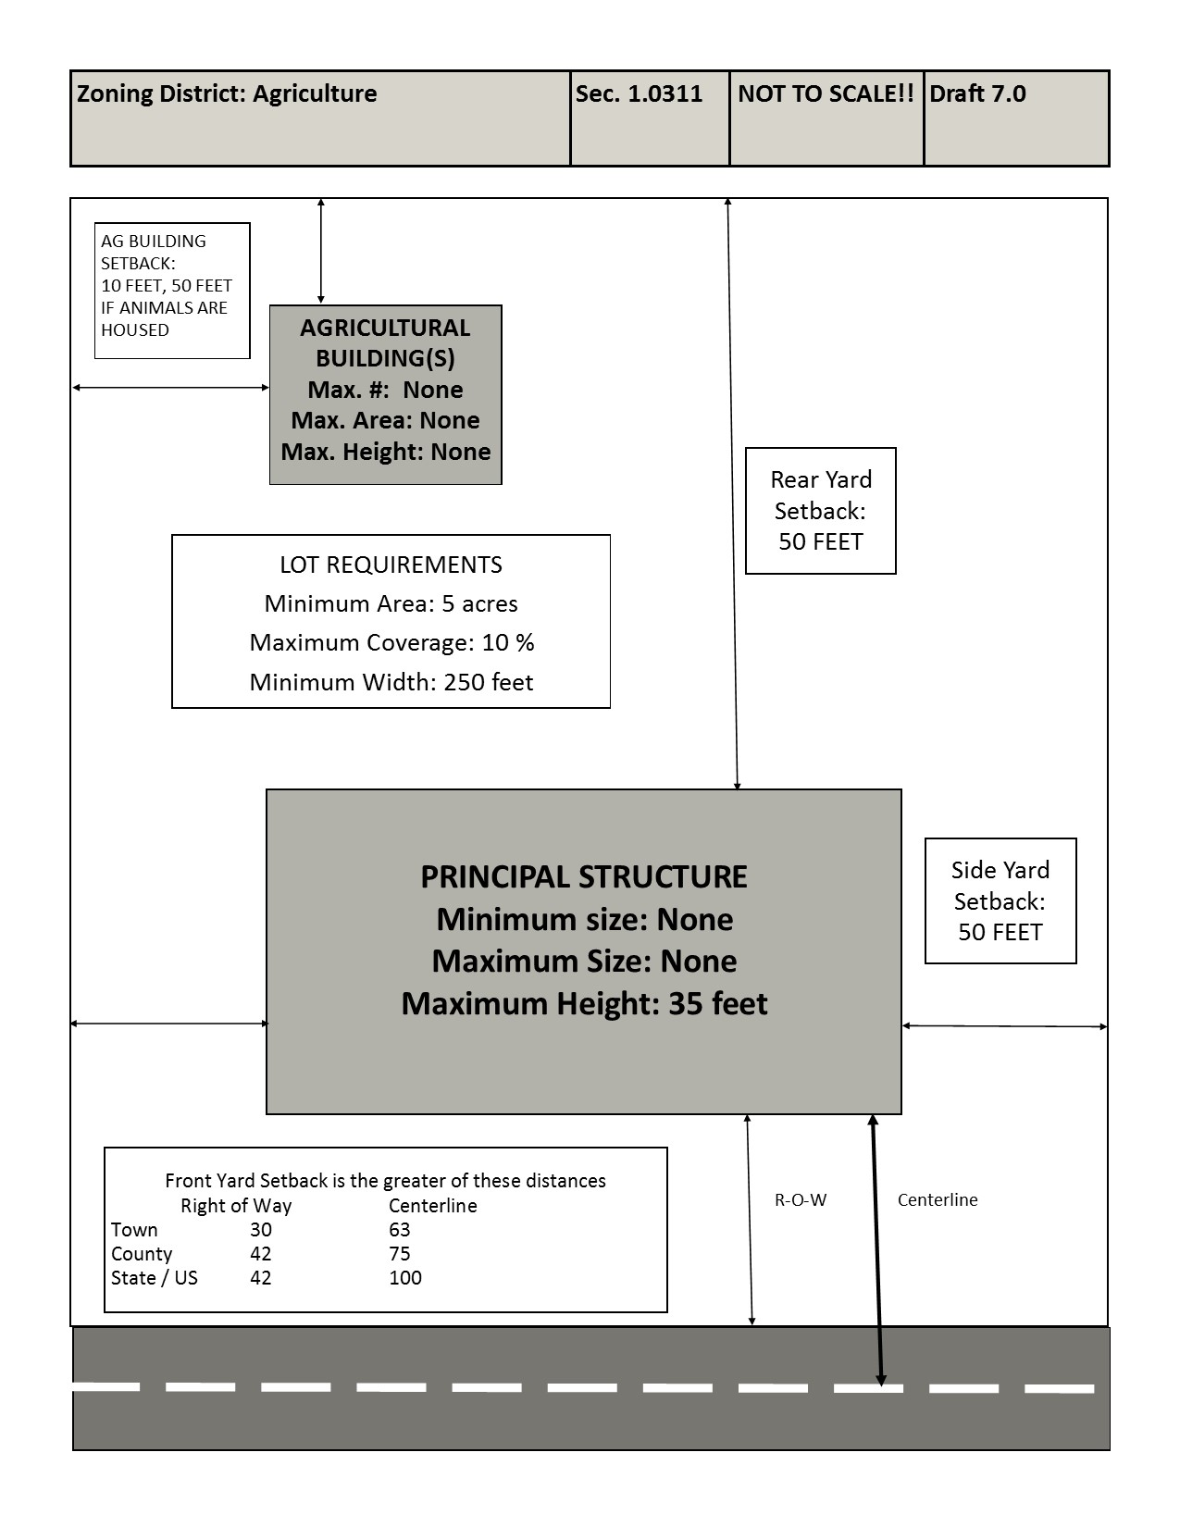
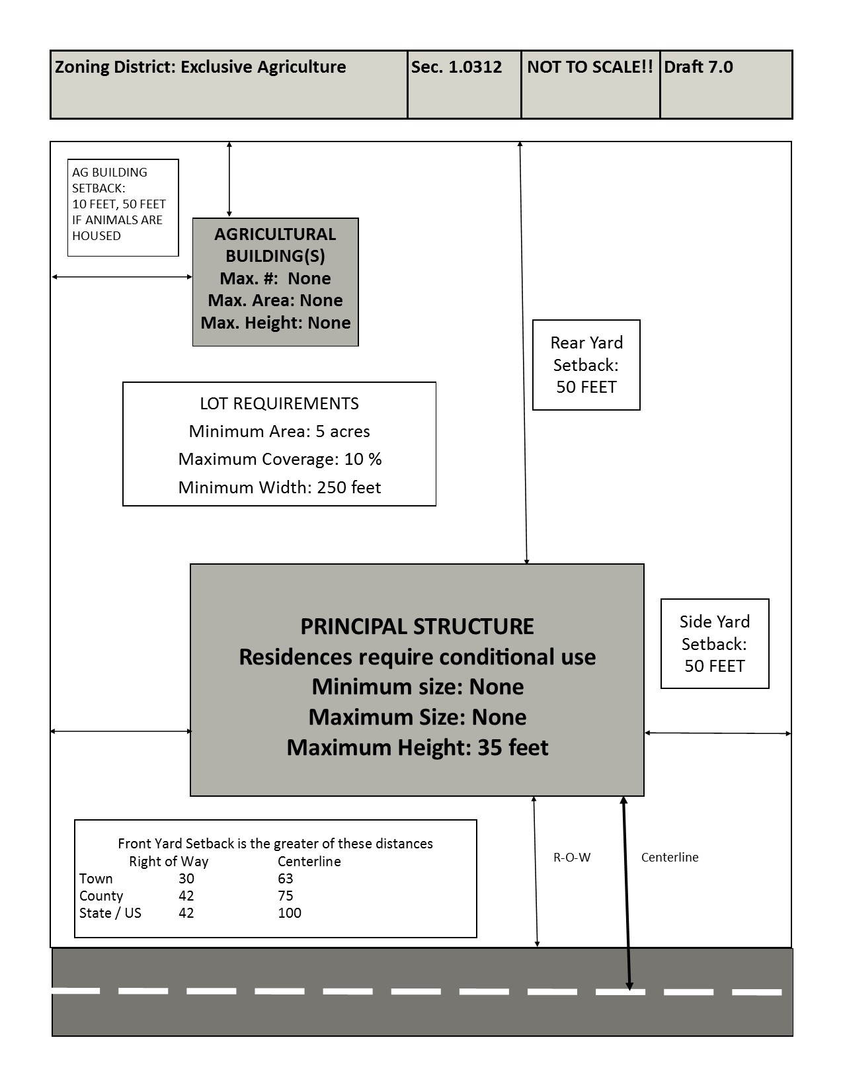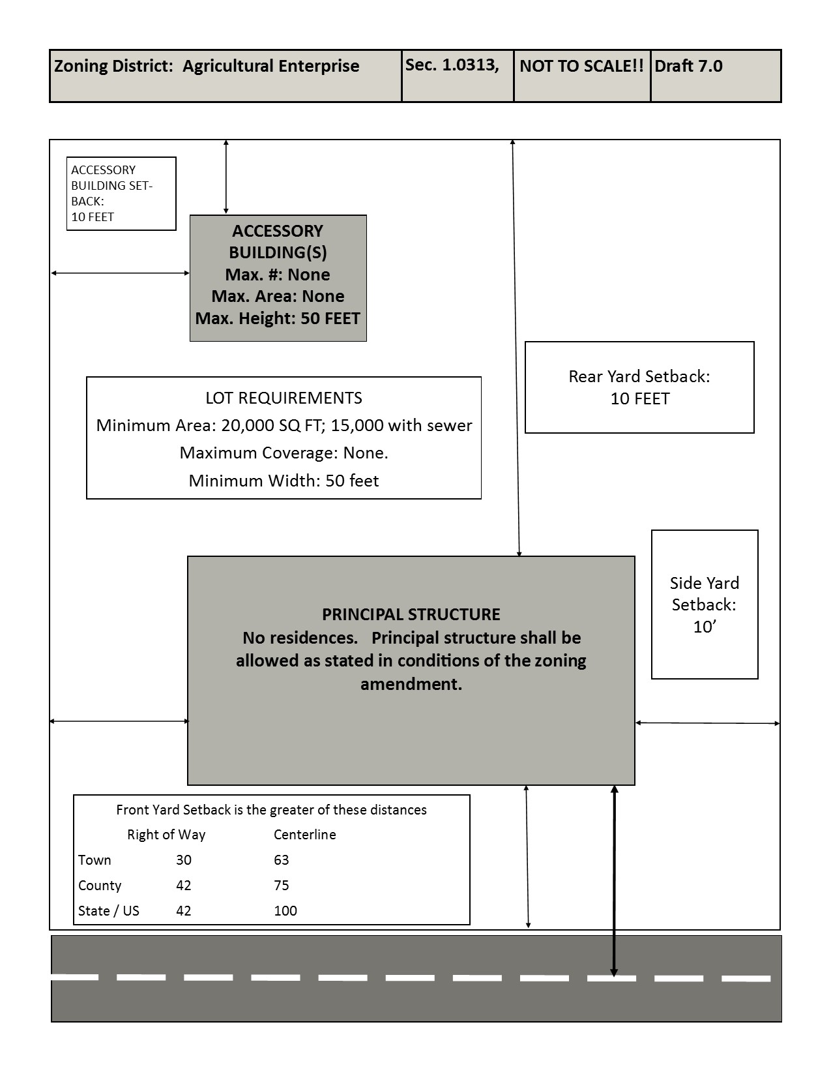
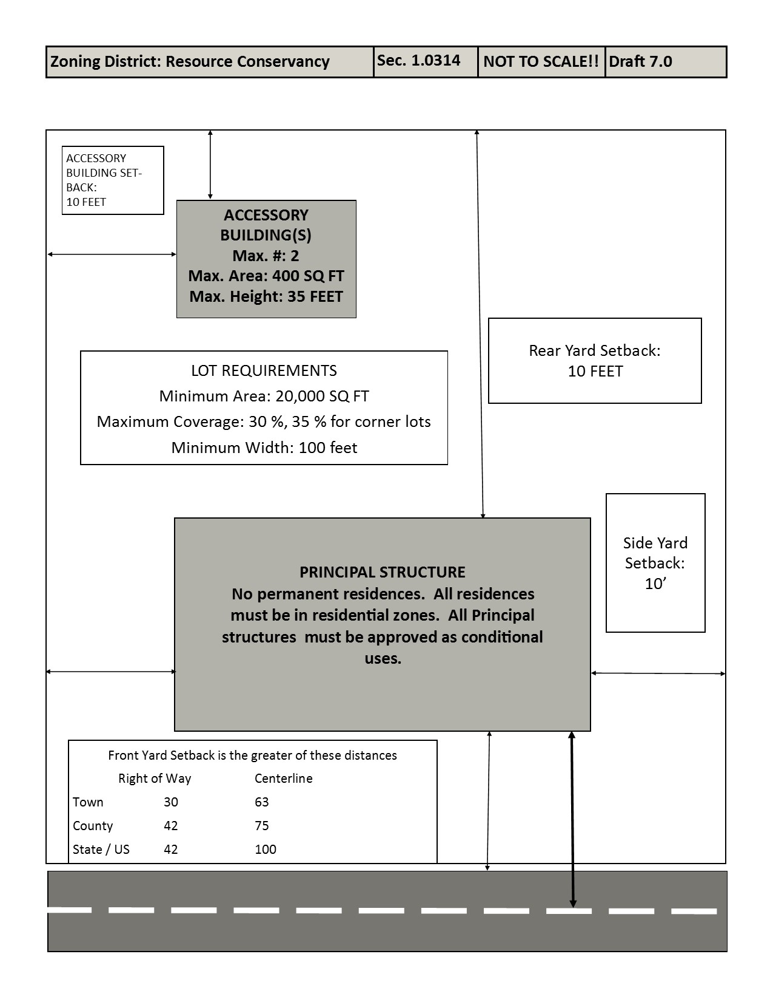
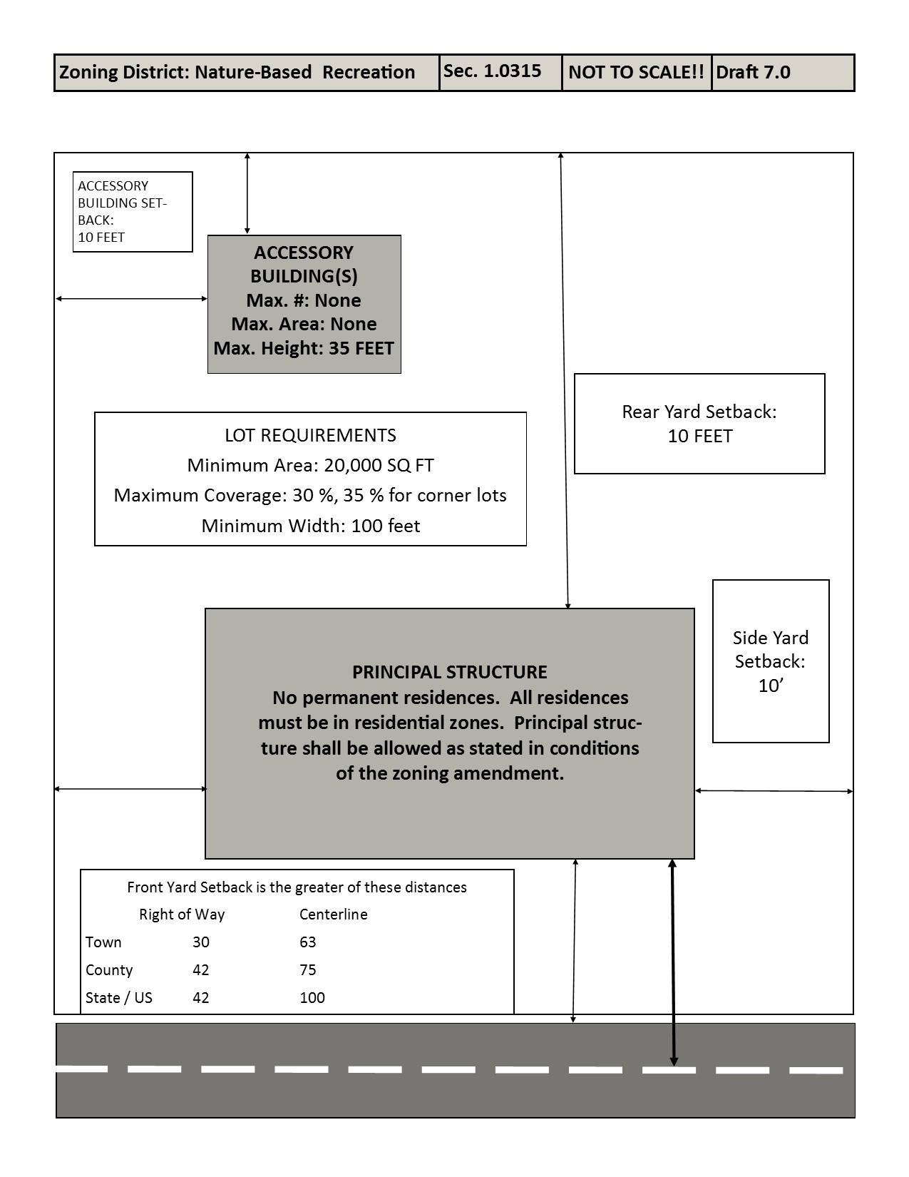
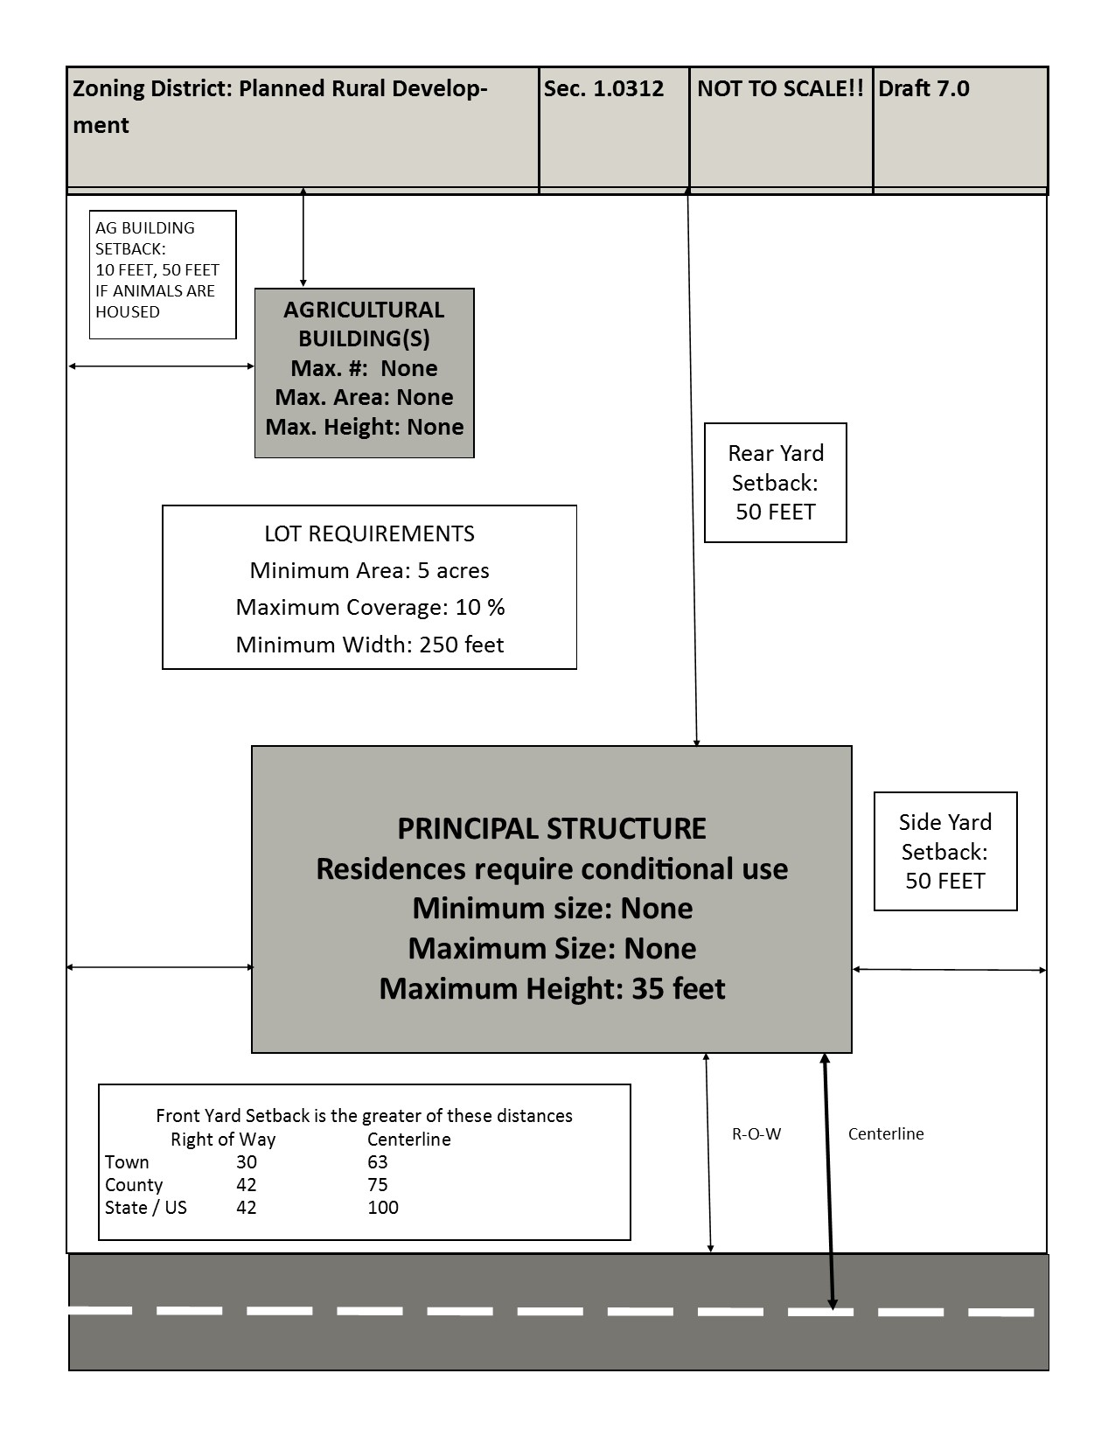
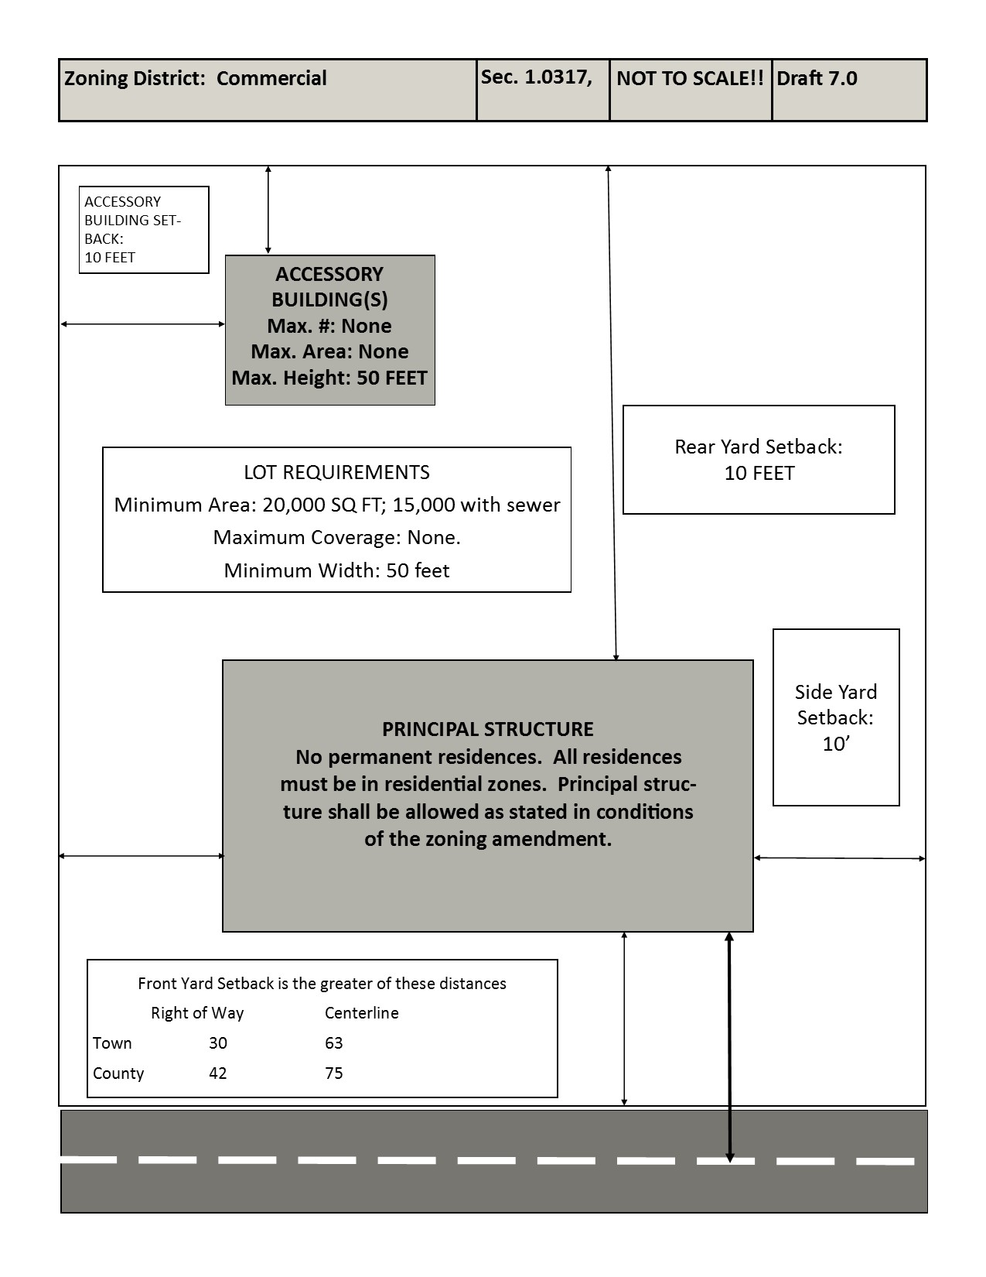
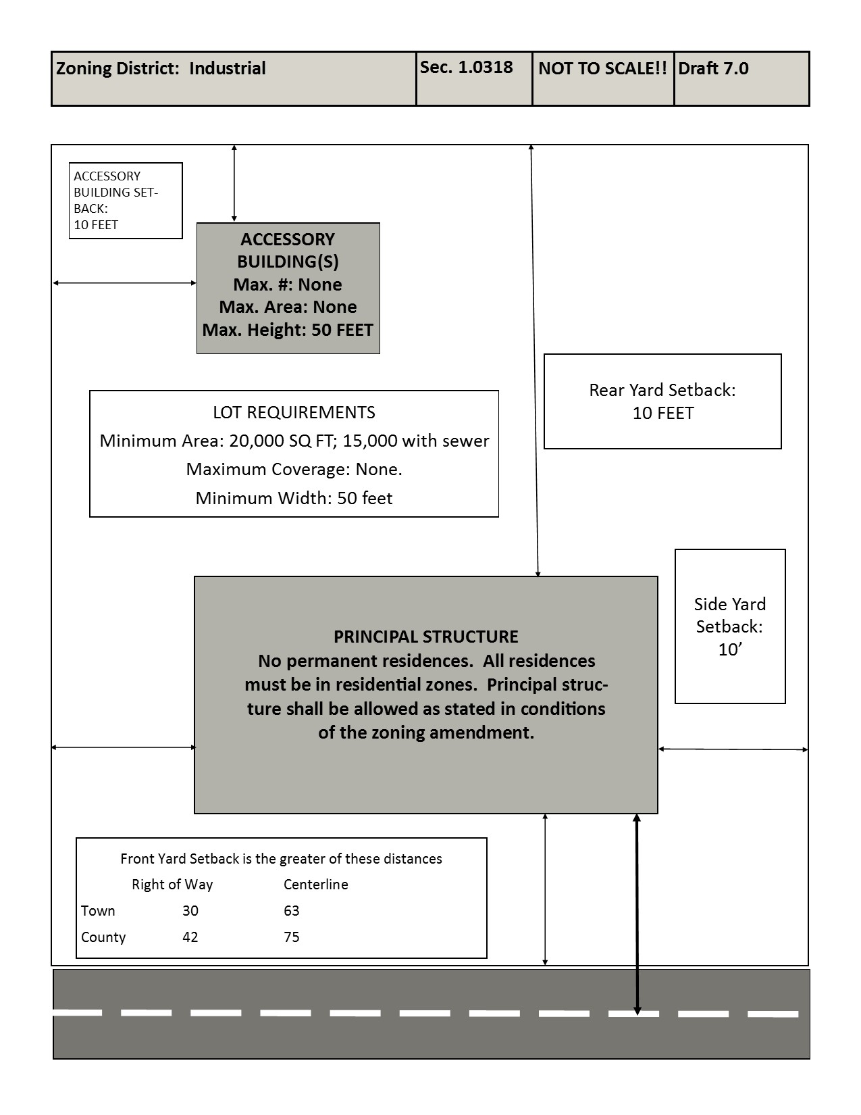.
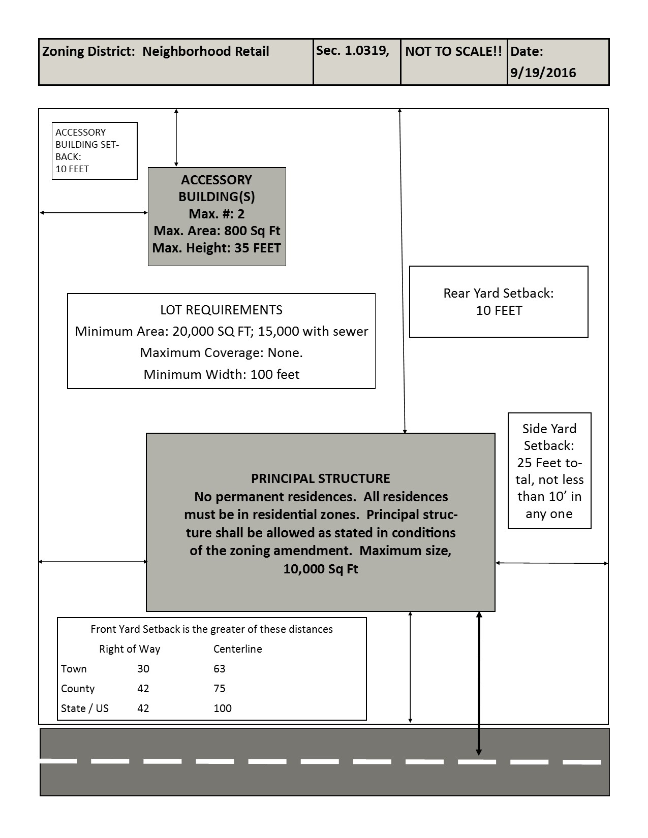
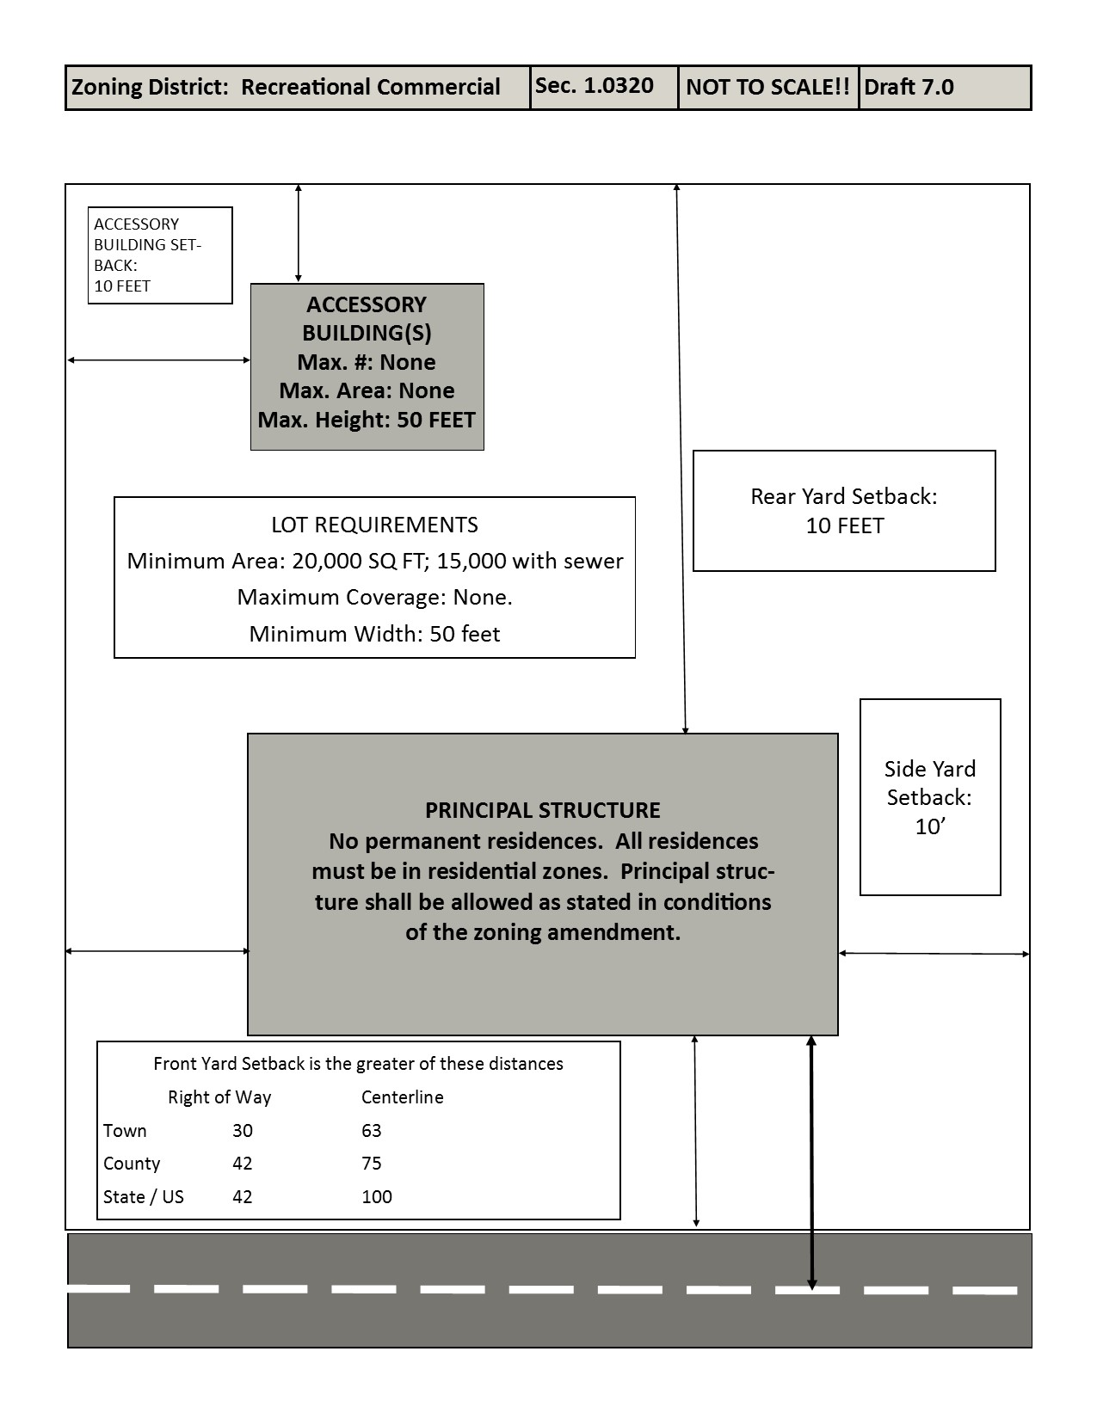
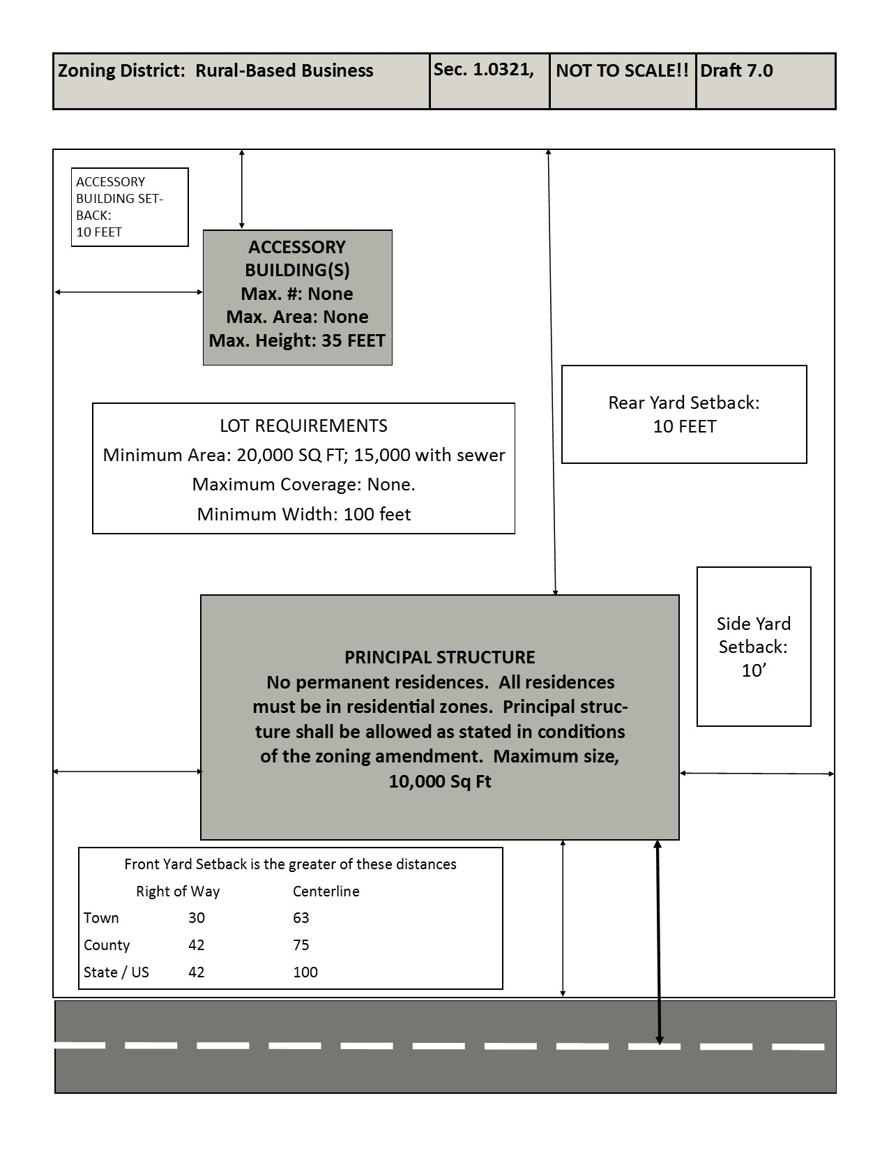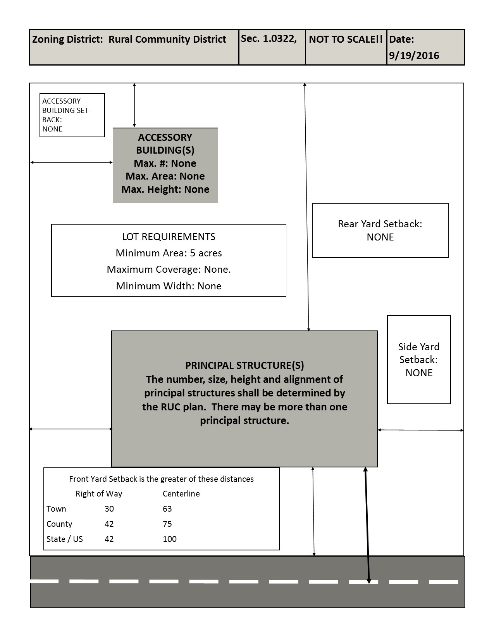
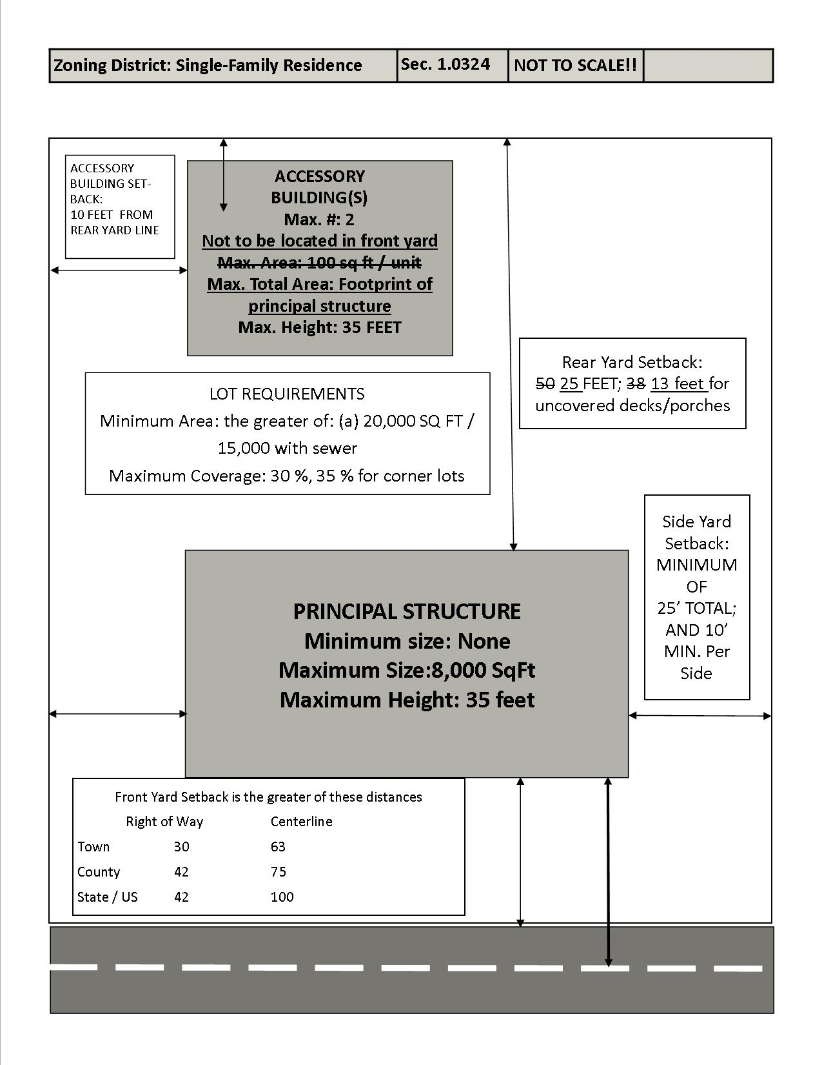
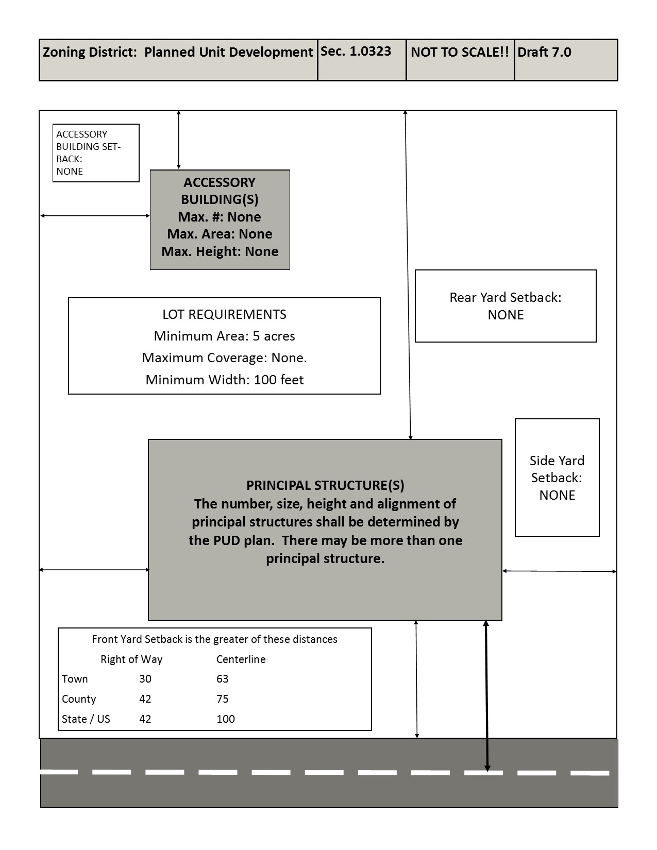
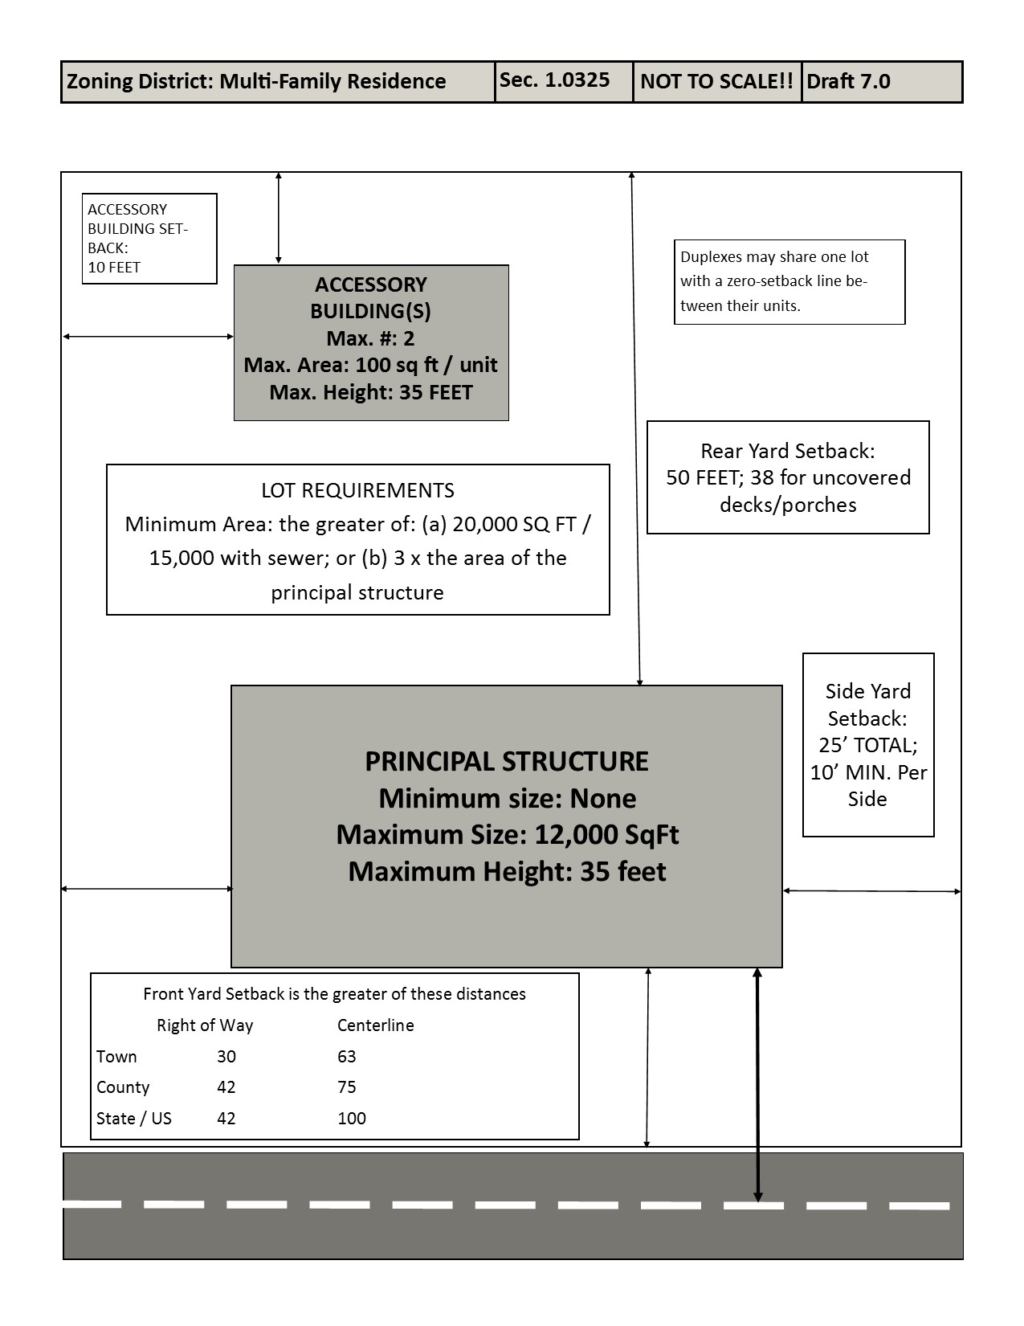

1.072 Livestock related and manure storage structure setbacks. Livestock facilities, livestock structures, manure storage structures, and any additions to such structures, shall maintain the following setbacks pursuant to Wis. Admin. Code § ATCP 51.012.
(1) Livestock Structure Setbacks.
(a) Livestock structures with fewer than 1,000 animal units shall be 100 feet from any property line or road right-of-way.
(b) Livestock structures 1,000 animal units or more shall be 150 feet from any public road right-of-way or 200 feet from any property line.
(c) Livestock structures located within the setback area may be expanded provided the area to be expanded meets required setbacks.
(2) Manure Storage Setbacks.
(a) Manure storage structures shall be 350 feet from any property line or road right-of-way.
(b) Manure storage structures located within the setback area may be expanded provided the area to be expanded meets required setbacks.
1.073 Road setbacks. Roads are divided into the following categories for the purpose of determining the distance buildings and other structures shall be set back from roads.
(1) State And Federal Highways. The setback line for state and federal highways shall be 100 feet from the centerline or 42 feet from the right-of-way line, whichever is greater. The right-of-way shall be as shown on the highway plans. If a specific road has a greater setback requirement, that requirement shall apply.
(2) County Roads. The setback line for county roads shall be 75 feet from the centerline or 42 feet from the right-of-way line, whichever is greater. The right-of-way shall be as shown on the highway plans. If a specific road has a greater setback requirement, that requirement shall apply.
(3) Town Roads. The setback line for town roads shall be 30 feet from the right-of-way line. The right-of-way shall be as shown on the highway plans.
(4) Exceptions To Required Setbacks. A setback that is less than the setback required by this section shall be permitted where there are at least 3 legally existing buildings, under separate ownership, within 250 feet on the same side of the road as the proposed site, and all built to less than the required setback. In such cases the setback shall be determined as follows:
(a) Where 2 contiguous parcels are occupied, the setback shall be the average of the setbacks on each side provided:
1. The buildings are legally existing structures and not temporary structures such as corn cribs and feeder pens.
2. A road setback for state and federal highways and Town roads shall not be less than 30 feet from the right-of-way line.
(b) Where only one contiguous lot is occupied by a building, the setback shall be determined by averaging the required setback with the setback of the adjacent building provided the conditions of par. (a) 1. and 2. are met.
(c) Any structure or building utilized in connection with a farm, either historically or currently, and which was built prior to the effective date of this Ordinance or any historic structure listed on the National Register of Historic Places, which does not meet road setbacks pursuant to this chapter, may be reconstructed to the same dimensions provided that the road setback is not further encroached upon.
(5) Vision Clearance Triangle. There shall be a vision clearance triangle in each quadrant of all intersections of highways or roads with other highways or roads. This section shall not be interpreted so as to prohibit the planting and harvesting of field crops, shrubbery, or trees, except that these plantings may not impede any sight lines within the area defined as a vision clearance triangle. The vision clearance triangle shall comply with the applicable standards of the Wisconsin Department of Transportation Facilities Development Manual, Section 11-10, for the functional classification of road involved.
1.074 Structures prohibited within setbacks. No new building, other new structure, or part thereof, shall be placed between the setback lines and any road right-of-way. No building, sign, structure, or part thereof, existing in setback lines on the effective date of this chapter, shall be altered or enlarged in any way that increases or prolongs its permanency, except as otherwise provided by this chapter.
1.075 Structures permitted within setbacks.
(1) Projection Into Setback. Bay windows, balconies, chimneys, sills, belt courses, cornices, canopies, eaves or ornamental architectural features may project into a required yard setback line no more than 3 feet provided that no such feature projects over a road setback line or into a vision clearance triangle.
(2) Platforms, Walks And Drives. Platforms, walks, and drives extending not more than 6 inches above the average ground level at their margins, and retaining walls when the top of such walls are not more than 6 inches above the average level of abutting ground on one side, may be located in any yard as long as they meet all other portions of this chapter.
(3) Fences And Walls. Fences and walls may be located as follows:
(a) Solid fences and walls greater than 20% opacity and located in a vision clearance triangle shall not exceed 30 inches in height.
(b) Solid fences and walls more than 6 feet in height shall be considered structures, subject to the requirements of this ordinance.
(c) Fences and walls shall not exceed 4 feet in height when located in a front yard or in a street side yard of a corner lot.
(d) Fences and walls shall not exceed 2½ feet in height when located within a vision clearance triangle, except retaining walls used to hold ground at or below its natural level and fences designed and constructed so as not to constitute a substantial obstruction to the view of motorists and pedestrians across the vision clearance opening from one street to another.
(4) Temporary roadside stands permitted under this ordinance may be located within the setback area.
1.076 Driveway, Field Road and Parcel Access Locations.
(1) No person may establish a driveway, field road access or parcel access location without approval of the Town.
(2) All new driveways must meet the location and construction standards of this section and the Town’s driveway construction ordinance. All replacement driveways shall meet the standards of the Town’s driveway construction ordinance and may be required to meet the locational standards of this ordinance.
(3) New driveways being constructed, reconstructed, rerouted or altered in the Town shall meet all of the minimum requirements of the Town’s Driveway Ordinance. No land use permit shall be issued unless the materials submitted as required by this Ordinance demonstrate compliance with the requirements of this section.
1.077 Maintenance of Topography.
(1) Purpose. The purpose of this subsection is to set forth the minimum requirements for preserving existing topography near property lines whenever development is planned, and to promote and protect the public health, safety, convenience and general welfare. This section is intended to regulate development:
(a) to protect adjacent property owners from possible damage due to changes to the existing topography of adjoining lands;
(b) to retain stormwater runoff on each property undergoing development; and
(c) to preserve the general character of neighborhoods.
(2) Standards.
(a) Except as authorized in this section, the topography within five (5) feet of any property line at the commencement of any development shall remain unchanged.
(b) When land disturbing activities associated with development occur within five (5) feet of any property line, finished grades in that area shall be restored to the topography in existence before the land disturbing activity began.
(c) Notwithstanding sub. (2)(a), a positive slope of one-half (1/2) inch vertical per one (1) foot horizontal within five (5) feet of the property line is allowed to provide proper drainage away from a one or two family residence.
(d) The established grade of the adjoining property shall determine the finished grade at the property line for any development. The owner of the property under development bears the burden of proof as to the established grade at the property line and the topography within five (5) feet of the property line. The Town Zoning Administrator may require detailed site grading plans of existing and proposed conditions to be submitted before commencement of land disturbing activities.
(e) Natural watercourses along property lines shall be maintained. Existing drainage ways and drainage easements along property lines including, but not limited to, stormwater management areas shown on subdivision plats and certified survey maps, shall be maintained.
(3) Exceptions.
(a) Development in Floodplain Districts requiring fill to comply with permits granted by the appropriate authority is exempt from this section.
(b) Upon written application, the Town Zoning Administrator may authorize exceptions resulting in changes to the existing topography at and within five (5) feet of any property line that would promote the purposes stated in this ordinance, only if the results do not direct additional stormwater runoff toward adjacent properties. Proposed exceptions may include, but are not limited to, retaining walls, berms and other structures, and other changes to existing grade at and within five (5) feet of a property line. The Town Zoning Administrator may require the submittal of detailed site grading plans of existing and proposed conditions including, but not limited to, detailed topographical information of the subject and adjoining properties, before land disturbing activities commence. The Town Zoning Administrator may consider the sentiments of adjoining landowners in determining whether or not to approve alteration of existing grades.
1.078 Parking and Loading.
(1) Purpose. The purpose of this section is to provide vehicle parking, loading, and circulation standards sufficient to prevent congestion of public rights-of-way and provide safe, efficient public access to properties while minimizing the impact of parking areas on nearby properties.
(2) Applicability. This subchapter applies to all zoning districts and uses. The requirements of this section shall apply when any new structure is erected, any use of a structure or land is enlarged or increased in intensity, or any other use or change of use is established that requires a land use permit.
(3) Land Use Permit Parking Plan requirements. As part of applying for a Land Use Permit under sec. 1.096, the applicant shall submit a site plan drawn to a scale, showing the location of the parking spaces relative to structures, roads, setbacks, other parking spaces, vision clearance areas, and any other dominate land features located within and adjacent to the proposed parking area.
(4) When multiple uses are located on one property, or parking areas are shared between different lots to meet the requirements of this section, adequate parking and loading areas shall be identified on a land use permit application.
(5) The Town Zoning Administrator may require additional information to assure compliance with this subchapter and all other applicable provisions of this chapter.
1.079 General standards. (1) Adequate ingress and egress to parking and loading areas by clearly limited and defined driveways shall be provided. Driveways shall be perpendicular to the public right-of-way wherever possible. Driveways shall be spaced a safe distance from road intersections, and each other, shall not be located within any vision clearance triangle, and may be limited in number and location according to federal, state, and local standards.
(2) All commercial driveways and all parking, loading, and circulation areas shall be paved with an all-weather surface. Grass surfacing may be used for special events only.
(3) Dimensions Of Lanes And Parking Areas. Dimensions of parking lanes and spaces shall be in accordance with the following table. Parking for people with disabilities shall be provided as specified by federal and state regulations.
(4) Circulation. Minimum width of internal aisles providing traffic access to parking spaces shall be 12 feet for each direction of travel. Directional marking or signage, or both, shall be provided where required to facilitate safe, efficient circulation. Uses with drive-through facilities shall provide sufficient space on-site for all vehicles being served. Vehicles queuing to be served shall not utilize any road.
(5) Loading Areas. Uses which involve deliveries or removal of goods, materials, supplies, or wastes shall provide adequate space for vehicle circulation and maneuvering.
(6) Drainage. Suitable grading and drainage shall be provided to collect and transmit storm water to appropriate retention or detention basins, drainage ways, ditches, or storm sewers.
(7) Lighting. Any lighting used to illuminate parking areas shall be directed away from adjacent properties and shall not cast any glare on public rights-of-way. Lighting shall be tented or shaded so that no light is directed upwards or off the property.
(a) All outdoor luminaires subject to this section shall be fully shielded lighting fixtures to minimize artificial sky glow.
(b) All outdoor lighting fixtures shall be placed to prevent light trespass or glare beyond the property line.
(c) All outdoor lighting shall be of a type and placement to prevent any light above the horizontal plane, as measured at the luminaire.
(d) Lighting shall also comply with any town ordinances regulating lighting.
(8) Screening. Parking lots containing 10 or more parking spaces located adjacent to a residential use shall be screened by a vegetative buffer under sec. 1.0639 or a privacy fence of not less than 80% opacity and built and maintained at a minimum height of 6 feet. Screening shall not be located within any public right-of-way or vision clearance triangle.
(9) Parking is allowed in a setback area provided that all parking areas must still meet a 10-foot setback and no parking shall be allowed in a vision clearance triangle.
1.079 Required parking spaces. (1) Vehicle Storage. The parking requirements are in addition to space for storage of trucks or other vehicles used in connection with any use.
Dimensions of Lanes and Parking Areas

Pattern | Lane width | Space width | Space length
Parallel | 12 | 8 | 23
Angle, 30 – 53 | 12 | 9 | 20
Angle, 54 – 74 | 15 | 9 | 20
Angle 75 – 90 | 20 | 10 | 10

(2) Fractional Spaces. Where fractional spaces result, the parking spaces required shall be constructed to be the next highest whole number.
(3) Comparable Requirements. The parking space requirements for a use not specifically listed pursuant to this chapter shall be the same as for a listed use of similar characteristics of parking demand as determined by the Town Zoning Administrator, and shall meet the parking requirements specified by flex parking.
(4) Mixed Uses. In the case of mixed uses, uses with different parking requirements occupying the same building or premises, the parking spaces required shall equal the sum of the requirements of the various uses computed separately.
(5) Parking Requirements. Uses are assigned a parking requirement category as follows:
(a) Intensive Parking. Space shall be provided to park 9 vehicles per 1,000 feet of floor area or one vehicle per 2 beds or chairs, as applicable, whichever number is more restrictive. Land uses that require intensive parking include, but are not limited to:
1. Health care facilities.
2. Places of worship.
3. Public/private elementary and secondary schools, colleges, universities, technical institutes, and related facilities.
4. Eating establishment, with or without alcohol.
5. Grocery store, bakery, deli, confectionary, and meat market.
6. Hotel, motel.
7. Resort.
8. Community living arrangements.
9. Vehicle repair and maintenance.
(b) Moderate Parking. Space shall be provided to park 4.5 vehicles per 1,000 feet of floor area or one vehicle per 4 beds or chairs, as applicable, whichever number is more restrictive. Land uses that require moderate parking include, but are not limited to:
1. Agriculture-related business.
2. Landscaping center.
3. Art gallery.
4. Art studio.
5. Child care center, 9 or more people. 6. Library, museum.
7. Bed and breakfast establishment, lodging houses.
8. Animal grooming, veterinary clinic.
(c) Low Parking. Space shall be provided to park 2 vehicles per 1,000 feet of floor area or one vehicle per 4 beds or chairs, as applicable, whichever number is more restrictive. Land uses that require low parking include:
1. Food processing facility.
2. Child care center, 8 or fewer people.
3. Lab or research facilities.
4. Manufacturing and production of hazardous material.
(d) Flex Parking. Uses in this category do not have specified regulations provided the applicant demonstrates that sufficient parking space is available to allow vehicles to park safely without obstructing traffic.
(e) These requirements may be modified at any time if the conditions or uses change, or at the discretion of the Town Board or Town Zoning Administrator provided that the purpose of this subchapter is met.

SUBCHAPTER VIII. SIGNS.

1.0800 Purpose and findings.
1.0801 Definitions.
1.0802 Classifications of Signs.
1.0803 Sign Requirements, Applicability and Construction
1.0804 Sign Location and Use Regulations.
1.0805 Sign Structural Requirements
1.0806 Sign Placement.
1.0807 Flags.
1.0808 Prohibited Signs.
1.0809 Signs Not Requiring a Sign DAC.
1.0810 Sign Design Approval Certificate.
1.0811 Construction and maintenance.
1.0812 Nonconforming existing signs
1.0813 Sign enforcement and penalties

1.0800 Purpose and findings.
(1) Purpose. It is the purpose of these sign regulations:
(a) To regulate signs in a manner that does not create an impermissible conflict with constitutional, statutory, or administrative standards, or impose an undue financial burden on the people of The Town.
(b) To provide for fair and consistent enforcement of sign regulations under the Town zoning authority.
(c) To improve the visual appearance of the Town while providing for effective means of communication and orientation, particularly in settings in which the need for communication and orientation is greater, consistent with the Town Board findings that follow.
(d) To maintain, enhance, and improve the aesthetic environment of The Town, including its scenic views and rural character consistent with the Town Comprehensive Plan and the purpose of each zoning district, by preventing visual clutter that is harmful to the appearance of the community, protecting vistas and other scenic views from degradation, and reducing and preventing commercialism in noncommercial areas.
(e) To promote public health, safety, and welfare in The Town by regulating the number, location, size, type, illumination, and other physical characteristics of signs within The Town.

(2) Findings. The Town, based upon the information available to the Town and the experience of the Town and other communities, hereby makes the following legislative findings:
(a) Exterior signs have a substantial impact on the character and quality of the environment.
(b) Signs provide an important communication medium.
(c) Signs can create safety hazards that threaten public health, safety, and welfare. The threat increases when signs are structurally inadequate, confuse or distract drivers or pedestrians, or interfere with official directional or warning signs.
(d) The physical characteristics of signs can threaten public welfare by creating aesthetic concerns and harming property values. These threats increase when an accumulation of signs results in visual clutter and detract from the character of the area.
(e) Sign related lighting can create public safety problems by distracting drivers and causing unnecessary glare. Light emitted from signs can detract from the natural environment and inhibit viewing night skies. Light from signs can diminish or eliminate enjoyment of night skies and impede recreational and educational activities.
(f) Signs serving certain other functions, such as directional signs, are necessary to enable visitors and residents to efficiently reach their destinations.
(g) The Town ’s land use regulations regulate signs. These regulations seek to assure the public has adequate information and means of expression of all viewpoints. The regulations also promote the economic viability of the community. The regulations protect the Town and its citizens from a proliferation of signs of a type, size, and location that would adversely impact community or threaten health, safety, or the welfare of the community including threatening the rural character of the community, the robust tourist economy, and aesthetic considerations. The appropriate regulation of the physical characteristics of signs in The Town and other communities has had a positive impact on the safety and appearance of the community.
(h) The Town intends that its regulations be administered and enforced without regard to the content of the signs.
(i) The internet and social media provide a low-cost and readily available means to communicate ideas, commercial information, political views and artistic expression to the community within the Town. Local newspapers and shopper publications provide a print medium for such messages as well. Signs are an appropriate form of expression for some messages, but limitations on the size, number and location of signs will not deprive residents of the Town of the ability to communicate ideas or expression within the Town or the larger community.
(j) The communities regulated under this zoning ordinance are predominantly rural with lower density residential and comparatively little commercial development. The general regulations contained in the sign regulations herein are intended to apply to that form of development. This ordinance contemplates that substantial commercial or large-scale resident development will be undertaken through planned unit development regulations, of which signage plans will be one component.
1.0801 Definitions. In this subchapter:
(1) “Copy area” means the area in square feet of a face of a sign, excluding the advertising surface, any framing, trim, molding, void or unused area between multiple sign faces, architectural, or decorative feature, and not including the support structure. On a banner, the copy area is the flexible material that does not include the permanent fixtures.
(2) “Design Approval Certificate” or “DAC” means the authority to construct a sign according to plans, specifications and construction requirements which are stated in the approval
(3) “Direction of travel” means the direction a vehicle travels on a public road. Two-lane roads allowing travel in opposite directions have 2 directions of travel.
(4) “Disrepair” means, as it pertains to signs, the presence of loose materials including excessive peeling paint, wood, or other material, rust, rot, vibration, lack of structural integrity, and any facility that is deemed to cause an unsafe condition.
(5) “Double-sided sign” means any sign that has 2 surfaces of copy area that face different directions. The maximum copy area is the area of one side if the sides are identical. If the sides are not identical, the maximum area is the sum of both sides.
(6) “Election Campaign Period” means:
(a) In the case of an election for office, the period beginning on the first day for circulation of nomination papers by candidates, or the first day on which candidates would circulate nomination papers were papers to be required, and ending on the seventh day following the day of the election.
(b) In the case of a referendum, the period beginning on the day on which the question to be voted upon is submitted to the electorate, and ending on the seventh day following the day in which the referendum is held.
(c) In the case of a political message which is not related to a specific campaign or election, the period of time within which the message may fairly be believed by the posting person to communicate concerning a current matter of public concern.
(7) “Electronic message sign” means any sign, which may or may not include text, where the sign face is electronically programmed and can be modified by electronic processes including television, plasma, and digital screens, holographic displays, multi-vision slatted signs, and other similar media.
(8) “Height” means the total height which an erected sign stands from the top of the highest point of the sign to the lowest point of the ground elevation directly below the sign. Mounding of soil or other material directly below the sign shall not be included in any height calculation.
(9) “Manual on Uniform Traffic Control Devices” or “MUTCD” means the document issued by the United States Department of Transportation Federal Highway Administration for the regulation of road and other traffic signs.
(10) “Nit” means a unit of measurement of luminance, or the intensity of visible light, where one nit is equal to one candela per square meter.
(11) “Obscene sign” means any sign which displays any matter which appeals to a prurient interest in sex, as determined by the average person applying contemporary community standards or portrays sexual conduct in a patently offensive way; and lacks serious literary, artistic, political, or scientific value.
(12) “Off-premises sign” means any sign on a separate parcel from the facility, establishment, or entity, which the sign is advertising, displaying, or giving directions to.
(13) “On-premises sign” means any sign on the same parcel as the facility, establishment, or entity that the sign identifies, advertises, or gives direction to.
(14) “Sign” means any object, structure, erected image, flag, or wall portraying a message, advertising slogan, directional aide, or identification symbol visible to the public. Letters or numbers painted on or attached to buildings portraying the occupants, fire numbers, or road addresses are not considered to be signs.
(15) “Sign owner” means the person, company, entity partnership, association, corporation, trustee, and any legal successors owning the sign on a specific piece of property, as well as the property owner.
(16) “Vehicle sign” means a motor vehicle or trailer of any kind which has advertising information on its exterior and is left in place in the Town for more than 72 hours in one specific location or a total of 10 days in any 30-day period and is not used in the course of a farm, business, trade or profession. The term does not include a vehicle which is licensed as a common carrier or commercial vehicle, is currently registered with the State of Wisconsin, and which bears ownership information customarily used or required for such vehicles.
1.0802 Classifications of Signs. The signs which may be placed in the Town are classified into the following types, according to the definitions stated in this section.
(1) “Awning sign” means a sign which is painted, screened, or otherwise presented on a roof like shelter or valance of fabric, plastic or other material which extends from a building over a door, window or wall.
(2) “Banner” means a sign consisting of characters or graphics applied to any kind of fabric with only non-rigid material for background and hung between 2 rigid points.
(3) “Blade sign” means a sign, other than a wall sign, which projects from and is supported by a wall of a building or structure.
(4) “Campaign sign” means a sign which advocates for or against the election of a candidate for an elected federal, state or local office, or for the adoption or rejection of a referendum.
(5) “Canopy sign” means a roof-like covers that project from the wall of a building. Canopies may be freestanding, such as a covering over a service station island.
(6) “Construction sign” means a sign advertising the name of a contractor or trade person who is engaged in providing services to a property.
(7) “Development sign” means a permanent sign at the entrance of a residential neighborhood or commercial development identifying the development by the given name of that development.
(8) “Directional sign” means an on-premises sign without a commercial message or advertising slogan that assists individuals with directions regarding entrances, exits, rights-of-way, road directions, or road numbers.
(9) “Farm crop identification sign” means a sign that identifies a crop that is growing in farm fields.
(10) “Farm identification sign” means any sign displaying the name, owners, cooperative, or family of an operating agricultural operation.
(11) “Government sign” means any sign authorized by a unit of government for the purpose of displaying government related information or, a sign consistent with the MUTCD for providing traffic control.
(12) “Ground sign” means any sign supported by means attached to the ground. Ground signs can be supported by pylons, uprights, ground cables, cribs, and landscaping means. Ground signs are self-supporting and not attached to a building.
(13) “Home-based business sign” means an on-premises sign that directs attention to a home-based business.
(14) “Inflatable sign” means a sign designed to be inflated or airborne and tethered to the ground, a vehicle, or any structure.
(15) “Marquee Sign” means a canopy or covering structure projecting from or attached to the building upon which a signboard or copy is placed.
(16) “Notification sign” means non-commercial signs that inform the public of hazards, rights-of-way such as bike or snowmobile trails, or are used to control access to property.
(17) “Open/Closed sign” means a sign which indicates whether a premises is conducting business or not.
(18) “Political sign” means any sign which is not a campaign sign as defined in sec. 1.0802(4) but conveys a message related to the property occupant’s views on an issue of policy, law, ethics or other matter of possible concern, and is not posted for a commercial purpose.
(19) “Portable sign” means a sign on trailers or other mobile systems.
(20) “Post sign” means a sign which is supported by one or more legs, standards or poles, the sign portion of which is not resting on the ground.
(21) “Pylon sign” means a sign, the bottom of which is elevated at least eight feet above grade on a post, lattice, or other support structure.
(22) “Real estate sign” means a temporary sign displaying the sale, rental, or lease of real property.
(23) “Roof sign” means any sign, which projects above the roof line of that building.
(24) “Rummage sale sign” means a sign directing attention to the sale of personal property inside or outside a building. This includes garage sale, estate, and auction signs.
(25) “Sidewalk sign” means a folding sandwich board, chalkboard, whiteboard, or other sign which is placed outside a business premise.
(26) “Temporary sign” means a sign advertising or announcing a special community-wide event or activity. Such events and activities include concerts, plays, festivals, community gatherings, community sidewalk sales, rummage sales, and farmers’ markets.
(27) “Unclassified Sign” means a sign which does not fall clearly within any of the classifications contained in this section.
(28) “Wall sign” means any sign, which is erected and mounted on the exterior wall of a building.
(29) “Way-finding sign” means an off-premises sign that guides the public from roads to civic, cultural, visitor, recreational, or commercial destinations. For purposes of this definition, way-finding signs shall only include the name of the destination, arrow, and distance, except that more than one destination name, arrow, and distance may be included on collocated signs.
1.0803 Sign Requirements, Applicability and Construction.
(1) The requirements and provisions of this subchapter shall apply to all signs that are erected, relocated, structurally altered, maintained or reconstructed after the effective date of this chapter.
(2) It shall be unlawful and a violation of this ordinance for any person to erect, relocate, structurally alter, maintain, or reconstruct any sign except in compliance with the requirements of this subchapter. If a sign requires a DAC, it is unlawful to display a sign without a DAC issued by the Town under this ordinance.
(3) Signs constructed in violation of these regulations are declared a public nuisance, the abatement of which is necessary to protect the public safety, health and welfare.
(4) The Town intends, by adopting these regulations, to govern completely all aspects of sign regulation and thereby to preempt any regulations by Dane County adopted pursuant to sec. 59.70 (22), Wis. Stats.
(5) The Zoning Administrator, Town Board and Board of Zoning Appeals shall interpret this Ordinance in favor of the right of free expression of ideas and opinions, subject to those regulations of the time, place and manner of expression which are contained in this ordinance.
(6) Any person or property owner displaying a sign in violation of this ordinance is guilty of a zoning violation and may be penalized as provided in subchapter IX of this Ordinance.
1.0804 Sign Location and Use Regulations.
(1) Signs of the various classifications stated in the table in sub. (2) may be located in the various zoning districts as shown in the table.

(2) SIGN LOCATION AND USE REGULATIONS TABLE
P = Permitted. Blank Cell = Prohibited. C = Conditional Use.
AG = Agricultural EA = Exclusive AG AE = Ag Enterprise RC = Resource Conservancy NBR = Nature-Based Recreation
PRD = Planned Rural Development COM = Commercial IND = Industrial NR = Neighborhood Retail
RCOM = Recreational Commercial RBB = Rural Based Business RUC = Rural Community PUD = Planned Unit Development
SFR = Single Family Residential MFR = Multi-Family Residential
All signs must meet structural, setback and highway requirements.
Sign Classification | AG | EA | AE | RC | NBR | PRD | COM | IND | NR | RCOM | RBB | RUC | PUD | SFR | MFR
Awning | C | C | C | C |  | C | P | P | P | P | C | C | P
Banner | C |  | C | C | C |  | P | P | P | P | C | C | P
Blade |  |  |  |  |  |  | P | P | P | C | C | C | P
Campaign | P | P | P | P | P | P | P | P | P | P | P | P | P | P | P
Canopy | C | C | C | C |  |  | P | P | C | C | C | C | P
Construction | P | P | P | P | P | P | P | P | P | P | P | P | P | P | P
Development |  |  | C |  |  |  | P | P | C | C | C | P | P | P | P
Directional | P | P | P | P | P | P | P | P | P | P | P | P | P | P | P
Farm Crop ID | P | P | P |  |  | P |  | P |  |  |  | P
Farm ID | P | P | P |  |  |  |  |  |  |  |  | P
Government | P | P | P | P | P | P | P | P | P | P | P | P | P | P | P
Ground |  |  | C |  | C |  | P | P | P | P | C | P | P
Ground with electronic message and/or illumination |  |  | C |  | C |  | C | C | C | C | C | C | C
Home-based Business | P | P | P |  |  | P |  |  |  |  |  |  |  | P | P
Inflatable |  |  |  |  |  |  | C | C
Marquee |  |  |  |  |  |  | P
Notification | P | P | P | P | P | P | P | P | P | P | P | P | P | P | P
Open/closed | P | P | P | P | P |  | P | P | P | P | P | P | P |  | P
Political | P | P | P | P | P | P | P | P | P | P | P | P | P | P | P
Portable | P | C | P | C | C | P | P | P | P | P | P | C | P
Post |  |  | P |  |  |  | P | P | P | P | C | C | P
Pylon |  |  | P |  |  |  | P | P |  |  |  |  | P
Real Estate | P | P | P | P | P | P | P | P | P | P | P | P | P | P | P
Roof |  |  |  |  |  |  | C | C |  |  |  |  | P
Rummage | P | P |  |  |  |  |  |  |  |  |  | P | P | P | P
Sidewalk |  |  |  |  |  |  | P | P |  |  |  | P
Temporary | P | P | P | P | P | P | P | P | P | P | P | P | P | P | P
Unclassified | C | C | C | C | C | C | C | C | C | C | C | C | C | C | C
Wall | C | C | C |  |  | C | P | P | C | C | C | C | P
Way-finding | P | C | P | C | C | P | P | P | P | P | P | P | P | P | P

(3) Subject to the owner’s consent, noncommercial speech of any type may be substituted for any duly permitted or allowed commercial speech; provided, that the sign is legal as expressed in this subchapter without consideration of message content. Such substitution of message content may be made without any additional sign permits required. This provision prevails over any provision to the contrary in this subchapter.
1.0805 Sign Structural And DAC Requirements
(1) Signs of the various classifications stated in the table contained in sub. (2) shall comply with the requirements stated in the table.
(2) Sign structural and DAC requirements. Signs shall be constructed according to the requirements of the ordinance and the following parameters:

Type  (Speed limit refers to the road on which the sign premises are located) | Copy Area  (Square feet) | Max.  Height  (at the top, in feet) | # per parcel | Limits on Time  Of Display  (Blank means none) | Miscellaneous | DAC Req?
Awning | No more than 33 % of awning area | Height of building | 1 |  |  | Yes
Banner | 40 | 8 | 1 |  |  | Yes
Blade | 4 | 10 | 1 per unit |  | May be double-sided. | Yes
Campaign  Property up to 2 acres | 32 total | 4 | Any number subject to area limit | Election campaign period. | Maybe double-sided. | No
Campaign  Property more than 2 acres | 32 per 2 acres. | 4 | Any number subject to area limit | Election campaign period. | May be double-sided. No one sign may be more than 32 square feet in area. | No
Canopy | No more than 33 % of canopy area | Building height | 1 |  |  | Yes
Construction | 8 | 6 | 3 | During project, and within 7 days after completion | May be double-sided. | No
Development - General | 32 | 8 | 1 |  | May be double-sided. | Yes
Type  (Speed limit refers to the road on which the sign premises are located) | Copy Area  (Square feet) | Max.  Height  (at the top, in feet) | # per parcel | Limits on Time  Of Display  (Blank means none) | Miscellaneous | DAC Req?
Development – 45 mph speed limit or more | 96 | 16 | 1 |  | May be double-sided. | Yes
Directional | 4 | 6 | 5 |  | May be double-sided. Administrator may allow more if property requires/ | No
Farm Crop ID | 3 | 6 | 1 per row | During growing season | May be double-sided. | No
Farm ID | 32 | 8 | 1 |  | May be double-sided. | No
Government | 32* | 8* | 1* |  | *May be larger to meet MUTCD rules | No
Ground -- General | 32 | 8 | 1 |  | May be double-sided. Bottom of sign must not be more than one foot above grade | Yes
Ground -- 45 mph speed limit or more | 96 | 16 | 1 |  | May be double-sided. Bottom of sign must not be more than one foot above grade | Yes
Home-based Business | 16 | 6 | 1 |  | May be double-sided | No
Inflatable | N/A | 15 | 1 | No more than15 days |  | Yes
Marquee | ½ front area of the building (all sides total) | Building height | 1 |  |  | Yes
Notification | 4 | 6 | 5 |  | Administrator may allow more if layout requires | No
Open/closed | 4 |  |  |  |  | No
Political  Property up to 2 acres | 32 total | 4 | Any number subject to area limit |  | Maybe double-sided. | No
Political  Property more than 2 acres | 32 per 2 acres. | 4 | Any number subject to area limit |  | May be double-sided. No one sign may be more than 32 square feet in area. | No
Portable | 32 | 6 | 1 | 15 days | May be double-sided. | No
Post | 32 | 6 | 1 |  | May be double-sided | Yes
Pylon -- general | 100 | 25 | 1 |  | May be double-sided. | Yes
Type  (Speed limit refers to the road on which the sign premises are located) | Copy Area  (Square feet) | Max.  Height  (at the top, in feet) | # per parcel | Limits on Time  Of Display  (Blank means none) | Miscellaneous | DAC Req?
Pylon -- Interstate | 500 | 150 | 1 |  | May be double-sided. Must meet DOT location and construction rules | Yes
Real Estate | 6 | 8 | 2 | Remove on sale | May be double-sided | No
Roof | 32 | 4 | 1 |  |  | Yes
Rummage | 6 | 4 | 2 | 1 week before sale | May be double-sided | No
Sidewalk | 6 | 4 | 1 | Open hours | May be double-sided | No
Temporary | 4 | 4 | 1 | One week |  | No
Unclassified | 4 | 4 | 1 | As determined |  | Yes
Wall, general | 100 | 20 | 1 |  |  | Yes
Wall -- 45 mph speed limit or more | 300 | 50, or within 20 feet of the building top | 1 |  |  | Yes
Wall, farm building | Building or silo side | Building or silo height | 1 |  | May not be within ½ mile of a bill board or another farm building sign. | Yes
Way-finding | 6 | 4 | 4 |  | Administrator may allow more if layout requires | No
Planned Unit Development | Political and Campaign signs in PUDs are governed by general rules. All other signs are governed by the PUD plan, and may exceed the area, height, number and use restrictions stated herein if the sign complies with the PUD sign plan. |  |  |  |  | Yes

(3) Electronic message signs.
(a) Sign Type Permitted. On-premises ground and pylon signs shall be the only type of sign that may incorporate electronic message components to the sign’s copy area.
(b) Change Interval. The electronic message shall not be changed more than once every 6 seconds.
(c) Malfunction. In the event of a malfunction in any portion of the electronic message sign, the sign shall be turned off upon notification until the malfunction is corrected.
(d) Nits. Electronic message sign copy areas shall not exceed a maximum illumination of 5000 nits during daylight hours and 500 nits between dusk to dawn as measured from the sign’s face at maximum brightness
(4) Illumination.
(a) Light Number And Direction. Signs that are illuminated from an external source shall have a maximum of 4 external lights directed at only the copy area from a downward angle attached to the top of the sign or sign structure.
(b) Glare. Light sources shall be effectively shielded to prevent beams or rays of light from being directed at any portion of a road that are of such intensity or brilliance as to cause glare or impair the vision of the driver of a motor vehicle, or that otherwise interfere with any driver’s operation of a motor vehicle.
(5) Interference With Traffic Signals. No sign may be placed or illuminated so it interferes with the effectiveness of, or obscures, an official traffic sign, device, or signal.
(6) Changing Light Sources. No sign shall use flashing, moving, reflecting, or changing light sources.
(7) Total Sign Area and Copy Area.
(a) The total area of a sign, including the frame surrounding the copy area, may not exceed 1.25 times the copy area.
(b) Total Copy Area Determination. The total copy area shall be determined by measuring the portion of sign face that can be used to display text or images by one viewer at one time, and does not include the frame.
(c) Total Area Calculation. The total area of a sign shall be calculated by delineating and connecting the exterior edges of each sign face erected on one structure, including the background, but not supporting features or roof like covers, so that the shape which connects all extreme edges and points of the sign faces on one structure including voids, unused space, or air space between multiple display features creates the total copy area of a sign.
1.0806 Sign Placement.
(1) View Blockage. No sign shall be placed in a way that blocks any part of a driver’s or pedestrian’s vision of a road, road intersection, crosswalk, vision clearance triangle, authorized traffic sign or device, or any other public transportation mechanism.
(2) Vision Clearance Triangle. No sign shall be located within a vision clearance triangle.
(3) Road Right-Of-Way Setback Requirements.
(a) Except as otherwise provided herein, the edge of a sign nearest the right of way line shall be set back not less than 5 feet from the right-of-way line of any road or highway.
(b) Wayfinding signs may be located within a road right-of-way following approval from the unit of government that governs the road right-of-way.
(c) Rummage sale signs may be placed on the road right-of-way during the time they are allowed to be erected.
(4) Side And Rear Yard Setback Requirements.
(a) Off-premises ground and wall signs shall meet the required setbacks for an accessory structure as expressed by the zoning district with which the sign is located.
(b) On-premises ground and wall signs shall be setback not less than 5 feet from any side or rear yard.
(5) Rustic road visibility. No sign visible from the main traveled way of a road designated as a rustic road pursuant to sec. 83.42, Wis. Stats. and Wis. Admin. Code §§ Trans-RR 1.015 and 1.017 may be erected except for the following signs:
(a) Government signs.
(b) Real estate signs.
(c) On-premises signs.
1.0807 Flags.
(1) The right to display a flag of reasonable size of the United States and/or the State of Wisconsin shall never be denied to the owner or occupant of any parcel of real estate in the Town.
(2) A standard 3- by 5-foot flag is presumed to be a reasonable size. A larger flag may be displayed on a pole not to exceed 50 feet in height from the ground. The height of the pole may not exceed the distance between the base and the nearest property line. The shortest dimension of the flag may not exceed one-sixth of the pole length.
1.0808 Prohibited Signs. The following signs are prohibited:
(1) Abandoned signs or signs in disrepair.
(2) Inflatable signs, except as specified in this ordinance.
(3) Noise making, steam emitting, or odor emitting signs.
(4) Obscene signs.
(5) Signs on utility poles, electrical boxes, or other public utilities.
(6) Signs that imitate or resemble any official traffic sign, signal, or device.
(7) Electronic message signs except as provided for in this subchapter.
(8) Signs, other than political or campaign signs, held or waved by people standing along highways or streets.
(9) Vehicle signs.
1.0809 Signs Not Requiring a Sign DAC. The following signs are exempt from the requirement to obtain a sign DAC pursuant to this subchapter, and may be placed in zoning districts where they are permitted, or are authorized by a conditional use permit, provided they meet the requirements of this chapter:
(1) Address, numbers and nameplates.
(2) Campaign signs
(3) Construction signs
(4) Directional signs.
(5) Farm crop identification signs.
(6) Farm identification signs.
(7) Government signs.
(8) Home-based business.
(9) Notification signs.
(10) Open-Closed Signs
(11) Political signs.
(12) Real estate signs.
(13) Rummage sale signs.
(14) Sidewalk signs.
(15) Temporary signs.
1.0810 Sign Design Approval Certificate. (1) In order to avoid wasteful expenditure on sign construction, avoid controversy and litigation expenses, the Town has determined that certain signs which are required to meet specific zoning requirements may not be erected or displayed unless a DAC has been issued.
(2) Except as otherwise provided in this ordinance no person may erect, relocate, structurally alter, or reconstruct, any sign without first obtaining a sign DAC from the Town Zoning Administrator. A change in the content of a permitted sign, such as a new business name, changes in hours or other updates, does not require a permit. Maintenance of a sign does not require a permit.
(3) An application for a sign DAC shall be made on a form provided by the Town Zoning Administrator and shall include the following information:
(a) The name, addresses, legal corporate status, and telephone number of the applicant responsible for the accuracy of the application, and site plan.
(b) The name, address, and telephone number of the landowner on whose property the sign is located.
(c) The name, address, legal corporate status and telephone number of the owner of the sign.
(d) A copy of an approved sign permit issued by the State of Wisconsin, where applicable.
(e) A description of the sign to be installed including height, setbacks, copy area, design, and a diagram on how such sign will be anchored to a building or the ground.
(f) A site plan drawn to a scale showing the location of the sign relative to structures, roads, setbacks, traffic and other signs, vision clearance areas, and any other dominant land features located within 5,280 feet of the proposed sign location.
(g) A drawing or other depiction showing the proposed sign.
(h) Cost of the sign.
(i) Such other information as the Town Zoning Administrator may require as confirmation of full compliance with this subchapter and all other applicable provisions of this chapter.
(4) Every DAC approval shall include a unique sign identification number.
(5) The Administrator shall issue a Design Approval Certificate which includes all the approved dimensions, features and locational information pertaining to the sign, and the unique identification number of the sign. The DAC may be summarized in a paper document to be displayed under subsec. (6) of this section.
(6) During construction of the sign, the person constructing the sign shall display a copy of the DAC summary.
(7) Upon completion of the sign, the Administrator shall inspect the sign to determine that it complies with the conditions of the DAC. If the Administrator determines that the sign complies with the DAC, the Administrator shall issue a compliance medallion to the sign owner, which shall include the sign’s unique identification number. The compliance medallion shall be affixed to a portion of the sign which is readily visible from the ground.
(8) An applicant aggrieved by the action or inaction of the Town Zoning Administrator on a DAC Application, or the refusal of the Administrator to issue a compliance medallion, may appeal to the Town Board.
1.0811 Construction and maintenance. (1) Any sign erected, relocated, structurally altered, reconstructed, or maintained shall comply with the provisions of this chapter.
(2) Signs with multiple copy areas shall be placed back-to-back (parallel).
(3)(a) Any sign that falls into a state of disrepair or is abandoned shall be repaired or removed by the owner.
(b) If the sign is to be repaired a new DAC shall be required which shall conform to the provisions of this chapter.
(c) As used in this section, abandonment shall be determined by the Town Zoning Administrator based on evidence of faded paint or images, rotting wood, rusted metal, broken glass, inoperable lights or other indicators that the sign has not been repaired or attended within the past twelve months. In such an instance, the Town Zoning Administrator shall provide written notice to the last known owner of the sign to repair the sign within thirty (30) days or remove it.
1.0812 Nonconforming existing signs. (1) Authority To Continue. Any sign which is permitted under this chapter, may continue, so long as the land use continues to exist and remains otherwise lawful according the provisions of this chapter. Land uses that no longer exist shall be removed.
(2) Any nonconforming sign may be maintained provided that such maintenance shall not create an additional nonconformity or increase the degree of the existing nonconformity of all or any part of the structure, and provided that the cost of maintenance does not exceed 50% of the sign’s assessed value at the time of maintenance.
(3)(a) In the event that any sign identified in whole or in part as a nonconforming use is damaged or destroyed, by any means, to the extent that the damage exceeds 50% of the assessed value of such sign immediately prior to such damage, such sign shall not be restored unless the sign and the use conforms to all regulations of this chapter.
(b) When such damage or destruction is 50% or less of the fair market value of the sign immediately prior to such damage, such sign may be repaired and reconstructed and used for the same purposes as it was before the damage or destruction provided that such repair or reconstruction is commenced and completed within 12 months of the date of such damage or destruction.
(4) No nonconforming sign shall be relocated in whole or in part to any other location on the same, or any other parcel or lot, unless the entire structure shall conform to the regulations of this chapter.
1.0813 Sign enforcement and penalties. (1) Every sign erected or maintained in violation of this Ordinance is declared unlawful. The owner of such signs is subject to penalties for the violation of this Ordinance.
(2) In all permitting and enforcement actions under this Ordinance, the content of the message communicated by the sign shall not influence whether the sign is permitted or not.
(3) This subchapter shall be enforced according to the provisions and penalties set forth in subch. IX.
(4) If a sign requiring a DAC has been placed in the right-of-way of highway or road, the personnel maintaining said highway may remove the sign without notice to the sign’s owner, but shall return it to the owner upon request.

SUBCHAPTER IX
ADMINISTRATION OF THIS ORDINANCE

1.090 Purpose.
1.091 Town Zoning Administrator: description and roles.
1.092 Planning Commission.
1.093 Dane Town Board Of Zoning Appeals And Adjustment: Description And Rules.
1.094 Zoning Map Amendments: Review Procedure And Standards.
1.095 Conditional use: review procedure and standards.
1.096 Land use permits: review procedure and standards.
1.097 Enforcement and penalties.

1.090 Purpose. The purpose of this subchapter is to establish responsibilities for administration of this Ordinance, procedural requirements for various approvals under this Ordinance, and enforcement procedures and penalties for non-compliance.
1.091 Town Zoning Administrator: description and roles.
(1) Authority. The Town Zoning Administrator is the administrative and enforcement officer for the provisions of this Ordinance pursuant to the general authorization of the Town Board and the Wisconsin Statutes.
(2) Duties And Responsibilities. With respect to this chapter, the Town Zoning Administrator shall have the following specific duties and responsibilities:
(a) Conduct on-site inspections of buildings, structures, waters, and land to determine compliance with all provisions of this chapter.
(b) Be permitted access to premises and structures to make inspections to ensure compliance with this chapter. If refused entry after presentation of identification, the Town Zoning Administrator may seek the assistance of the town attorney to procure a special inspection warrant in accordance with the Wisconsin Statutes.
(c) Maintain records associated with this chapter including all maps, amendments, land use permits, conditional uses, site plans, variances, appeals, inspections, interpretations, applications, and other official actions.
(d) Receive, file, and forward applications to the designated review and approval bodies, and provide related technical information or reports, or both, to assist such bodies in decision-making.
(e) Provide staff support to the Town Board and the Board of Zoning Appeals and Adjustment, including the scheduling of public hearings, other meetings, and site visits; and the recording of the actions, recommendations, and minutes of such bodies.
(f) Issue land use permits.
(g) Review and approve site plans for land uses under this chapter prior to the issuance of land use permits for such uses, ensuring compliance with this and other applicable ordinances and any additional requirements of designated official review and approval bodies for associated rezoning, conditional use, or variance requests.
(h) Make interpretations regarding the provisions of this chapter in a manner that is consistent with the purpose of this chapter. All interpretations are subject to appeal to the board of zoning appeals and adjustment in accordance with the procedures in this chapter.
(i) Make interpretations regarding the permissibility of land uses in certain zoning districts where such land uses are not explicitly listed as permitted-by-right or conditional uses, in accordance with the procedures and criteria of this chapter.
(j) Investigate all complaints made relating to the location and use of structures, lands, and waters; and fulfill enforcement functions prescribed by this chapter.
(k) Any other duties or responsibilities delegated or assigned by competent authority.
1.092 Planning Commission. (1) Establishment. The Town hereby designates the Planning Commission as the town zoning agency, authorized to act in all matters pertaining town planning and zoning in which it is authorized to do so by the Town Board.
(2) Duties And Responsibilities. In addition to the duties and responsibilities specified under the Town Code of Ordinances and the Rules of the Town Board of Supervisors, the Plan Commission shall have the following specific duties and responsibilities pertaining to this chapter:
(a) Conduct public hearings associated with petitions to amend the official zoning map, and consider conditional use.
(b) Conduct public hearings and advise the board on appropriate amendments to the text of this chapter or to the official zoning map, and initiate such amendments as it may deem desirable, all in a manner that is consistent with the Town Comprehensive Plan, Town Farmland Preservation Plan, the procedures established under sec. 62.23, Wis. Stats., and this chapter.
(c) Conduct public hearings, review, and decide on requests for conditional use in a manner that is consistent with the Town Comprehensive Plan, the Town Farmland Preservation Plan, and with this chapter.
(d) Act on other development-related requests as may be specified under this chapter or other ordinances within the Town Code of Ordinances.
(e) Direct the preparation of the Town Comprehensive Plan under sec. 66.1001, Wis. Stats.
(f) Establish fees for various permits and approvals required and allowed under this chapter.
(3) Any function in this Ordinance which is designated to be performed by the Town Board, except approval of zoning amendments and conditional use permits, may be delegated to the Plan Commission. The Town Board may direct the Plan Commission to advise the Town Board prior to Town Board action, or authorize the Plan Commission to take action on such matters.
1.093 Dane Town Board Of Zoning Appeals And Adjustment: Description And Rules.
(1) Affiliation; Representative (a) Pursuant to sec. 66.0301, Wis. Stats., the Town hereby affiliates with the Dane Town Board of Zoning Appeals and Adjustment created by those Dane County towns which elect to participate in that Board.
(b) The Chair of the Town Board of Supervisors is hereby directed to appoint a member representing the Town to the Dane Town Board of Zoning Appeals and Adjustment according to the requirements of sec. 62.23, Wis. Stats. The member shall receive an allowance for payment of per diem and mileage as permitted by the ordinances of the Town appointing the member. The Town Chair shall also appoint an alternate member in accordance with sec. 62.23, Wis. Stats.
(2) Composition; Powers And Duties. The Board Of Zoning Appeals And Adjustment shall consist of five members who shall serve two-year terms. The initial members shall be divided into a group of three members who shall be appointed for an initial two-year term and two who are appointed for an initial one-year term. Towns shall appoint a member of the Board of Zoning Appeals according to the date that the town adopted notice of intent to withdraw from Dane County zoning. The initial members of the Board shall be selected by the first five towns to withdraw from the Dane County Zoning ordinance. As the terms of the first appointees expire, the towns next in order shall appoint a member. Member appointments shall rotate in that order.
(3) The Board of Zoning Appeals shall have the following powers:
(a) To hear and decide appeals where it is alleged that there is error in any interpretation, order, requirement, decision, or determination made by the Town Zoning Administrator or any administrative official in the enforcement, administration, or interpretation of this chapter or of sec. 62.23, Wis. Stats.
(b) To hear and decide appeals where it is alleged that there is an error in any decision of the Town Zoning Administrator or other officer related to a conditional use request, with such review limited to determining whether the Plan Commission’s action considered the appropriate standards and met the requirements of this chapter, and not a de novo review.
(c) To authorize such variances from the terms of the ordinance as will not be contrary to the public interest, where, owing to special conditions, a literal enforcement will result in unnecessary hardship, and so that the spirit of the ordinance shall be observed and substantial justice done.
(d) To establish rules of procedure for actions of the board of zoning appeals and adjustment.
(4) Recording Of Actions.
(a) The Board Of Zoning Appeals And Adjustment shall keep minutes of its proceedings, showing the vote of each member on each question, or if absent or failing to vote, indicating such fact, and shall keep records of its examinations and other official actions, all of which shall be filed by the Town Zoning Administrator and shall be a public record.
(b) The final disposition of an appeal or variance application to the Board Of Zoning Appeals And Adjustment shall be in a form of a written decision signed by the chair of the board of zoning appeals and adjustment.
(5) Rules.
(a) The Board Of Zoning Appeals And Adjustment will meet as needed at a fixed time and place as may be determined by the chair and at such other times as the board of zoning appeals and adjustment may determine.
(b) All meetings of the Board Of Zoning Appeals And Adjustment shall be open to the public.
(c) The Board Of Zoning Appeals And Adjustment shall fix a reasonable time and place for the public hearing and give public notice thereof, including due notice to the parties in interest. Public notice shall be publication of a class 2 notice under Wis. Stat. Ch. 985 and mailing a copy of the notice to the owner of any lot within 1,500 feet of the proposed use measured from the edge of the property, except that notice does not have to be given if the dwelling is not within the jurisdiction of this ordinance. A failure to send notice to the above dwellings shall not invalidate the public notice.
(d) The Board Of Zoning And Appeals Adjustment shall have power to call on any town staff or contractors for assistance in the performance of its duties and it shall be the duty of such other town officers and agencies to render all such assistance as may be reasonably required. The town attorney shall provide legal counsel to the board or arrange for legal counsel in the event of a conflict.
(e) The Board Of Zoning Appeals And Adjustment may adopt such additional rules as are necessary to carry into effect the regulations of the Town board.
(5) Appeals.
(a) Appeals to the board of zoning appeals and adjustment may be taken by any person aggrieved or by any officer, the Town Zoning Administrator, board, or the Town where affected by any decision of the Town Zoning Administrator. Such appeal shall be taken within 30 days after receiving notice of the decision, by filing with the Town Zoning Administrator and the Board Of Zoning Appeals And Adjustment a notice of appeal specifying the grounds thereof. The Town Zoning Administrator shall forthwith transmit to the Board Of Zoning Appeals And Adjustment all the papers constituting the record upon which the action appealed from was taken. An appeal shall stay all proceedings in furtherance of the action appealed from, unless the Town Zoning Administrator shall certify to the Board Of Zoning Appeals And Adjustment after the notice of appeal shall have been filed with the Town Zoning Administrator that by reason of facts stated in the certificate, a stay would cause imminent peril to life or property. In such cases, the proceedings shall not be stayed other than by a restraining order, which may be granted upon application to the Board Of Zoning Appeals And Adjustment or by petition to a court of record, with notice to the Town Zoning Administrator.
(b) The Board Of Zoning Appeals And Adjustment shall fix a reasonable time for the hearing of the appeal, give public notice thereof, as well as due notice to the parties in interest, and decide the same within a reasonable time. At the hearing, any party may appear in person or by agent or attorney.
(6) Certiorari. A person aggrieved by a decision of the board of zoning appeals and adjustment, or a taxpayer, or any officer, the Town Zoning Administrator, board or bureau of the municipality, may, within 30 days after the filing of the decision in the Town Zoning Administrator, commence an action seeking the remedy available by certiorari.
1.094 Zoning Map Amendments: Review Procedure And Standards. (1) Purpose. This section creates the procedure for review and action on proposed amendments of the official zoning map. Changes to the official zoning map have the effect of changing the district boundaries. The Town Board may, from time to time, amend the official zoning map or this chapter in the manner provided by sec. 62.23, Wis. Stats., and as specified in this section.
(1a) If it is proposed to rezone a parcel of land out of Exclusive Agriculture to another zoning classification, the process shall comply with sec. 91.48 (1) of the Wisconsin Statutes.
(2) Review Process. The Town’s process for each amendment to the official zoning map is as directed by sec. 62.23, Wis. Stats. The following procedures shall be applied in considering amendments:
(a) Initial consultation. Applicants are encouraged to consult informally with the Town Zoning Administrator before making application for a zoning map amendment. Statements made during an informal consultation shall not be used in any subsequent zoning hearings without agreement of the applicant.
(b) Application materials and submittal requirements. The Town Zoning Administrator shall prepare submittal requirements for zoning applications which specify the information which the Town needs to consider applications for map amendments. The submittal requirements, zoning application and information about land use requirements, shall be posted on the Town’s internet site. The submittal requirements may include a requirement that applications, or classes of applications, include a site plan showing existing utilities, grades, soils, water drainage, and buildings, as well as proposed driveways, structures, houses and drainage ways.
(c) A petition for a zoning map amendment or for amendment of the text of this chapter may be made by a property owner in the area to be affected by the amendment. Each petition shall be accompanied by:
1. The application fee of $ XX.
2. A signed agreement between the applicant and the Town in which the applicant promises to pay all expenses incurred by the town in review of the application.
3. A cash deposit as security for the payment of expenses.
4. The information required under the Town’s submittal requirements.
(d) Schedule. The Town Clerk shall annually prepare a schedule of the dates on which the Plan Commission and Town Board shall meet, and the dates by which applications and supporting materials must be submitted to be considered at each such meeting.
(e) The petition and any supplemental or additional materials shall be filed with the Town Zoning Administrator, with a copy provided to the Town Clerk.
(f) The Town Zoning Administrator shall review the petition and supporting materials within five (5) business days to determine whether the application and supporting materials are complete.
(g) If the application and supporting materials are not complete, the Town Zoning Administrator shall inform the applicant which specific additional items of information are required for the application to be complete.
(h) Upon a determination that the application is complete, the Town Zoning Administrator shall send the application to the Town Board. Immediate notice of the petition shall be sent to the Town Board.
(3) Town Board Hearing And Notice.
(a) On determination of completeness by the Town Zoning Administrator, the Town Clerk shall schedule the time and place of the public hearing on the petition and shall publish notice of the public hearing as a class 2 notice under Wis. Stat. Ch. 985.
(b) A copy of the notice, application, petition, all maps, plans, and other documents submitted by the petitioner shall be mailed to all property owners located within 200 feet of the perimeter of the area affected by the proposed amendment at least 10 days prior to the date of such hearing.
(c) If the petition is for any change in an airport affected area as defined by sec. 62.23(6)(am)1.0b., Wis. Stats., the notice shall be mailed to the owner or operator of the airport bordered by the airport affected area.
(4) Town Board Action On The Proposed Amendment.
(a) As soon as possible after the public hearing, the Town Board shall act on the petition by approving, modifying and approving, or disapproving the petition.
(b) If its action is favorable to granting the requested change or any modification thereof, it shall cause an ordinance to be drafted to implement its determination and shall submit the proposed ordinance directly to the Town Board with its recommendations.
(c) If the Plan Commission after its public hearing, recommends denial of the petition it shall report its recommendation directly to the Town Board with its reasons for the action.
(5) Town Board Action On Plan Commission Recommendation. The Town Board action on the Plan Commission recommendation shall be one of the following:
(a) The Town Board may adopt the map amendment as submitted by the Plan Commission or with or without amendments.
(b) The Town Board may reject the map amendment as recommended by the Plan Commission.
(c) If a protest against a proposed amendment is filed with the Town Clerk at least 24 hours prior to the date of the Town Board meeting at which the report of the Plan Commission is to be considered, duly signed and acknowledged by the owners of 50% or more of the area to be rezoned, or by abutting owners of over 50% of the total perimeter of the area proposed to be rezoned included within 300 feet of the parcel or parcels proposed to be rezoned, action on the ordinance may be deferred until the Plan Commission has had a reasonable opportunity to ascertain and report to the Town Board as to the authenticity of the ownership statements. Each signer shall state the amount of area or frontage owned by that signer and shall include a description of lands owned by that signer. If the statements are found to be true, the ordinance may not be adopted except by the affirmative vote of three-fourths of the members of the Town Board present and voting. If such statements are found to be untrue to the extent that the required frontage or area ownership is not present, the protest may be disregarded.
(d) If the proposed amendment makes any change in an airport affected area, as defined by sec. 62.23(6)(am)1. b., Wis. Stats., and the owner or operator of the airport bordered by the airport affected area files a protest against the proposed amendment, the procedure under sec. 62.23 (7)(d) 2., Wis. Stats., shall be followed.
(6) Zoning Map Amendment Standards. In its review and action on the application, the Town Board shall consider whether the proposed amendment meets the following criteria:
(a) The proposed map amendment is consistent with the overall purpose and intent of this chapter.
(b) The proposed map amendment is consistent with the Town Comprehensive Plan and the Farmland Preservation Plan, if applicable.
(c) Factors, including landowner preferences, have changed from the time of initial ordinance adoption that warrant the map change, or an error, inconsistency, or technical problem administering this chapter as currently depicted has been observed.
(d) In rezoning land out of any exclusive agricultural district, the Town Board shall find all of the following, after a public hearing:
1. The land is better suited for a use not allowed in the exclusive agricultural district.
2. The rezoning is consistent with the Town Comprehensive Plan.
3. The rezoning is substantially consistent with the Town Farmland Preservation Plan.
4. The rezoning will not substantially impair or limit current or future agricultural use of surrounding parcels of land that are zoned for or legally restricted to agricultural use.
(7) Effect Of Denial. No application that has been denied under this subsection shall be resubmitted for a period of 365 days from the date of final Town Board action, except on grounds of new evidence or proof of a bona fide change of circumstances as found by the Town Board.
(8) Land division required. If a zoning map amendment proposes a use which involves the creation of additional lots, a plat or certified survey map shall be submitted for review within one year of the date of approval of the zoning amendment.
1.095 Conditional use: review procedure and standards.
(1) Purpose. To provide the procedures and standards for the review of conditional use and amendments to conditional use previously granted in addition to standards referenced under this ordnance. Lawful uses existing at the time of adoption of this chapter that require a conditional use may continue as nonconforming uses. This subsection does not apply to a conditional use for a PRD.
(2) Authority.
(a) The authority to approve a conditional use shall be exercised by the Town Board. The Board may elect to receive advice from the Plan Commission.
(b) The Plan Commission, if requested to review a matter, after a public hearing, shall, within a reasonable time, recommend grant or denial of each application for a conditional use.
(c) Prior to granting or denying a conditional use, the Town Board shall make proposed findings of fact based on the evidence presented, issue a determination whether the standards prescribed in the ordinance are met, and require additional conditions as needed. The Town Board may modify or reverse such findings as the Town Board determines is appropriate.
(d) No conditional use may be granted if the town determines the standards have not been met, nor may a conditional use be denied when the town determines that the standards are met. The standards include the applicable primary and secondary standards, the standards found in pars. (5) and (6) below, or any other standards found in this ordinance.
(e) 1. If an applicant for a conditional use permit meets or agrees to meet all of the requirements and conditions specified in the town ordinance or those imposed by the town zoning board, the town shall grant the conditional use permit. Any condition imposed must be related to the purpose of the ordinance and be based on substantial evidence.
2. The requirements and conditions described under subd. 1. must be reasonable and, to the extent practicable, measurable and may include conditions such as the permit's duration, transfer, or renewal. The applicant must demonstrate that the application and all requirements and conditions established by the town relating to the conditional use are or shall be satisfied, both of which must be supported by substantial evidence. The town's decision to approve or deny the permit must be supported by substantial evidence.

(3) Application And Notice Of Hearing. Application for approval of a conditional use shall be made to the Town Zoning Administrator on forms furnished by the Town Zoning Administrator and shall include the following:
(a) Names and addresses of the applicant, owner of the property, architect, and professional engineer, as applicable.
(b) A narrative of the proposed conditional use, indicating a description of the subject property by lot, block, and recorded subdivision or metes and bounds; address of the site, types of structures, and proposed use.
(c) A site plan which shall include a scalable drawing showing the location of all drives, entrances, sidewalks, trails, and signs; the location, size, number, and screening of all parking spaces; a landscaping plan; a grading and drainage plan; a detailed proposal including covenants, agreements, or other documents showing the ownership and method of assuring perpetual maintenance of land to be owned or used for common purposes.
(d) Public hearings shall follow an application for a conditional use. The Town Zoning Administrator shall fix a reasonable time and place for the public hearing on the conditional use and give public notice thereof. Public notice shall include publication of a class 2 notice under Ch. 985, Wis. Stats., and a copy of the notice to any dwelling within 1,500 feet of the proposed use measured from the edge of the property, except that notice does not have to be given if the dwelling is not within the jurisdiction of this ordinance.
(e) A failure to send notice to the above dwellings shall not invalidate the public notice.
(4) Review And Approval. The following procedures shall apply to conditional uses:
(a) The Town Zoning Administrator shall, upon request of any party affected by the conditional use application, mail a copy of the application, all maps, plans, and other documents submitted by the applicant and notice of the time and place of the public hearing to be held on the proposed conditional use. This information shall be mailed at least 10 days prior to the date of the public hearing.
(b) The Town Zoning Administrator may, if requested by the Town Board chair prior to the Town Board’s consideration of the application, prepare a staff report on the application, which may include her or his recommendation regarding granting, denying, and granting in part or with conditions, the conditional use. The Town Zoning Administrator’s recommendations for approval or denial shall be accompanied by appropriate written findings of fact. Findings shall, at a minimum, address whether the conditional use is consistent with adopted town plans, plan elements, and any adopted ordinances, compatibility or non-compatibility with adjacent land uses, and any specific substantiated objections.
(c) If the applicant or the Town Board requests an extension of time in which to determine its position, the conditional use application will be postponed until the next regularly scheduled meeting of the Town Board. The Town Board may defer action on a conditional use permit for the purpose of obtaining additional information, but may make only one request for additional information from the applicant. If a conditional use permit is deferred to a future meeting, the Town Board shall list all undetermined issues, which shall be the only issues which may be discussed and determined at future meetings.
(d) The Town Board shall transmit a copy of its recommendation to the applicant within a reasonable time after the public hearing at which the recommendation is made.
(e) The Town Board shall review the Plan Commission’s action on the conditional use permit application, if there is a Plan Commission report. The Town Board shall affirm, reject or approve with modifications, the conditional use permit.
(e) Approval of a conditional use does not eliminate the requirement to obtain the appropriate land use permit or any other permits.
(5) Conditional Use Standards. In reviewing the conditional use, the Town Board shall follow these standards:
(a) The establishment, maintenance, or operation of the proposed use may not be detrimental to or significantly endanger the public health, safety, or general welfare of the occupants of surrounding lands.
(b) The use will be designed, constructed, operated, and maintained so as to be compatible, and be appropriate in appearance with the existing or intended character of the general vicinity, and that such use may not change the essential character of the area by substantially impairing or diminishing the use, value, or enjoyment of existing or future permitted uses in the area.
(6) Conditional Use Criteria. In reviewing the conditional use, the Town Board shall consider the following:
(a) The erosion potential of the site based on topography, drainage, slope, soil type, and vegetative cover and mitigation of erosion potential.
(b) The prevention and control of water pollution, including sedimentation, and the potential impacts on floodplain and wetlands.
(c) Whether the site has adequate utilities including, if necessary, acceptable disposal systems.
(d) Whether the site has access to roads and highways.
(e) Whether the site has suitable, ingress and egress.
(f) Whether the site is designed to minimize traffic congestion, and the potential effect on traffic flow.
(7) Application, Recording, And Adherence To Conditions. The Plan Commission shall have the authority to recommend conditions and restrictions. The Town Board shall have authority to adopt, such conditions and restrictions. The conditions and restrictions may regulate the establishment, location, maintenance, and operation of the conditional use as the Town Board deems necessary to ensure the conditional use adheres to the purpose and review criteria of this chapter. If applicable, prior to commencing the authorized activity on the site and obtaining any necessary land use permits, the Town Zoning Administrator may require the property owner to record notice against the property of the approved use, applicable plans, and conditions of approval with the Dane County Register of Deeds.
(8) Time Limits Associated With Conditional Use. If the conditional use permit is not exercised by securing a land use permit within 365 days of the date of the approval, the conditional use shall be considered void. The applicant may apply, without a fee, and the Town Board may grant a one-time 365-day extension provided that a written request for extension is submitted to the Town Zoning Administrator before the original expiration date. If a use or activity associated with a previously approved conditional use ceases for 365 days or more after first being established on the property, the use will be deemed to have been terminated and the property owner or authorizing agent must reapply and obtain another conditional use before recommencing the use or activity.
(9) Effect Of Denial. No application that has been denied under this section may be resubmitted for a period of 365 days from the date of final Town Board action, except on grounds of new evidence or proof of changes of factors found valid by the Town Board
(10) Monitoring And Potential Revocation Of A Conditional Use. (a) The Town Board or Town Zoning Administrator may require evidence and guarantees as either may deem necessary as proof that approved plans are being followed, required conditions are being met, and review criteria are being satisfied for conditional use at all times.
(b) If the Town Board or Town Zoning Administrator finds that the review criteria of this section or the conditions attached to the permit are not complied with, the Town Zoning Administrator may suspend the permit and require an additional public hearing to alter the conditional use.
(c) A conditional use permit may be revoked if the Town Board finds, after a public hearing, that substantial evidence has been presented to show that the conditional use permit has been violated in a manner which renders the use incompatible with the district in which it is located. Before any such hearing, the conditional use permit holder shall be presented specific allegations identifying the alleged violations of the conditional use permit, and shall be afforded the opportunity to present evidence and argument.
(11) Expansion Of Conditional Use. The expansion of any use approved by a conditional use shall require an application and review by the Town Board. Whether there has been an expansion of use shall be determined by the Town Zoning Administrator.
(12) Once granted, a conditional use permit shall remain in effect as long as the conditions upon which the permit was issued are followed, but the town may impose conditions such as the permit's duration, transfer, or renewal, in addition to any other conditions specified in the zoning ordinance or by the town zoning board.
(13) If a town denies a person's conditional use permit application, the person may appeal the decision to the circuit court under the procedures described in s. 61.35.
1.096 Land use permits: review procedure and standards. (1) Purpose. The purpose of this section is to specify the requirements and procedures for the issuance of land use permits. Land use permits are issued by the Town Zoning Administrator for structures and uses specified in this chapter in order to verify compliance with the provisions of this chapter. A land use permit is not a substitute for a building permit. In certain cases, other land use approvals including but not limited to rezoning, conditional use, or variance approval, are required before a land use permit may be issued.
(2) Applicability. Except as exempted under this subsection, a land use permit is required from the Town Zoning Administrator in the following instances:
(a) Before a structure is erected, affixed, moved, or structurally altered.
(b) Before the construction of any foundation.
(c) Before any substantial alteration in the heating plant, sanitary facilities, or mechanical equipment which would affect or change the use of an existing site or structure.
(d) Before any conditional use commences operation.
(e) Before the commencement of any structural modification or structural repair of an existing, nonconforming structure, or to a structure housing a nonconforming use.
(f) No building or other structure or any part of a building or structure may be built, enlarged, altered, located, or moved within the area subject to the provisions of this chapter until a land use permit has been obtained.
(g) Before the use of any building or structure is changed from that originally permitted.
(h) Before any sign that requires a sign land use permit under this ordinance is erected, relocated, structurally altered, or reconstructed.
(i) Failure to obtain a permit or violation of an existing permit shall be grounds for the issuance of a stop-work order or enforcement pursuant to this subchapter.
(j) Any other instances that have been indicated in other parts of this chapter.
(3) Exemptions. (a) Unless otherwise required pursuant to the Ordinances, no land use permit is required for any accessory structure of 120 square feet of floor area or less or any wind tower less than 25 feet in height provided that such structure conforms with all applicable zoning district minimum required yard setbacks and other standards of this chapter. Fences and walls more than 6 feet in height and greater than 50% opacity shall be considered a structure and the appropriate requirements of this chapter shall apply.
(b) Buildings used exclusively for agriculture shall not require a land use permit. The Town may require a building permit.
(4) Application For A Land Use Permit. An application for a land use permit shall be made to the Town Zoning Administrator. Such application shall be made by the owner of the property on which the land use permit is requested. If the application is not complete, the Town Zoning Administrator shall notify the owner within 10 working days. To be determined complete by the Town Zoning Administrator, the application shall include:
(a) A completed form, provided by the Town Zoning Administrator and signed by the owner, including information on the owner and project to ensure compliance with this chapter.
(b) A legal description of the subject site by lot, block, and recorded subdivision or certified survey map, or by metes and bounds, or a copy of the deed.
(c) A site plan, drawn to scale, and showing and labeling the date of preparation, landowner’s name, north arrow, lot dimensions, adjacent public roads and rights-of-way, visual clearance triangles required in accordance with existing and proposed structures and their dimensions, parking and driveway areas, distances between structures and lot lines, between structures and the centerlines of abutting roads and highways, and between structures and the ordinary high water mark of any abutting watercourse.
(d) A sanitary permit, indicating the location of the existing and proposed private on-site wastewater treatment system location.
(e) If applicable, a landscape plan showing an overhead view of all existing and proposed landscaping on the site including the location, species, size at time of planting, and mature size for all new plantings.
(f) If applicable, a lighting plan showing the location, height, type, orientation, and power of all proposed exterior lighting.
(g) A grading and storm water plan, showing existing and proposed surface elevations, and proposed erosion control and storm water management provisions.
(h) Written permit for highway access from the appropriate highway authority.
(i) The required permit application fee.
(j) The road or street number assigned to the lot by Dane County.
(k) Other pertinent information as requested by the Town Zoning Administrator to determine if the proposed use or structure meets the requirements of this chapter.
(5) Land Use Permit Review Criteria. No land use permit may be granted or shall become effective until all applicable requirements of this chapter, conditions of any preceding Town approval related to the project, the remaining chapters in the Ordinances and all applicable Wisconsin Statutes and rules are met, including but not limited to those related to shoreland zoning, floodplain zoning, airport height limitations, and drainage districts.
(6) Time Limits Associated With Land Use Permits. Once issued, each land use permit shall be posted in a prominent place on the premises prior to and during the period of construction, alteration, or movement. If the work authorized by the land use permit is not completed within 24 months of the date of the approval, the land use permit approval shall be considered void. The applicant may apply for, and the Town Zoning Administrator may grant, a one-time, 24-month extension provided that a written extension request is submitted before the original expiration date.
(7) Location Survey. Where a land use permit is issued for a structure and it is proposed to be located within 10 feet of any minimum required yard area or setback under this chapter, or in other cases where the Town Zoning Administrator cannot, with confidence, determine compliance with the provisions of town ordinances, immediately upon completion of the construction of footings, concrete slab, or other foundations, the owner shall cause a registered land surveyor to prepare a plat of survey showing the locations, boundaries, and dimensions of the lot and all existing structures, including the new slab, footing, or other foundation, and including the relationships and distances of all structures to lot lines, and shall immediately file such plat of survey with the Town Zoning Administrator. The Town Zoning Administrator shall compare the location of all new or extended foundations with the requirements of this chapter. If a zoning violation is determined, the owner shall move the construction or structure or shall adjust the lot line so as to conform to this chapter. Failure to comply with the requirements of this subsection shall be grounds for the issuance of a stop-work order or enforcement pursuant to this subchapter.
(8) Reasonable Accommodations For Handicapped Persons. (a) The Town Zoning Administrator may issue a determination waiving specified requirements of this ordinance, if it is determined that the requested accommodation meets all the following criteria:
1. It is necessary to afford handicapped or disabled persons equal housing opportunities or equal access to public accommodations.
2. It is the minimum accommodation that will give the handicapped or disabled person adequate relief.
3. It will not unreasonably undermine the basic purposes of this ordinance.
(b) If the Town Zoning Administrator issues a determination that waives specified zoning provisions, the permit will include a condition that the structure authorized by the permit shall be removed not more than 30 days after the handicapped or disabled person vacates the property or the structure ceases to be a public accommodation. The permit will not become effective until the property owner records a deed restriction with the Register of Deeds setting forth the condition that the structure authorized by the permit shall be removed as required.
1.097 Enforcement and penalties. (1) Investigation And Notice Of Violation. The Town Zoning Administrator or designee is responsible for conducting the necessary inspection and investigation to ensure compliance with this chapter and documenting the presence of violations.
(2) Enforcement Of Violations. (a) Violations of a permit or other approval issued under this chapter, or any condition or approved plan associated with such permit or other approval, shall be deemed a violation of this chapter and shall constitute grounds for revocation of the permit as well as fines, forfeitures, and any other available remedies. A permit or other approval may be revoked only by action of the body that initially granted the permit or other approval, following procedures required for its initial issuance to the extent practical. The decision of the appropriate body shall be furnished to the permit holder in writing, stating the reasons thereof.
(b) A permit or other approval issued in violation of this chapter, other ordinances, the Wisconsin Administrative Code, or Wisconsin Statutes, gives the permit holder no vested right to continue the activity authorized by the permit, and the permit is considered voidable.
(3) Any building or structure erected, moved or structurally altered or any use established in violation of the provisions of this chapter by any person, firm, association, corporation, including building contractors or their agents, shall be an unlawful structure or use.
(4) The town attorney may bring an action to enforce this chapter and seek any remedy, legal or equitable, subject to prosecutorial discretion. The town attorney may seek an order to enjoin, remove, or vacate any violation of this chapter; or any use, erection, moving or structural alteration of any building, or use in violation of this chapter and seek fines as provided herein.
(5) The provisions of this chapter shall be enforced under the direction of the Town Board of Supervisors, through the Town Board, the Town Zoning Administrator, law enforcement officers, and the town attorney. Any person, firm, company, or corporation who violates, disobeys, omits, neglects, or refuses to comply with; or who resists the enforcement of any of the provisions of this chapter; shall be subject to a fine of not less than $50 or more than $200 per day as long as the violation exists; together with the costs of action. This chapter may be enforced by any remedy, legal or equitable. Actions may be brought by the town attorney or by the owner of land within the zoning district affected by the regulations of this chapter.
(6) Except where a deed restriction, subdivision covenant or easement grants enforcement authority to the Town, and the Town has accepted that grant of authority, the Town has no authority to enforce deed restrictions, subdivision covenants or easements.
(7) The owner of property is charged with knowledge of the requirements of this Ordinance and is responsible for compliance with this Ordinance, regardless of whether a violation may be committed by a contractor or agent.
1.098 Variances.
(1) Intent. (a) Zoning variances are a discretionary action which provides relief from practical difficulties or unnecessary hardships resulting from strict application of zoning ordinance requirements.
(b) A property owner bears the burden of proving “unnecessary hardship," as that term is used in this section, for an area variance, by demonstrating that strict compliance with a zoning ordinance would unreasonably prevent the property owner from using the property owner's property for a permitted purpose or would render conformity with the zoning ordinance unnecessarily burdensome or, for a use variance, by demonstrating that strict compliance with the zoning ordinance would leave the property owner with no reasonable use of the property in the absence of a variance.
(c) In all circumstances, a property owner bears the burden of proving that the unnecessary hardship is based on conditions unique to the property, rather than considerations personal to the property owner, and that the unnecessary hardship was not created by the propertyowner.
(2) Applicability; Authorized Variances. The board of zoning appeals is authorized to grant variances to the provisions of this zoning ordinance in accordance with the variance procedures of this section, except that these variance procedures may not be used to:
(a) Waive, modify or otherwise vary any of the review and approval procedures;
(b) Waive, vary, modify or otherwise override a condition of approval or requirement imposed by an authorized decision-making body or the state or federal government;
(c) Waive, vary or modify applicable "minimum lot area per unit" (density) standards for a land division or subdivision.
(d) Waive, vary or modify provisions over which jurisdiction for exceptions or other modifications is assigned to another decision-making body; or
(e) Waive, vary or modify provisions for which variances are expressly prohibited.
(3) Authority to File. Variance applications may be filed by eligible applicants or an eligible applicant's authorized agent
(4) Application Filing. Variances applications must be filed with the zoning administrator. The application must contain detailed information in support of the application, including a scale map of the parcel involved showing the dimensions of the lot, sideyards, setbacks and building sizes and heights. The application shall include photographs depicting the site.
(5) Transmittal to Board of Zoning Appeals. The zoning administrator shall transmit the variance application to the board of zoning appeals before their hearing on the matter.
(6) Notice of Hearing.
(a) Class 1 notice of the board of zoning appeals' required hearing on a variance application must be published in accordance with chapter 985 of the Wisconsin Statutes.
(b) Notice must be mailed to all of the following at least 7 days before the board of zoning appeals' required hearing:
1. the subject property owner; and
2. all owners of property within 100 feet of the subject property.
3. Notice of the filing of a variance application must be forwarded to the Town Board.
4. If the property is located in a shoreland or a floodplain, or within 75 feet of a wetland, the application also shall be sent to the Dane County Department of Planning and Development.
(7) Hearing and Final Decision.
(a) The board of zoning appeals must hold a hearing to consider the variance request.
(b) Following the close of the hearing, the board of zoning appeals must make its findings of fact and act to approve the requested variance, approve the variance with modifications and/or conditions, or deny the variance request based on the review criteria and standards of subsection (8).
(c) Approval of a variance requires a simple majority vote of board of zoning appeals' members present and voting.
(8) General Review Criteria and Standards. No variance may be approved unless the board of zoning appeals finds that all of the following conditions exist:
(a) Exceptional circumstances exist pertaining to the subject lot;
(b) That the requested variance is necessary for the preservation and enjoyment of the property rights possessed by other properties in the district and vicinity;
(c) That the variance will not create special detriment to adjacent property and will not materially impair or be contrary to the purpose and spirit of this ordinance or to the public interests; and
(d) That the difficulty or hardship was not created by the property owner.
(e) Negligence of a contractor in locating a setback, sideyard or building location shall not be considered a practical difficulty or a hardship.
(f) Personal characteristics, needs or desires of the lot owner shall not constitute a practical difficulty or hardship, except that a variance may be granted to permit installation of ramps, modification of driveways or garages or other physical alterations to a structure necessary to accommodate a disability.
(9) Recording and Transferability.
(a) Variances shall be recorded against the property for which they are granted.
(b) Approved variances run with the land and are not affected by changes of tenancy, ownership, or management.
(10) Amendments. A request for changes in conditions of approval of variance must be processed as a variance application, including the requirements for fees and notices.
(11) Lapse of Approval. An approved variance will lapse and have no further effect one year after it is approved by the board of zoning appeals, unless:
(a) a building permit has been issued (if required);
(b) the use or structure has been lawfully established; or
(c) unless a different lapse of approval period or point of expiration has been expressly established by the board of zoning appeals.
(12) Successive Applications. Once a variance request has been denied by the board of zoning appeals, no rehearing on the same or substantially similar variance application may be held except upon a simple majority vote of board members present and voting and a finding that substantial new evidence is submitted that could not reasonably have been presented at the previous hearing.
(13) Review by Court of Record.
(a) Any person aggrieved by the decision of the board of zoning appeals may present to the Dane County Circuit Court a petition duly verified setting forth that such decision is illegal and specifying the grounds of the illegality.
(b) The petition shall be presented to the Court within 30 days after the filing of the decision in the office of the board of zoning appeals. The Board shall be made a party to the appeal.
(c) The record on appeal shall be limited to the evidence and information presented to the Board. The Zoning Administrator shall compile and certify the record, and forward it to the Court within 30 days of the filing of the appeal.
(d) The decision of the Board shall be reviewed under the certiorari procedure. The Court shall affirm the decision of the Board unless it appears to the Court that the decision is not supported by the record.
1.099 Substandard Lots. (1) Notwithstanding any other law or rule, or any action or proceeding under the common law, The Town may not enact or enforce an ordinance or take any other action that prohibits a property owner from doing any of the following:
(a) Conveying an ownership interest in a substandard lot.
(b) Using a substandard lot as a building site if all of the following apply:
1. The substandard lot or parcel has never been developed with one or more of its structures placed partly upon an adjacent lot or parcel.
2. The substandard lot or parcel is developed to comply with all other ordinances of the political subdivision.
(2) The Town may not enact or enforce an ordinance or take any other action that requires one or more lots to be merged with another lot, for any purpose, without the consent of the owners of the lots that are to be merged.

SUBCHAPTER X.
TRANSITION FROM
THE DANE COUNTY CODE OF ORDINANCES;
NON-CONFORMING USES

1.0101 Prior Dane County Zoning
1.0102 Nonconforming Uses.
1.0103 Nonconforming lots of record.

1.0101 Prior Dane County Zoning. (1)(a) All property in the Town was subject to the Dane County Zoning Ordinance from the date that the Town elected to be subject to the Dane County Ordinance through the date this Ordinance became effective.
(b) Chapter 10 of the Dane County Code of Ordinances is hereby incorporated by reference in the form it existed as of the effective date of this Ordinance. That ordinance is known in this Ordinance as the “Legacy Zoning.”
(c) The Zoning Map of the Town, as it was in effect on the effective date of this Ordinance, is incorporated by reference, and is known as the Legacy Zoning Map.
(d) Uses which were permitted or conditional uses under the Legacy Zoning are known as “Continuing Uses.”
(e) All property in the Town may continue to be used in the manner in which it was used under the Legacy Zoning until the Legacy Zoning has been amended.
(f) Continuing Uses which were permitted uses under the Legacy Zoning shall be permitted uses under this Ordinance. However, the use of a parcel may not be changed to another permitted or conditional use under the Legacy Zoning, but must be rezoned to a use provided under this Ordinance.
(g) Continuing Uses which were permitted as conditional uses under the Legacy Zoning shall continue to be conditional uses under this Ordinance. Continuing Use conditional uses shall comply with the applicable rules and regulations of the Legacy Zoning, but may not be modified to any other permitted use or conditional use under the Legacy Zoning.
(h) No parcel shall be deemed non-conforming solely by reason of the adoption of this Ordinance.
(i) The Zoning Administrator shall, upon request, furnish any property owner, title company or financial institution with an affidavit verifying the zoning status of a parcel and assuring that the parcel’s continued use under the Legacy Zoning is lawful.
(j) Applications for rezoning which had been scheduled for public hearing before the Dane County Zoning and Land Regulation Committee prior to the effective date of this Ordinance shall continue to be processed by the Town Board. If an application was filed but not scheduled for hearing, the application shall be transferred to the Zoning Administrator and processed as an application for modification of the Legacy Zoning, or, for adoption of zoning under this Ordinance, at the option of the Property Owner. No additional application filing fees shall be collected.
(2) The Town will administer the Legacy Zoning subject to the following rules:
(a) The use or uses of a parcel as of the effective date shall continue to be permitted uses under the Town zoning ordinance. Permitted uses, structures or uses may be expanded, repaired, replaced or modified to the same extent permitted under the applicable permitted use or uses as provided in the Legacy Ordinance.
(b) At such time as a property owner seeks to change the use of the parcel to a different use, application shall be made to rezone the parcel to a zoning district under this Ordinance. Existing structures which do not comply with the dimensional standards of this ordinance may rezoned to a different permitted use under this ordinance without being required to comply with the dimensional standards of this ordinance, and shall remain permitted uses notwithstanding the inconsistency of dimensions.
(c) If a parcel of land is zoned in a Legacy Zoning classification which permits its subdivision into 5 or more lots, before a subdivision plat may be approved, the land shall be rezoned to a classification under this Ordinance. The Town Board shall rezone such parcel into a classification which will allow at least as many lots to be created as was possible under the Legacy Zoning.
(3) All new principal uses and structures in the Town shall be established pursuant to zoning or conditional uses under this Ordinance and not the Legacy Ordinance.
(4) If a principal non-residential use or any conditional use is discontinued for 12 months or more, the use lapses. The non-residential use or conditional use may not be resumed without rezoning the parcel to an appropriate zoning classification under this Ordinance.
(5) If a principal use is destroyed by casualty, it may be reconstructed as permitted by the Legacy Zoning, or, the property owner may request that the property be rezoned under this Ordinance, and a land use permit issued.
(6) This Ordinance shall be interpreted and administered to assure that property owners shall continue to be allowed to use their property as they were allowed to do under the applicable zoning regulations of the Legacy Zoning.
(7) Uncorrected violations of the Legacy Zoning are not legalized by this section. If it is determined that a property is being used in violation of the Legacy Zoning, the property owner shall either correct the violation to comply with the Legacy Zoning or apply for rezoning under this Ordinance.
1.0102 Nonconforming Uses. (1) The purpose of this subchapter is to establish regulations and limitations on the continued existence of uses, lots, and structures established prior to the effective date of amendments to this zoning ordinance that do not conform to the provisions of this chapter. Such nonconformities may continue, but the provisions of this chapter are to curtail substantial investment in nonconformities and to bring about their eventual elimination, where appropriate, in order to preserve the integrity of the regulations established in the zoning ordinance.
(2) Continuing Uses are permitted and not non-conforming uses.
(3) Authority to continue. Any lawfully existing nonconforming use or nonconforming structure, may be continued so long as it remains otherwise lawful, subject to the provisions of this chapter.
(4) Nonconforming uses. (a) In this subsection “nonconforming use” means a use of land, a dwelling, or a building that existed lawfully before the current zoning ordinance was amended, but that does not conform to the use restrictions in the current ordinance.
(b) Ordinary Repair And Maintenance. Maintenance and incidental repair or replacement, and installation or relocation of non-load-bearing walls, non-load-bearing partitions, fixtures, wiring or plumbing, may be performed on any structure that is devoted in whole, or in part, to a nonconforming use.
(c) Temporary Structure. The continuance of the nonconforming use of a temporary structure is hereby prohibited.
(d) Expansion, Relocation, Damage Or Destruction. The alteration of, or addition to, or repair in excess of 50% of its assessed value of any existing building, premises, structure, or fixture, for the purpose of carrying on any prohibited trade or new industry within the zoning district where such buildings, premises, structures, or fixtures are located, is prohibited. The continuance of a nonconforming use may continue if any expansion, relocation, maintenance, repair, or other restoration of any nonconforming use is less than 50% of the assessed value of any existing building, premises, structure, or fixture used for the purpose of carrying on the nonconforming use provided that such repair or reconstruction is commenced and completed within 365 consecutive days of the date of such damage or destruction. A land use permit is required prior to starting any construction.
(e) Change In Use. A nonconforming use of land or of a structure shall not be changed to any use other than a use permitted by this zoning ordinance. When such nonconforming use has been changed to a permitted use, it shall only be used thereafter for a use permitted by this chapter. For purposes of the section, a use shall be deemed to have been changed when an existing nonconforming use has been terminated and a new use has been permitted.
(f) Abandonment Or Discontinuance. When a nonconforming use of land, or a nonconforming use of part or all of a structure is discontinued or abandoned for a period of 365 days, such use shall not be reestablished or resumed. Any subsequent use or occupancy of such land or structure shall comply with this chapter.
(g) Damage Or Destruction. 1. In the event that any structure that is devoted in whole, or in part, to a nonconforming use is damaged or destroyed by any means, to the extent that the damage exceeds 50% of the equalized assessed value of such structure immediately prior to such damage, such structure shall not be restored unless the structure and the use will conform to all regulations of this chapter.
2. When such damage or destruction is 50% or less of the equalized assessed value of the structure immediately prior to the damage, the structure may be repaired and reconstructed and used for the same purposes as it was before the damage or destruction.
(5) Nonconforming structures. (a) In this section, “nonconforming structure” means a dwelling, or other building, that existed lawfully before the current zoning ordinance was enacted or amended, but that does not conform to one or more of the development regulations in the current zoning ordinance.
(b) Authority To Continue. Any nonconforming structure which is devoted to a use which is permitted in the zoning district in which the structure is located, or a valid nonconforming use, may continue so long as it remains otherwise lawful.
(c) Enlargement, Repair, And Alterations. Any nonconforming structure may be repaired, maintained, altered, renovated, or remodeled. Enlargement of any nonconforming structure shall meet the requirements of this chapter. In instances in which other applicable ordinances are more restrictive, the more restrictive ordinance shall apply.
(d) Damage Or Destruction. In the event that any structure that is devoted in whole or in part to a nonconforming use is damaged or destroyed by any means, such structure shall not be restored unless the structure and the use will conform to all regulations of this chapter, except if the damage or destruction is caused by violent wind, vandalism, fire, flood, ice, snow, mold, or infestation. If the damage was caused by violent wind, vandalism, fire, flood, ice, snow, mold or infestation, the structure may be restored to a size equal to or less than the size it had prior to the damage or destruction, and to the location, and use that it had immediately before such damage or destruction occurred. The size of a structure may be larger than the size it was immediately before the damage or destruction if necessary for the structure to comply with applicable state or federal requirements.
(e) Relocation. No nonconforming structure shall be relocated unless the entire structure shall conform to the regulations of this chapter.
1.0103 Nonconforming lots of record. (1) Authority To Use For Development. Any legal, nonconforming lot of record may be used for the development of structures to the same extent the lot was buildable under the Legacy Zoning.
(2) Size Alteration. Any non-conforming lot of record may be increased or decreased in size provided the land added to or taken away from the nonconforming lot does not result in the creation of a new nonconforming lot.

APPENDIX 1: TOWN DENSITY POLICIES IN THE EXCLUSIVE AGRICULTURE ZONE.

